

NativeCoders

Tutoring Service Finder for University Students

TutorME

Kumarathunga S. A. D. S. - IT21118340

Rashen W.G.M - IT21291364

Kumanayake I. A. - IT21267772

Siriwardhana S.M.R.R. - IT21388934

Group 08

User Experience Engineering SE3050

Department of Computer Science and Software Engineering, Faculty of Computing, Sri Lanka Institute of Information Technology (SLIIT)

# Declaration

We declare that this is our own work, and this report does not incorporate without acknowledgment any material previously submitted for a degree or diploma in any other university or institute of higher learning, and to the best of my knowledge and belief it does not contain any material previously published or written by another person except where the acknowledgment is made in the text. Also, we hereby grant to Sri Lanka Institute of Information Technology the non-exclusive right to reproduce and distribute our report in whole or part in print, electronic, or another medium. We retain the right to use this content in whole or part in future works (such as articles or books).

|  |  |  |  |
| --- | --- | --- | --- |
| Student No. | Name | Date | Signature |
| IT21118340 | Kumarathunga S. A. D. S. | 2023-10-31 |  |
| IT21291364 | Rashen W.G.M. | 2023-10-31 |  |
| IT21267772 | Kumanayake I. A. | 2023-10-31 |  |
| IT21388934 | Siriwardhana S.M.R.R. | 2023-10-31 |  |

# Abstract

This report addresses the absence of a mobile or web platform for university students to efficiently find and contact student tutors, highlighting the need for a tailored solution. The report's purpose is to chronicle the comprehensive process of designing and developing a mobile application to fulfill this void.

The main areas covered in this report encompass requirements gathering, UI design, prototyping, and implementation, with an emphasis on the Agile methodology for iterative development. The ultimate solution is a user-friendly mobile application exclusively designed for university students to easily find and engage with student tutors.

In conclusion, the establishment of a singular platform for university students to locate and connect with student tutors is a pivotal step towards enhancing academic success, streamlining the tutoring process, and promoting effective learning. The report underscores the vital role such a platform plays in fostering a conducive academic environment.

Table of Contents

Declaration 1

Abstract 2

List of Figures 5

List of Tables 5

List Of Abbreviations 6

1 Introduction 7

2 Background 8

2. 1 Problem identified 8

2. 2 Competitive product(s) and Identified Gaps 8

2. 3 Solution 8

2. 4 System Overview Diagram 9

2. 5 Design Purpose 9

2. 6 Team Members 10

2. 7 Contribution Table 10

3 Design Process 11

3. 1 User Involvement 11

4 Milestone 01: Identify user groups 12

4. Persona(s) 12

4. Empathy maps 16

4. User stories 20

4. User flow(s) 21

4. Service Blueprint(s) – 01 Service Blueprint from a group 26

4. Identify basic functionality of the proposed system 27

5 Milestone 2: Plan and conduct user research 28

6 Milestone 3: Verify the key-user flow(s) 45

6.1 IT21118340 48

6.2 IT21291364 52

6.3 IT21267772 55

6.4 IT21388934 58

7 Competitor Analysis 61

8 Milestone 4: Sketching & Wireframes 62

9 Milestone 5: Figma Prototype 85

9.1 Design 1 85

9.2 Design 2 - accepted 98

10 Milestone 6: User Feedback for your Prototype 99

11 Milestone 7: Implementation 130

12 Requirement Specification 150

12. Usability Goals 150

12. User Experience Goals 150

12. Functional Requirements 150

12. Non-Functional Requirements 150

13 Design Principles 151

14 Project Management 152

14. Meetings 152

14. Risk Management 152

14. Milestones 152

14. Problems Encountered 153

15 Conclusion 154

References 155

Glossary 156

Appendix 157

15. Initial User Survey Responses 157

15. Contribution Table 157

# List of Figures

# List of Tables

1. Team Members 012
2. Contributions 012
3. Participant Profile 036
4. Tasks and Scenarios 037
5. Competitor Analysis 063
6. Participant Profile 101
7. Milestone Timeline 135
8. Contributions 138

# List Of Abbreviations

* GUI – Graphical User Interface
* SLIIT – Sri Lanka Institute of Information Technology
* KDU – General Sir John Kotelawala Defence University
* SE – Software Engineering
* DS – Data Science
* IT – Information Technology
* UI – User Interface
* UX – User Experience

# Introduction

In today's dynamic educational landscape, students often seek personalized guidance to excel in their academic journeys. TutorME emerges as a beacon, uniting university students with dedicated student tutors for enhanced learning experiences.

In an era where education extends beyond traditional classrooms, TutorME was conceived to address the growing need for accessible and effective tutoring. Our app acts as a digital bridge connecting university students striving for excellence and passionate student tutors eager to share their expertise.

The significance of this project is underscored by the evolving demands of modern education. With a focus on convenience and customization, TutorME harnesses the power of technology to facilitate seamless connections between students and tutors. Our platform empowers students to choose tutors based on their subject expertise, availability, and even peer reviews – nurturing an environment of trust and academic growth.

Designed to cater to the dynamic nature of higher education, TutorME caters to diverse subjects and a wide spectrum of students, ensuring relevance across the academic spectrum. With intuitive features and user-friendly interfaces, we aim to empower both students and tutors to engage in meaningful, collaborative learning experiences.

TutorME isn't just an app; it's a transformative tool that harmonizes education and technology, fostering learning journeys enriched by personalization, convenience, and mentorship. Join us as we embark on a journey to shape the future of learning, one connection at a time.

# Background

## 1 Problem Identified

The problem that this mobile application sets out to address is the lack of a dedicated platform for university students and student tutors to effectively engage with each other. The current scenario presents considerable pain points and challenges for both groups. University students often encounter difficulties in locating suitable student tutors, while the tutors themselves lack a designated platform to showcase their expertise and connect with potential clients. In light of these challenges, there arises a compelling need for a distinctive solution in the market, one that offers a higher degree of accessibility and convenience for both students seeking academic assistance and tutors seeking opportunities to provide their services.

## 2 Competitive product(s) and Identified Gaps

Currently, our mobile application, designed to connect university students and student tutors, does not have any direct competitors. The remaining indirect competitors primarily provide web services that are limited to merely finding tutors. Although these services excel in facilitating tutor discovery, they fall short in enabling the complete engagement between students and tutors. This leaves a distinct gap in the market, which our mobile application seeks to address comprehensively. By offering a one-stop platform for locating tutors and establishing direct connections, our solution bridges this existing gap, creating a more seamless and comprehensive environment for academic assistance and knowledge exchange.

## 3 Solution

Our proposed solution is a cutting-edge mobile application designed to address the issue of connecting university students and student tutors in a distinctive manner. In a market with limited direct competitors, our app offers a unique advantage. It stands out by not only streamlining the process of finding tutors but also facilitating direct and efficient engagement between students and tutors. Key features include a user-friendly interface for both students and tutors, comprehensive tutor profiles, an in-app review system, a secure and transparent payment process, and the ability for students to access and download shared lecture materials. This multifaceted approach ensures that our mobile application addresses the identified problem comprehensively, creating an integrated platform that significantly enhances academic success and convenience for all users.

## 4 System Overview Diagram

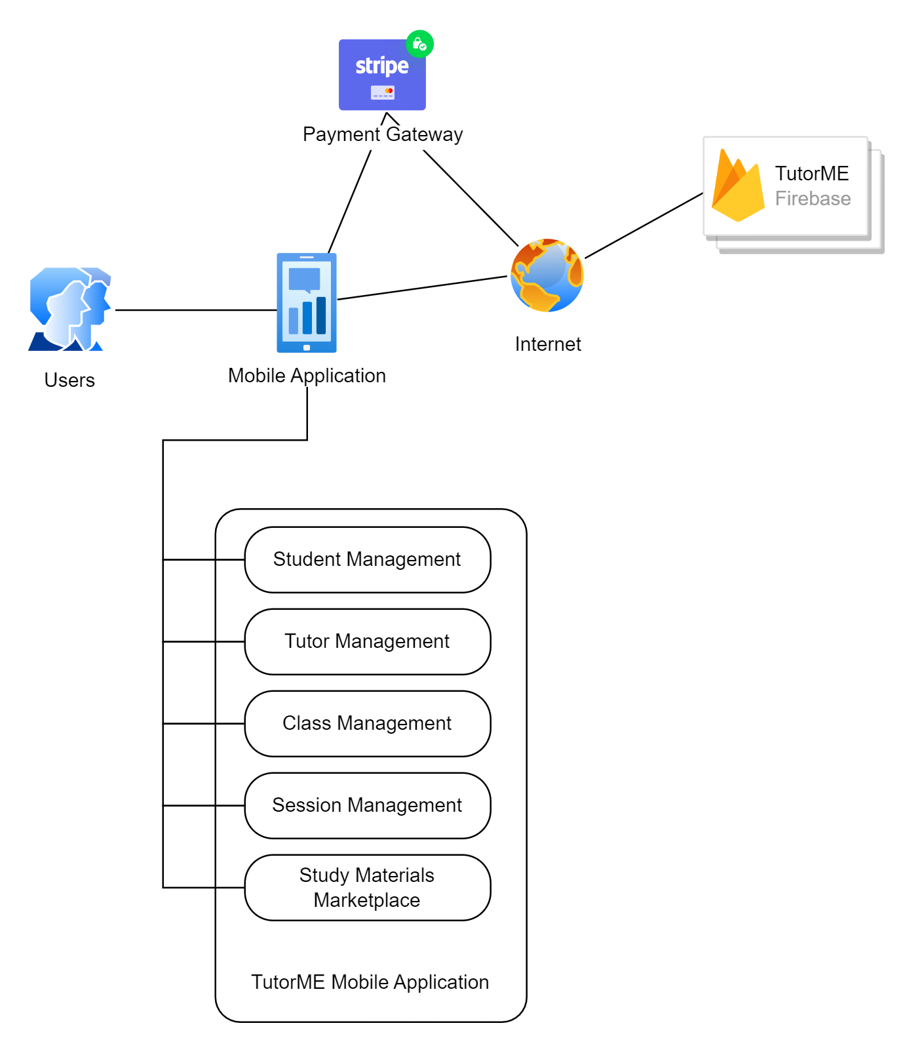

## 5 Design Purpose

The primary goals we aim to achieve through the design of our GUI revolve around user-friendliness, efficiency, and attractiveness. By emphasizing user-friendliness, we intend to ensure that our mobile application is easy to navigate, making it accessible to a wide range of users, including those who may not be technically proficient. Efficiency is a core focus, as we strive to streamline the process of finding and connecting with student tutors, ultimately saving users time and effort. Moreover, we aspire to create an attractive and engaging interface that enhances the overall user experience, making the application not only functional but visually appealing, thus encouraging active and continued use.

## 6 Team Members

|  |  |  |
| --- | --- | --- |
| **Member ID** | **Name** | **Role** |
| IT21118340 | Kumarathunga S. A. D. S. | Team leader |
| IT21291364 | Rashen W.G.M | Team member |
| IT21267772 | Kumanayake I. A, | Team member |
| IT21388934 | Siriwardhana S.M.R.R. | Team member |

TABLE 1. Team Members

## 7 Contribution Table

|  |  |  |
| --- | --- | --- |
| **Member ID** | **Name** | **Function** |
| IT21118340 | Kumarathunga S. A. D. S. | Functionalities related to study materials marketplace and student management |
| IT21291364 | Rashen W.G.M | Functionalities related to tutor management and calendar management |
| IT21267772 | Kumanayake I. A. | Functionalities related to booking session and payment process |
| IT21388934 | Siriwardhana S.M.R.R. | Functionalities related to class management |

TABLE 2. Contributions

# Design Process

The utilization of the Design Thinking model is instrumental in the development of our mobile application, particularly in addressing the identified problem and market gaps. This approach, based on empathizing with users and understanding their needs, allows us to innovate and devise a unique solution. By critically analyzing existing competitive products and recognizing their strengths and weaknesses, we can pinpoint the unmet requirements in the market. The absence of direct competitors in our domain, coupled with the limitations of current indirect competitors, underlines the distinctive value of our mobile application. Design Thinking facilitates the strategic identification of these market gaps and informs the creation of a more comprehensive and user-centric solution, ensuring our application's success in delivering enhanced experiences to both university students and student tutors.

## 1 User Involvement

To involve users in the user-centered design process, we will implement a multi-faceted approach. First, we will conduct surveys and focus group discussions to understand their needs, pain points, and preferences. We will also create interactive prototypes and conduct usability testing sessions, gathering feedback directly from users. Additionally, we plan to engage users in co-design workshops to collaboratively shape the app's features. Regular feedback loops and iterative design will ensure continuous user involvement, guaranteeing that the final product is tailor-made to address their specific requirements.

# Milestone 01: Identify user groups

## 1 Persona(s)

4.1.1. IT21118340

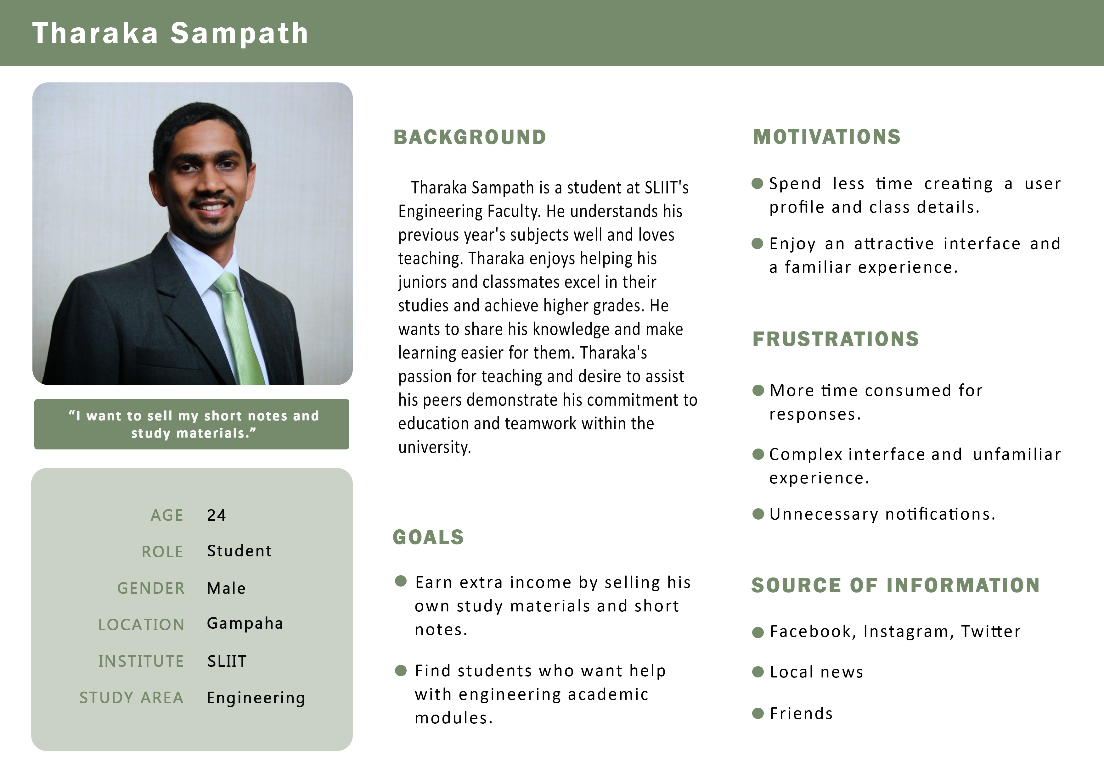

4.1.2. IT21291364

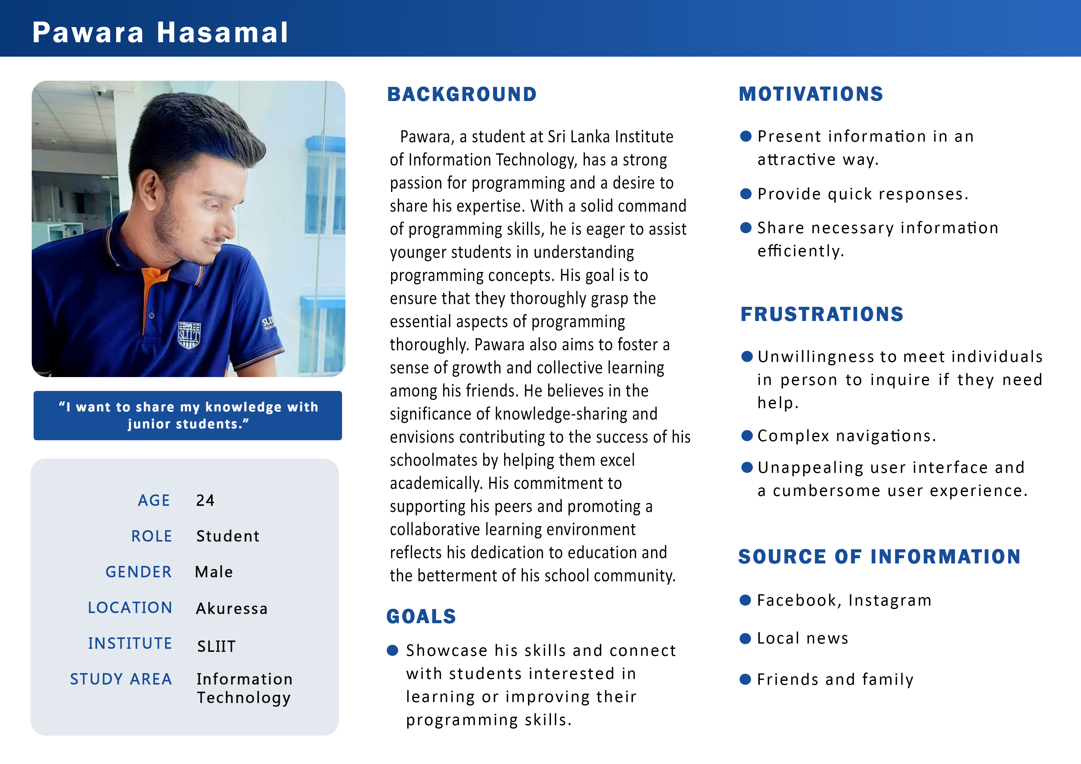

4.1.3. IT21267772

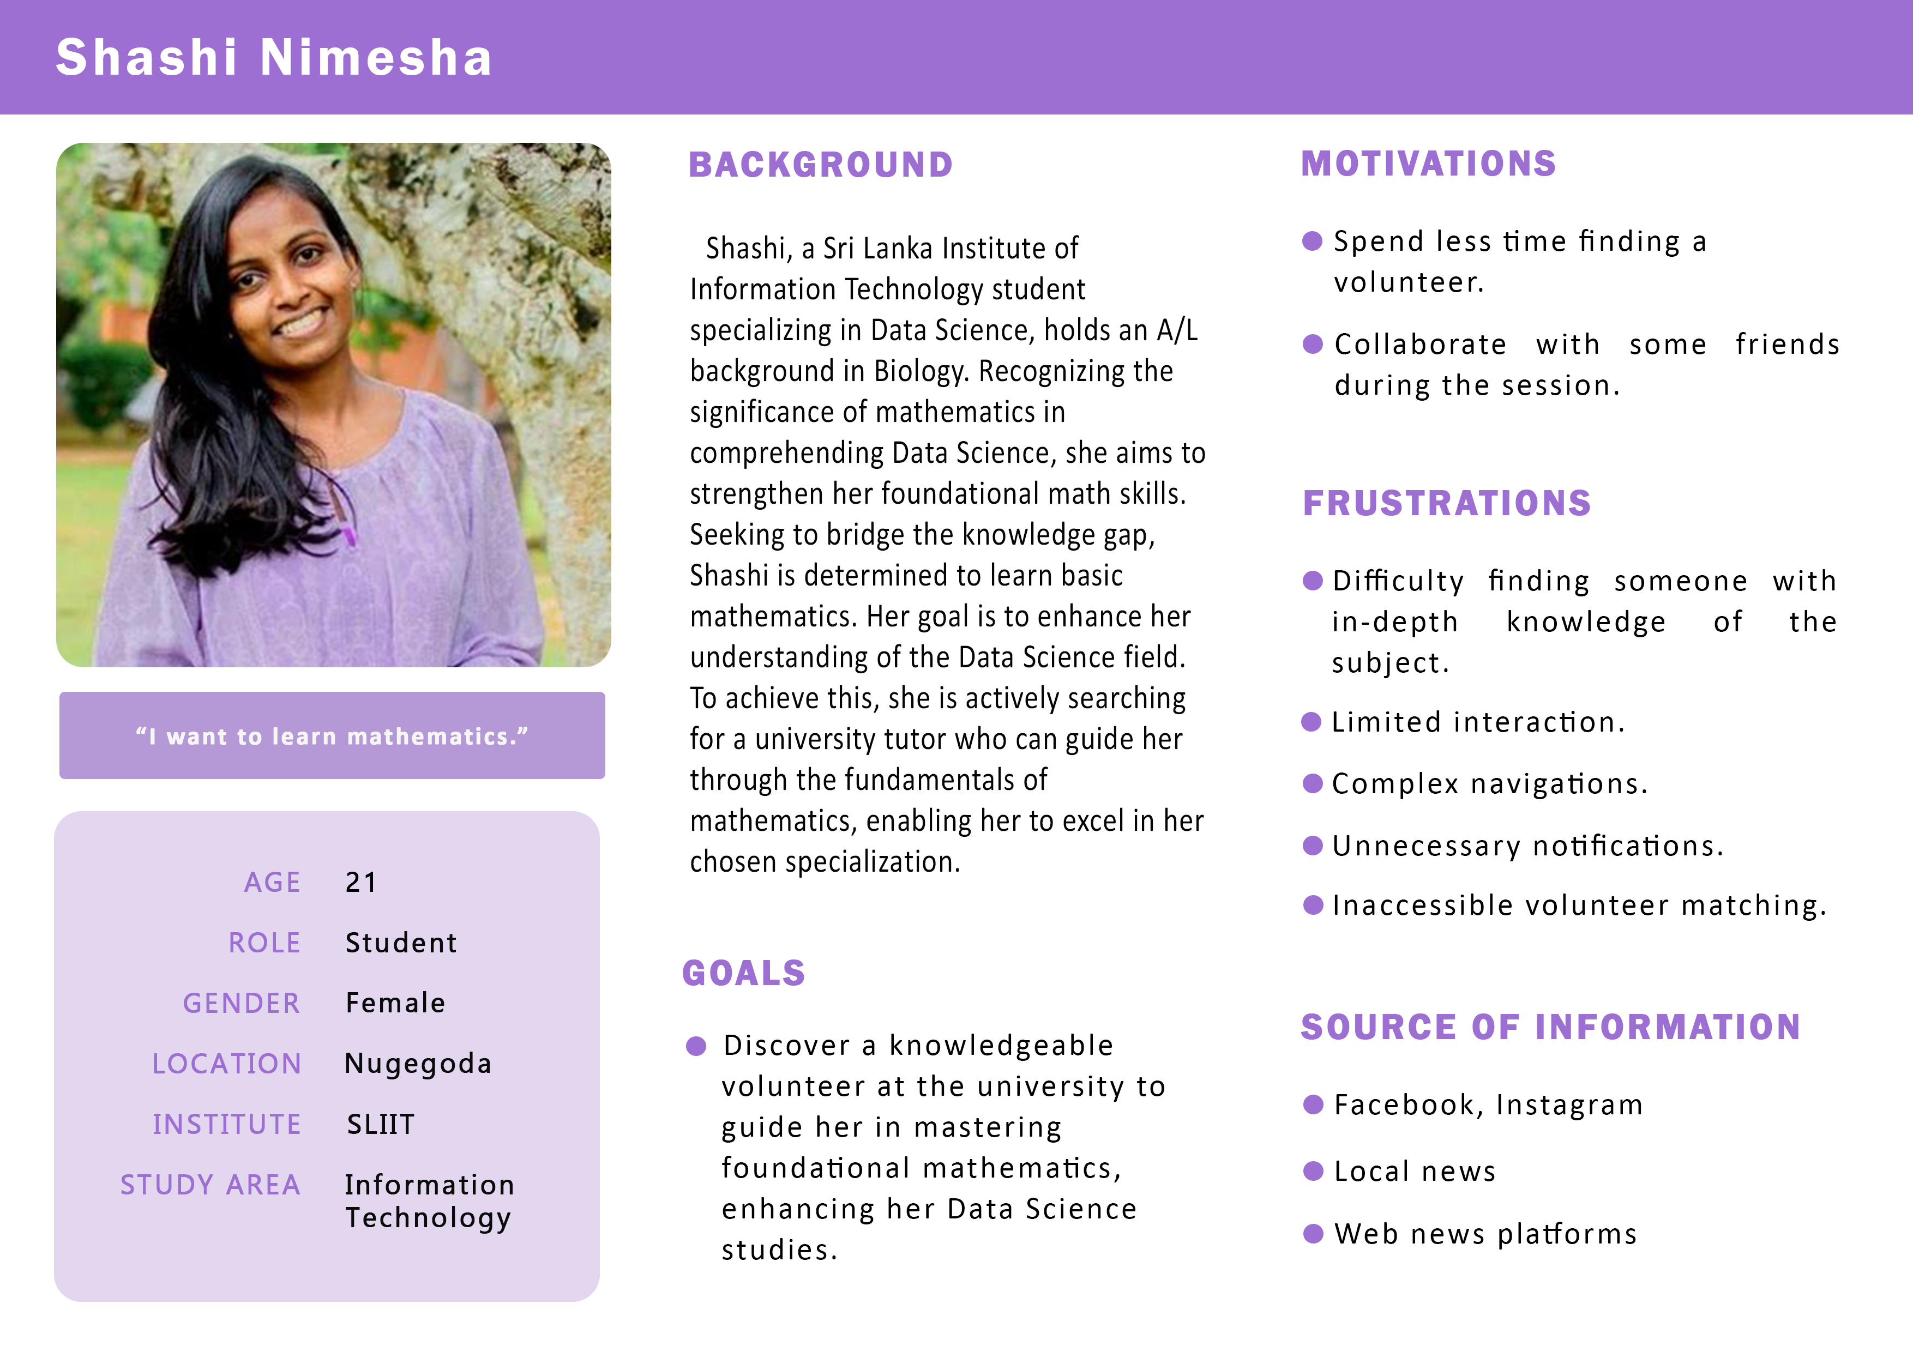

4.1.4. IT21388934

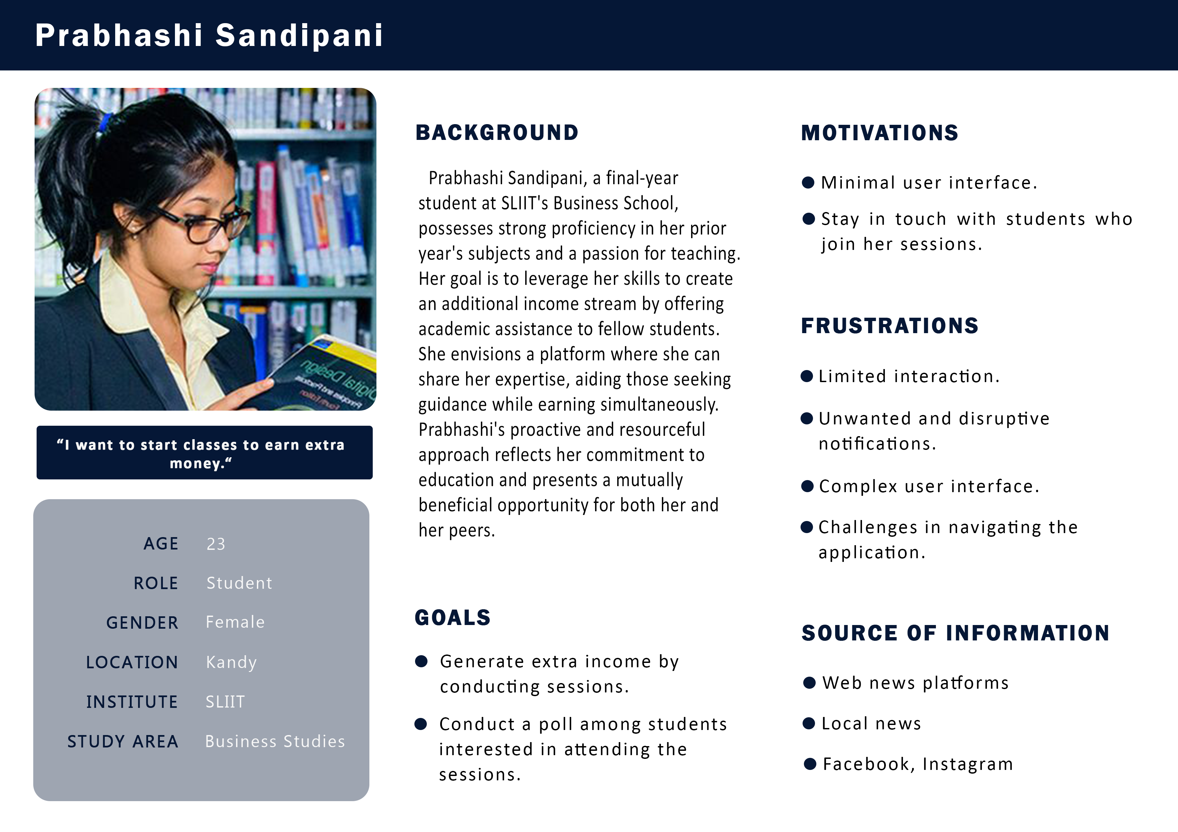

## 2 Empathy maps

4.2.1. IT21118340

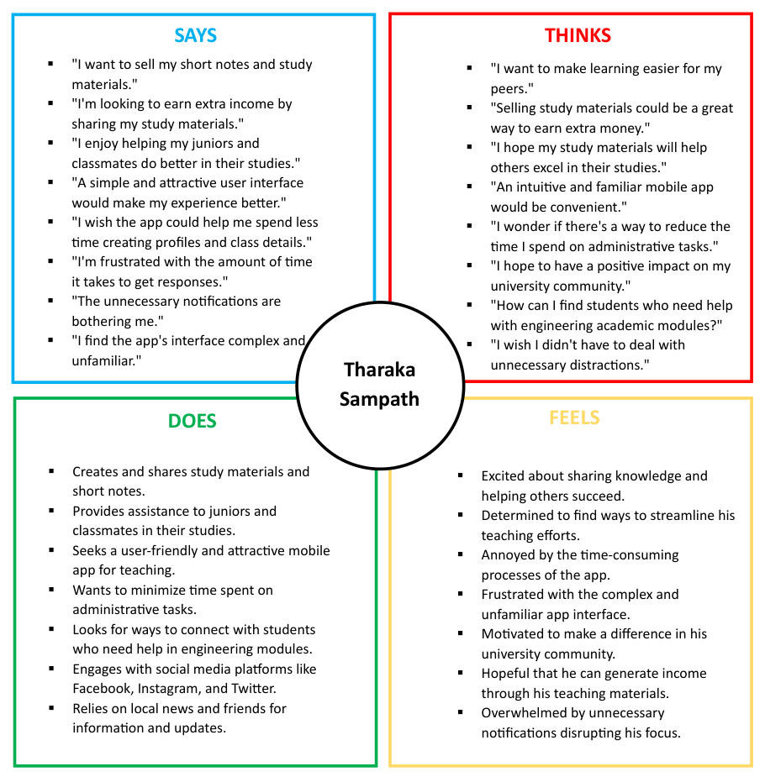

4.2.2. IT21291364

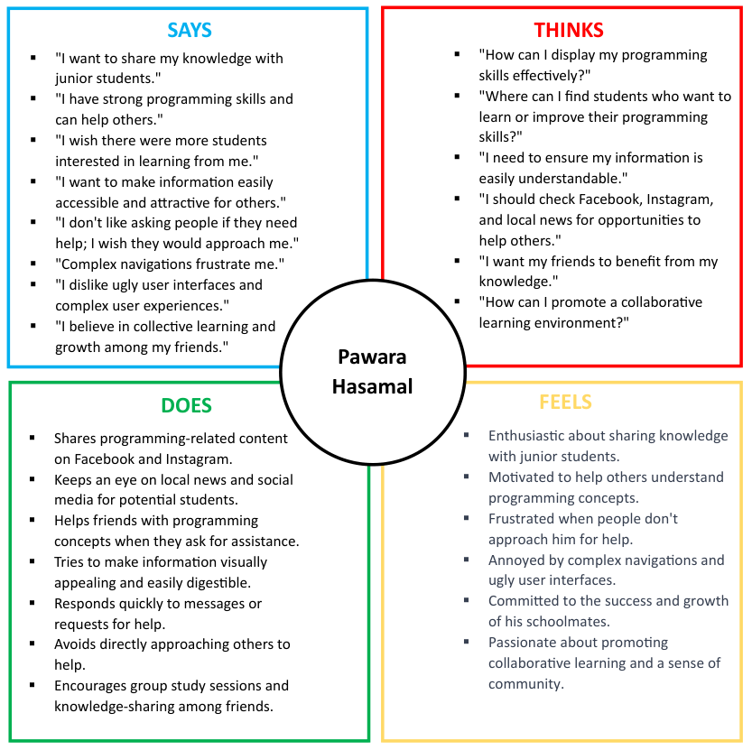a

4.2.3. IT21267772

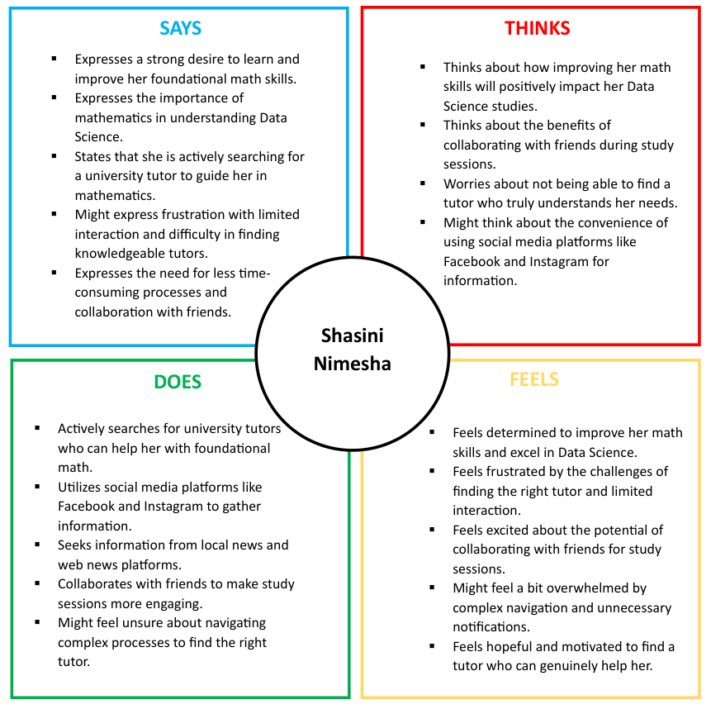

4.2.4. IT21388934

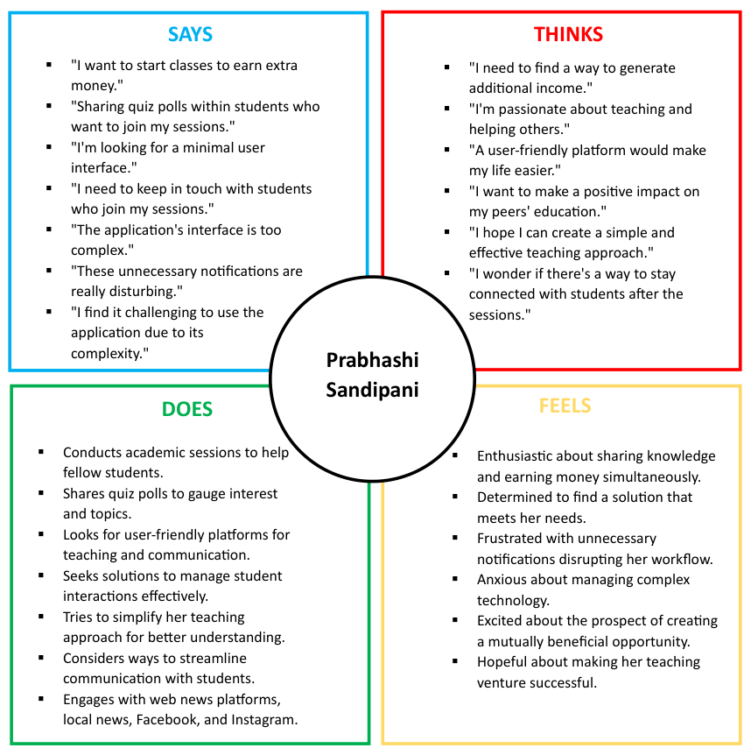

## 3 User stories

4.3.1. IT21118340

As a student tutor,

I want to sell my short notes and study material

So that I can earn extra income

4.3.2. IT21291364

As a university student,

I want to rate the tutor,

So that I can provide feedback about their abilities

4.3.3. IT21267772

As a university student,

I want to easily request a session with a student tutor

So that I can schedule a session with them

4.3.4. IT21388934

As a student tutor,

I want to to create and display information regarding classes I conduct

So that students seeking tutoring can make informed decisions

## 4 User flow(s)

4.4.1. IT21118340

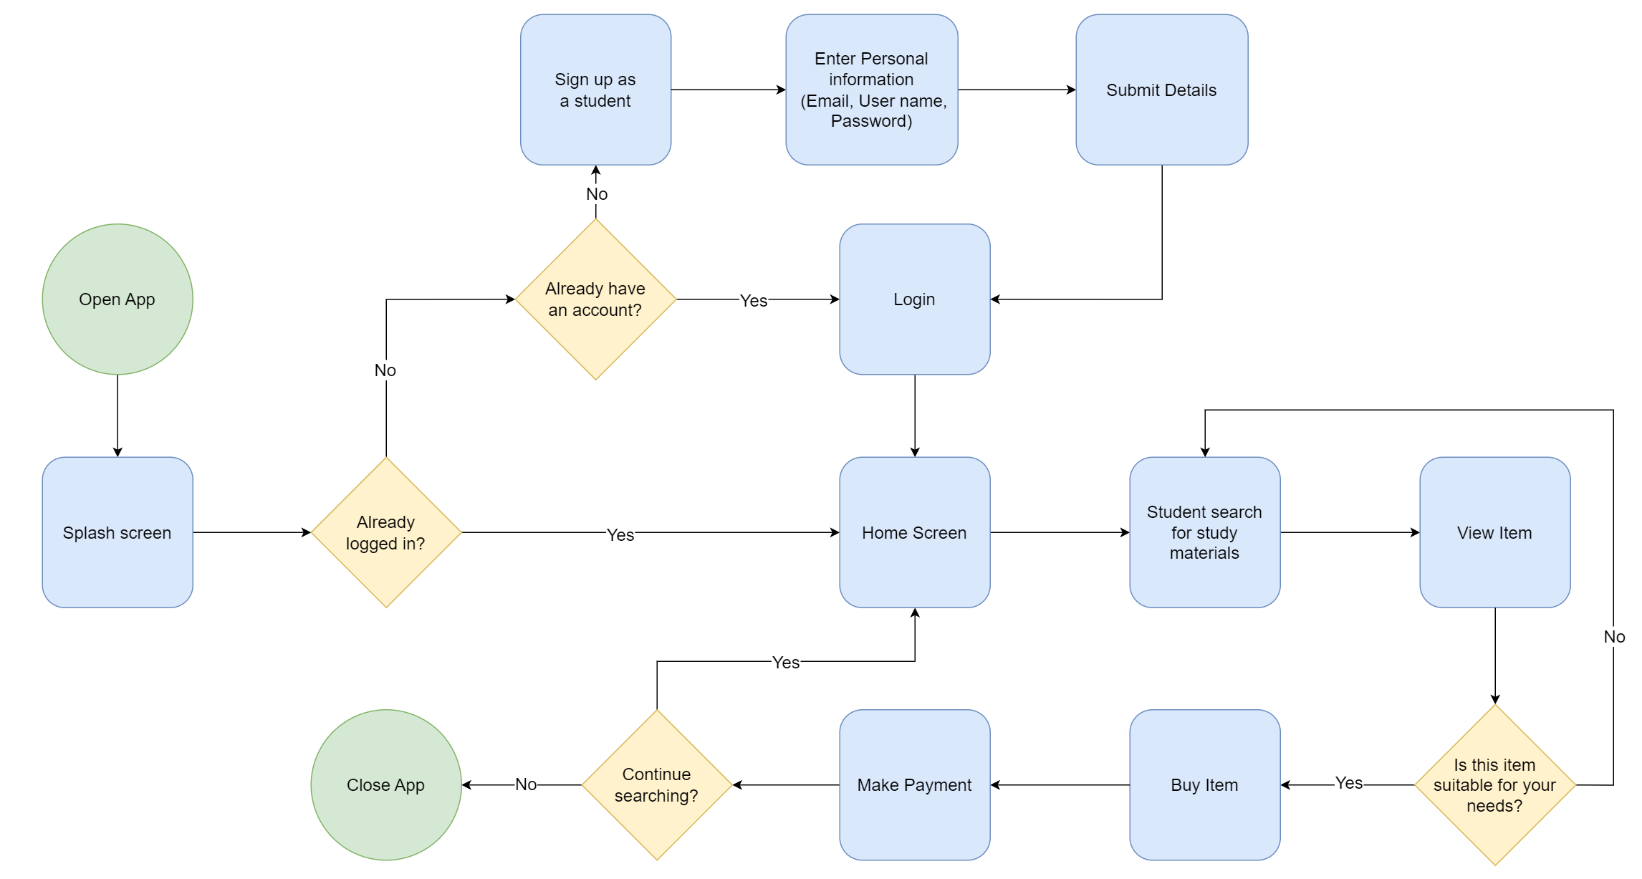Student: Buy Study Materials

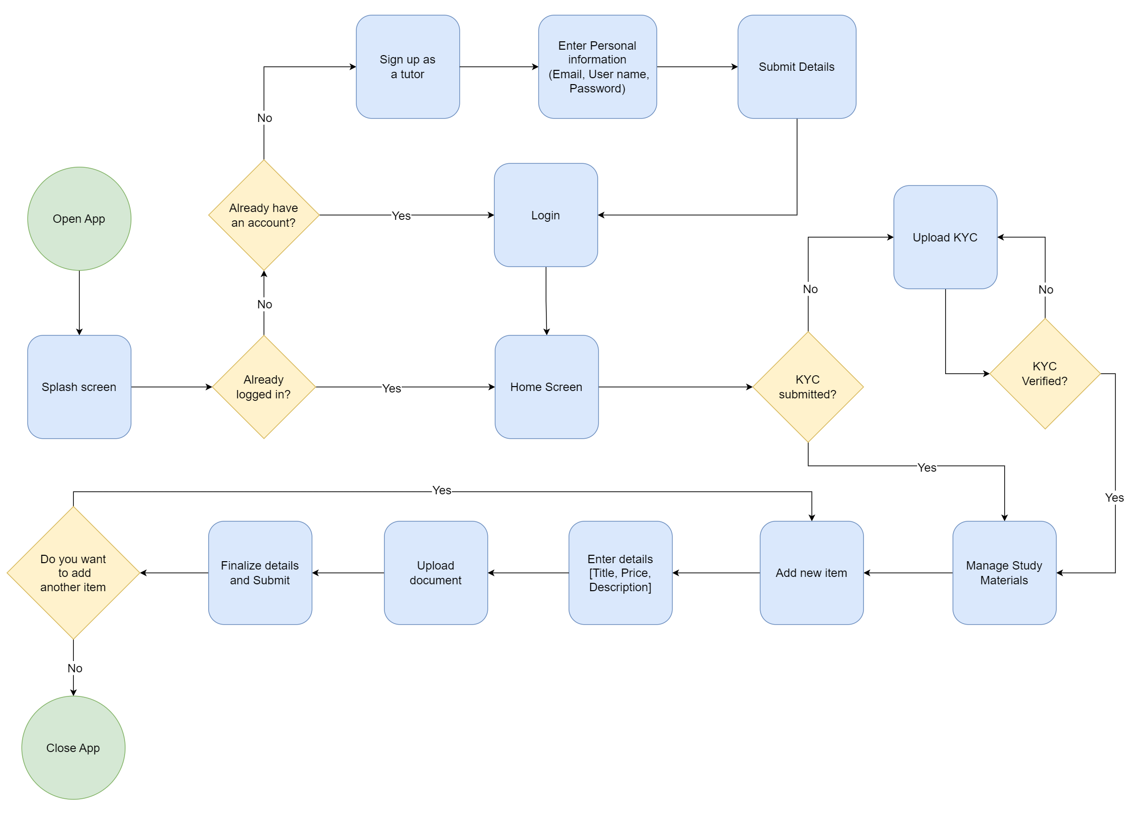Tutor: Upload Study Materials

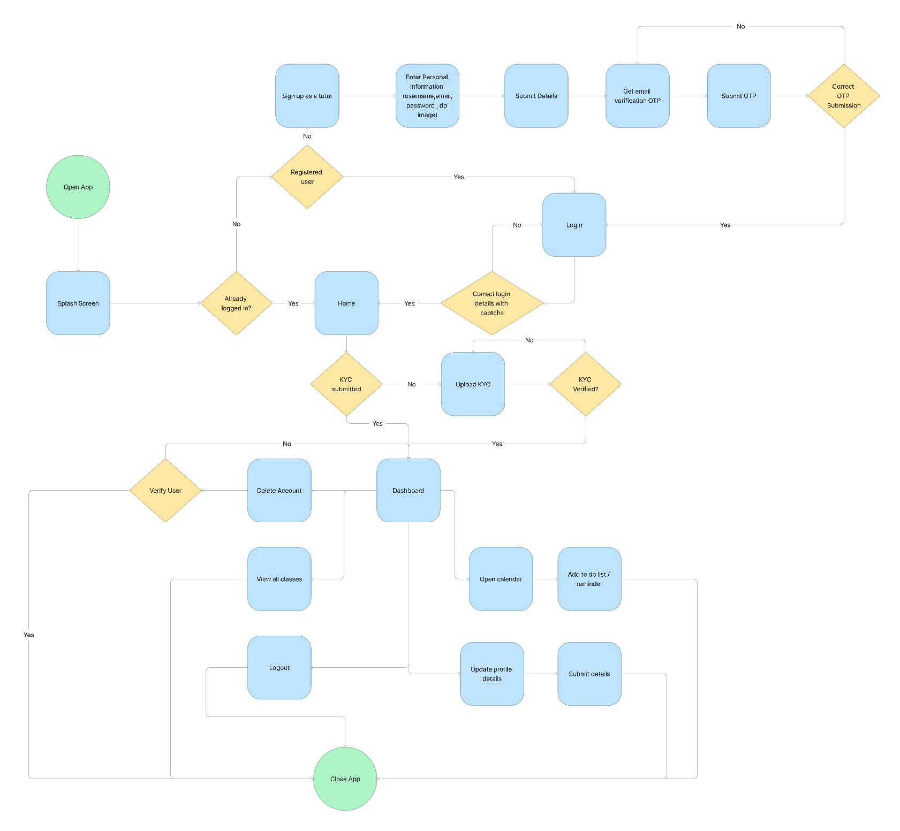4.4.2. IT21291364

4.4.3. IT21267772

Student: Booking Class

4.4.4. IT21388934

Tutor: Publish Class



## 5 Service Blueprint(s) – 01 Service Blueprint from a group

From Student’s Perspective

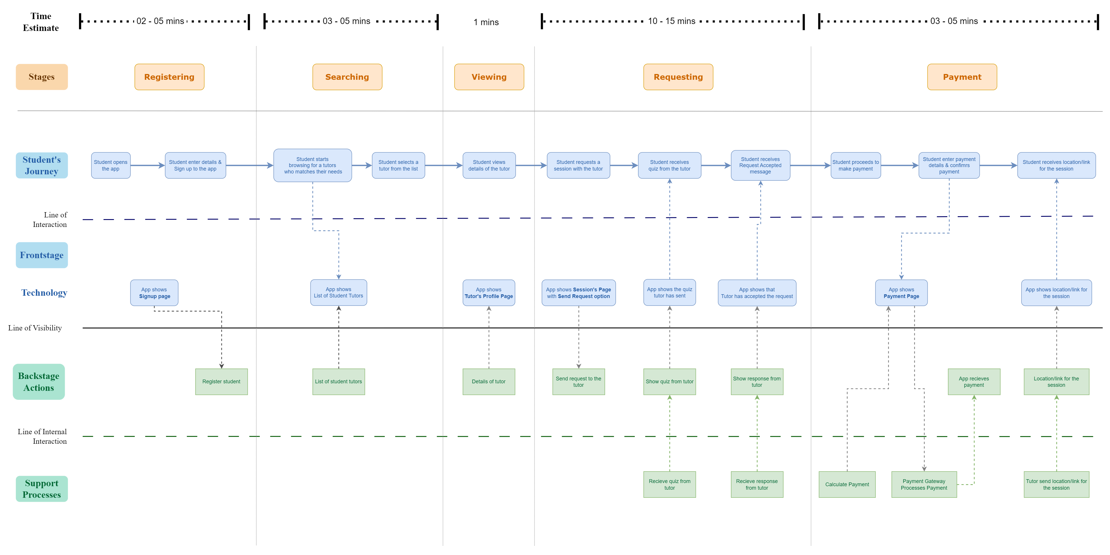

From Tutor’s Perspective

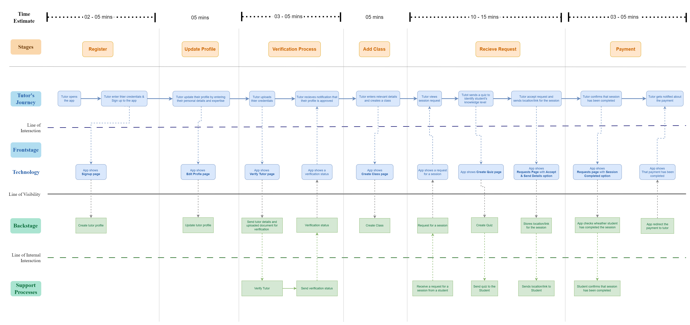

## 6 Identify basic functionality of the proposed system

1. **User Registration:** Allow users to create accounts by providing necessary information.
2. **Tutor Search:** Enable students to search for available tutors based on criteria like subject, availability, and location.
3. **Tutor Selection:** Allow students to select and connect with tutors for academic assistance.
4. **Payment Processing:** Facilitate secure payment transactions for tutoring services.
5. **Review and Rating:** Allow users to rate and review tutors, fostering transparency and trust.
6. **Session Management:** Enable users to schedule and manage tutoring sessions with chosen tutors.
7. **Tutor Profiles:** Provide detailed profiles of tutors, including their qualifications, ratings, and reviews.
8. **Class management:** Enable tutors to schedule and manage classes.
9. **Document Sharing:** Allow the exchange of study materials, notes, and slides between students and tutors.
10. **Notifications:** Keep users informed about upcoming sessions, new tutors, and relevant updates.

# Milestone 2: Plan and conduct user research

5.1 Test Objectives

1. Identify factors that motivate students to seek or offer tutoring services

2. Identify challenges faced by students when they want to seek or offer tutoring services

3. Evaluate user’s willingness to pay for tutor services or study materials

4. Identify features or incentives that would enhance user engagement

5.2 Methodology

Firstly, two structured questionnaires will be distributed among a selected group of thirty university students from different subject areas and academic levels. Afterward, in-depth video interviews will be conducted with four students to gain a better understanding of user behavior and motivation. Google Forms and WhatsApp will be used to conduct the questionnaires, while Zoom will be the platform of choice for the video interviews.

5.2.1 Questionnaire

Structured questionnaires will be distributed among thirty university students. Students will be selected from the Computing, Humanities, and Engineering faculties. From each faculty, five students will be selected for their tutoring experience, while five students will be selected based on their academic level and seniority.

Two structured questionnaires will be created for tutors and students, using Google Forms, a survey platform developed by Google. Google Forms provides a comprehensive suit of tools for creating questionnaires, analysing, and visualizing user responses.

Selected students will be contacted via the WhatsApp messaging platform. After they agree to the interview, the relevant questionnaire will be shared with the participant. 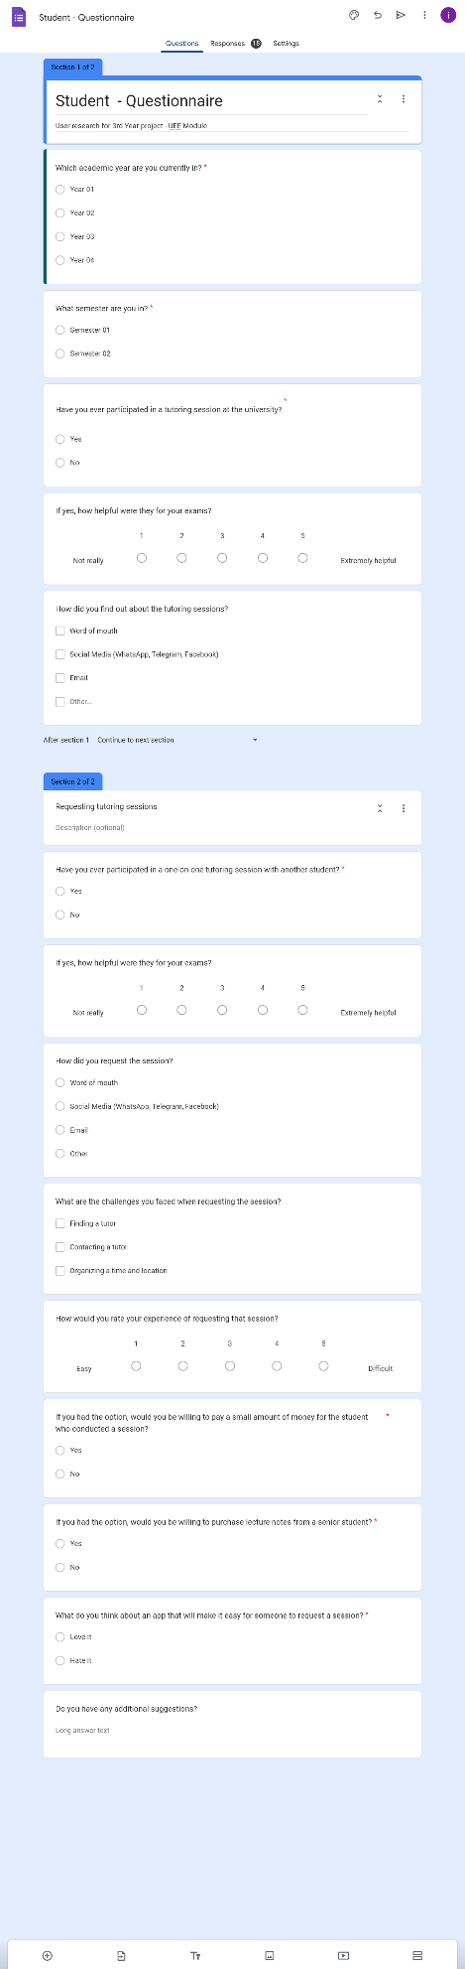Questionnaire for Students

Section 01

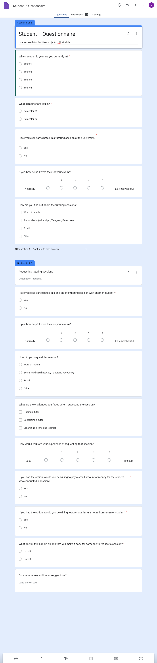Section 02

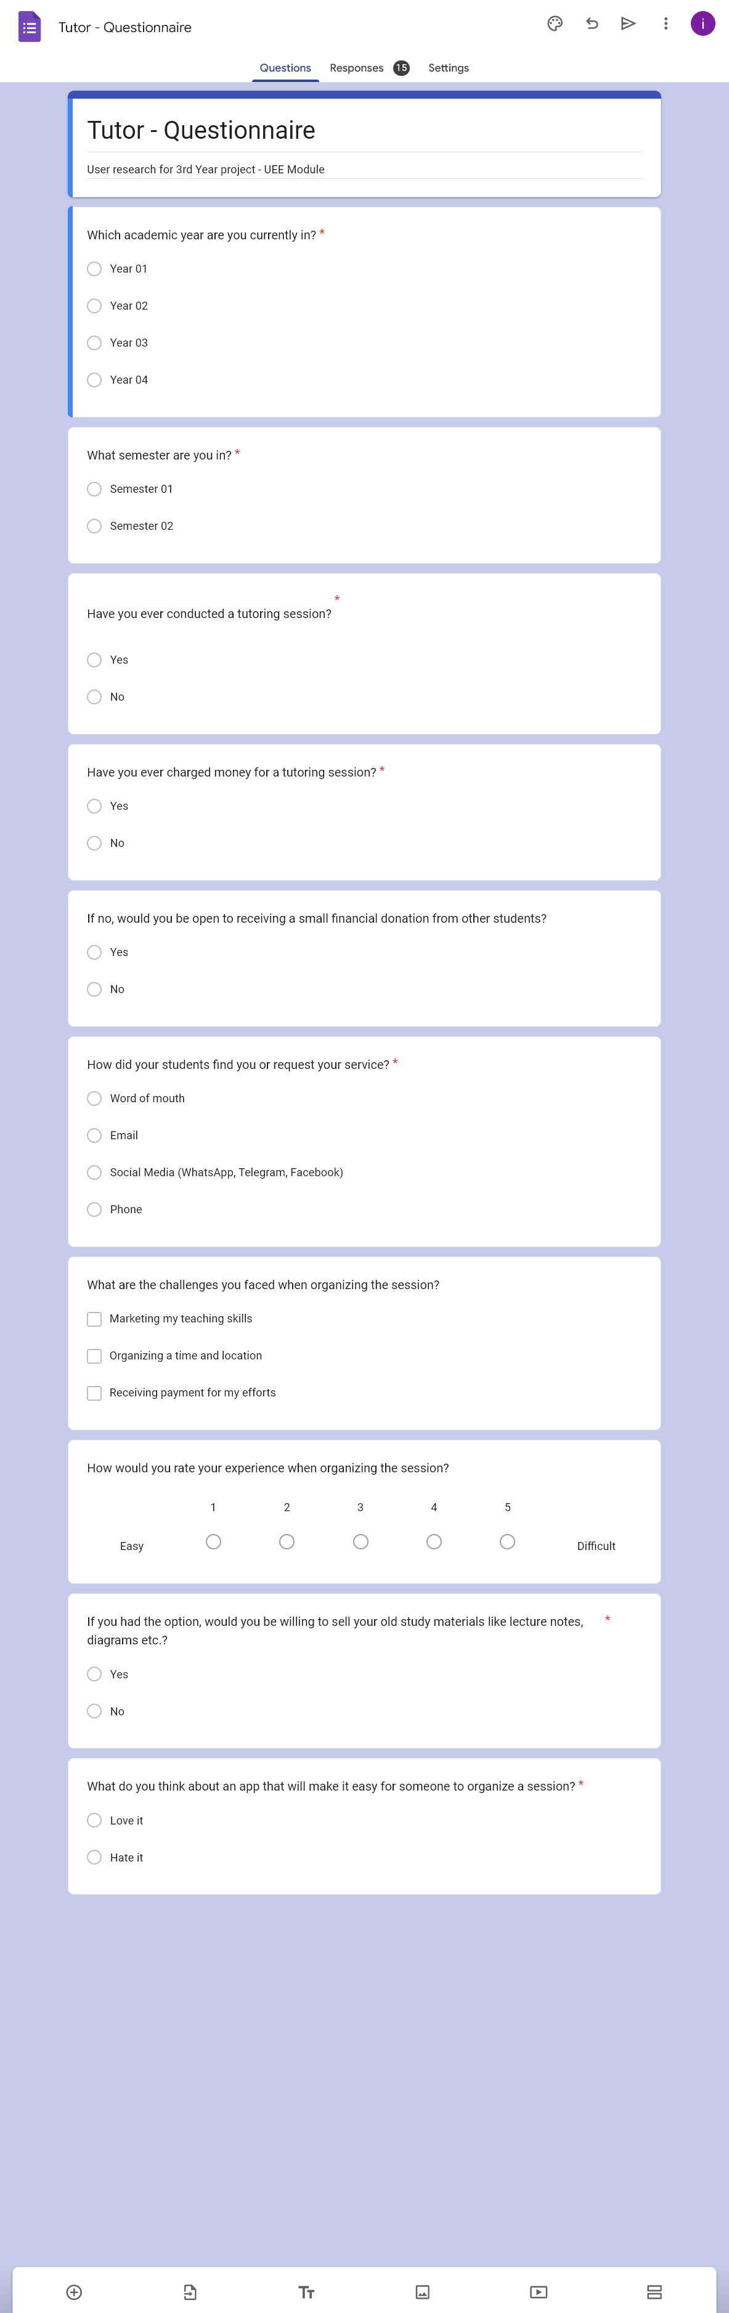Questionnaire for Tutors

5.2.2 Video Interviewing

Four students will be selected for a video interview: one to represent the student's perspective and three to represent the tutor's perspective. Students will be selected based on their tutoring experience and academic level.

Selected students will be contacted via the WhatsApp messaging platform. After they agree to the interview, a video interview will be conducted via the Zoom platform.

* Interview Questions

**Student:**

* Have you ever participated in a one-on-one tutoring session with another student?
* How helpful were they to your exam?
* What motivated you to seek tutoring services?
* How did you request the session?
* Can you describe your experience when requesting the session?
* What are the challenges you faced when requesting the session?
* If you had the option, would you be willing to pay a small amount of money to the student who conducted a session?
* If you had the option, would you be willing to purchase study materials from a senior student?
* What would you think about an app that will make it easy for someone to request a session?
* Do you have additional suggestions for the app?

**Tutor:**

* Have you ever conducted a tutoring session?
* What motivated you to offer tutoring services?
* How did your students find you or request your service?
* How did your students contact you to request your service?
* Have you ever been paid for a tutoring session?
* Can you describe your experience when organizing the session?
* What are the challenges you faced when organizing the session?
* If you had the option, would you be willing to sell your old study materials like lecture notes, diagrams etc.?
* What would you think about an app that will make it easy for someone to organize a session?
* Do you use any separate app to manage your availability and set reminders for yourself when conducting sessions? If so, can you describe it?
* Do you have any additional suggestions?
* Interviewing – All Video Link**:** <https://drive.google.com/drive/folders/1It7_XEsuAzOBSU0OnGVB_mGOKA-zAMH2?usp=drive_link>
* Participant Profiles

The table below provides a breakdown of the participants selected for video interview:

|  |  |  |
| --- | --- | --- |
| **Name** | **Demography** | **Date & Time** |
| *Sathsarani Wijeratne* | *3rd year Information Technology student at SLIIT.* | *2023-08-25 18.30* |
| *Dananjaya Siriwardhana* | *3nd year Data Science student at SLIIT.* | *2023-09-18 18.30* |
| *Rosara Dayaratne* | *3rd year Software Engineering student at SLIIT.* | *2023-09-22 18.30* |
| *Sasini Nimesha* | *1st year Computer Science student at*  *KDU* | *2023-09-20 18.30* |

TABLE 3. Participant Profile

* Tasks and Scenarios

|  |  |  |
| --- | --- | --- |
| **Task** | **Target** | **Probe** |
| Tutor - Login & Register | User registers as a tutor by providing details and then login to land in the tutor home page. |  |
| Publish class | Tutor publishes a class by adding class details and the session times. |  |
| Upload study materials | Tutor uploads a study material to be downloaded by a student. |  |
| Make a withdrawal | Tutor withdraws money from the wallet after conducting a session. |  |
| Student - Login & Register | User registers as a student by providing details and then login to land in the student home page. |  |
| Make session request | Student searches a class by the category and then requests a session with the tutor by providing details. |  |
| Download study materials | Student downloads a study material uploaded by a tutor. |  |

TABLE 4. Tasks and Scenarios

* Interview 01

**Participant**: Sathsarani Wijeratne

**Description**: 3rd year Information Technology student

**Role**: Tutor

**Date**: *2023-09-03*

**Link:** <https://drive.google.com/file/d/1ReHpQ4KsjQ8TbbwVjMKX2fWNRXD8oDFO/view?usp=drive_link>

**Transcript:**

Manuka: Hey Sathsarani, I'm Manuka, and these are my teammates Dilru, Rumesh, and Isuru. We're developing an app that will help university students connect with tutors. So, we're really excited to talk with you today to get your thoughts as a tutor. We think your insights will be really helpful for us in making our app even more user-friendly. First can you introduce you yourself?

Sathsarani: Hi everyone, My name is Sathsarani, and I'm currently in my third year of studying Information Technology.

Manuka: Have you ever conducted a tutoring session?

Sathsarani: Yes, I've done quite a few tutoring sessions, mostly covering programming-related topics.

Isuru: What motivated you to offer tutoring services?

Sathsarani: I just really wanted to help my friends do well in their studies. Back in my university days, I saw some of my friends really struggling with tough subjects. That's when I got the idea to set up my very first tutoring session. It felt amazing to see my friends make real progress in their studies.

Isuru: How did your students find you or request your service?

Sathsarani: Usually, my students discovered me through a mix of recommendations and online presence. It was often friends who had experienced my tutoring would suggest me to others. On top of that, I used to upload my tutoring sessions on YouTube, and, some people came across them and reached out to me.

Rumesh: How did your students contact you to request your service?

Sathsarani: They usually reached out to me through email or text messages.

Rumesh: Have you ever been paid for a tutoring session?

Sathsarani: Yes, back in my university days, I noticed that some of my fellow students were really grateful for my tutoring help and even wanted to pay me for it. It was a pleasant surprise and a big help financially. It not only eased my money worries but also made me realize how much they valued what I was doing.

Manuka: Can you describe your experience when organizing the session?

Sathsarani: Setting up a tutoring session takes some thoughtful steps. First, I chat with the student to figure out when and where works best for them. If it's an online session, we decide on the video call platform. Next, I change the session material to match what the student's studying, so it's relevant. When we're in the session, I keep things organized by following a plan. We go through what they need to learn, and I'm always open to questions and discussions to make sure they really get it.

Isuru: What are the challenges you faced when organizing the session?

Sathsarani: When it comes to setting up tutoring sessions, I've faced a few problems. Scheduling can be a real puzzle, especially when exams are near. Finding a peaceful spot for face-to-face sessions without interruptions is not easy either. Plus, working with students who have different learning preferences means I've got to be flexible and really good at talking things through.

Dilru: If you had the option, would you be willing to sell your old study materials like lecture notes, diagrams, etc.?

Sathsarani: Yes! I'm believe in sharing knowledge and resources. I thought about selling my old study materials like lecture notes and diagrams to help fellow students, but I don't want to burden them with high costs. I'm leaning towards giving them away for free. It's a way for me to showcase my teaching skills and assist others at the same time.

Rumesh: Akke, What would you think about an app that will make it easy for someone to organize a session?

Sathsarani: I think that is really great idea. Being a tutor myself, I know firsthand how tricky it can be to juggle schedules, handle payments, and keep in touch with students. Having an app tailor-made for managing tutoring sessions could really make things smoother, making life easier for both tutors and students.

Manuka: Do you use any separate app to manage your availability and set reminders for yourself when conducting sessions? Can you describe it?

Sathsarani: Right now, I rely on a calendar app to keep track of my schedule and remind me of important events. I put in all my tutoring appointments, study sessions, and other personal commitments into the calendar. It's good for preventing conflicts in my schedule, but it's missing specific features that would make tutoring even easier. Like, it doesn't have any way for me to handle payments or communicate directly with my students. So, I'm pretty excited to check out a tutoring app that's designed just for those needs.

Isuru: Do you have any additional suggestions?

Sathsarani: Yes. What do you think about adding a feature where tutors can assess students' understanding of the topics they want to concentrate on.

Manuka: Yes. We will definitely consider about it. Thank you so much for taking the time to do this interview. We genuinely appreciate it!

Sathsarani: Thank you guys for having me. I wish you all the very best.

* Interview 02

**Participant**: Dananjaya Siriwardhana

**Description**: 3rd year Data Science student

**Role**: Tutor

**Date**: *2023-09-15*

**Link*:***[*https://drive.google.com/file/d/1yQ80PozVElbcb1F1Fsc71fo_3I-IHYjM/view?usp=drive_link*](https://drive.google.com/file/d/1yQ80PozVElbcb1F1Fsc71fo_3I-IHYjM/view?usp=drive_link)

**Transcript:**

Dilru: Hey Dananjaya, I'm Dilru, and these are my teammates Manuka, Rumesh, and Isuru. We're developing an app that will help university students connect with tutors. In this interview, we'd like to ask you a few questions and gather your thoughts as a tutor. We think your insights will be really helpful for us in making our app even more user-friendly. First can you introduce your yourself?

Dananjaya: Hi everyone, My name is Dananjaya! and I'm currently in my third year of studying Data Science.

Dilru: Have you ever conducted a tutoring session?

Dananjaya: Yes, I've conducted several tutoring sessions, primarily focusing on topics related to engineering and mathematics.

Manuka: What motivated you to offer tutoring services?

Dananjaya: In previous years, I noticed some of my classmates having a hard time with certain subjects. That's when I thought of starting some tutoring session, to help them.

Isuru: How did your students find you or request your service?

Dananjaya: Most of my students find me through word of mouth or online. It's usually friends who've had tutoring sessions with me and then recommend me to others. And I used to maintain a blog about engineering related topics, so some people stumbled upon them and got in touch.

Rumesh: How did your students contact you to request your service?

Dananjaya: They usually reached out to me through email or WhatsApp. It is not easy for them to find me as there is no specific platform for this.

Rumesh: Have you ever been paid for a tutoring session?

Dananjaya: Yes, I did some research and found out that there are so many students out there who could really use some extra academic help. So, I started offering tutoring services to students who needed it. It actually helped improve my finances without putting too much pressure on my parents.

Manuka: Can you describe your experience when organizing the session?

Dananjaya: When I'm setting up a tutoring session, I like to keep things organized. First, I chat with the student to find out a time and location, it's most convenient for them. If it's going to be online, we choose a video call platform that works for both of us. Then, I create some study materials to help them understand the session further. During the session, We discuss what they need to learn, and I give them a small quiz to make sure they really understand everything.

Isuru: What are the challenges you faced when organizing the session?

Dananjaya: When arranging tutoring sessions, scheduling and payment are the trickiest parts, especially trying to find that perfect time when both of us are available, and making sure everything gets settled smoothly.

Dilru: If you had the option, would you be willing to sell your old study materials like lecture notes, diagrams, etc.?

Dananjaya: Yes, but you know, I've been thinking that sharing them for free might actually be a better idea. I mean, you can easily get old lecture notes from another senior without paying anything, right? So, instead of charging for them, I give them away for free. This way, I can not only showcase my teaching skills but also lend a hand to others. It's a win-win situation.

Rumesh: What would you think about an app that will make it easy for someone to organize a session?

Dananjaya: I think that is really great idea. Being a tutor myself, I know firsthand how difficult it can be to juggle schedules, handle payments, and keep in touch with students. Having an app specifically made for managing tutoring sessions could really make things easier for both tutors and students.

Manuka: Do you use any separate app to manage your availability and set reminders for yourself when conducting sessions? Can you describe it?

Dananjaya: Currently, I'm using Google services to manage my schedule and set reminders for important stuff. I put all my tutoring sessions, study meet-ups, and personal plans into my Google Calendar. It's great for avoiding schedule clashes, but it lacks some features that could make tutoring smoother. For instance, there's no built-in payment system or direct communication with my students. That's why I'm really looking forward to trying out this new tutoring app, specially designed to cater to those needs.

Isuru: Do you have any additional suggestions?

Dananjaya: Yes. What do you think about adding a feature where tutors can send a quiz to students, so they can know what topics to focus on.

Dilru: Yes. We will definitely consider about it. Thank you so much for taking the time to do this interview. We genuinely appreciate it!

Dananjaya: Thank you guys for having me. I wish you all the best.

* Interview 03

**Participant**: Rosara Dayaratne

**Description**: 3rd year Software Engineering student

**Role**: Tutor

**Date**: *2023-09-16*

**Link:** <https://drive.google.com/file/d/1bHxC8pnL_uWpyrf3bxMRPMUhrk96pG0N/view?usp=drive_link>

**Transcript:**

Dilru: Hello Rosara, I'm Dilru, and these are my teammates Manuka, Rumesh, and Isuru. We're developing a mobile application that will help university students connect with tutors. In this interview, we'd like to ask you a few questions and gather your thoughts as a tutor. We think your insights will be really helpful for us in making our app even more user-friendly. First can u introduce ur urself?

Interviewee: Hi everyone, My name is Rosara! and I'm currently in my third year of studying Software Engineering.

Dilru: Have you ever conducted a tutoring session?

Interviewee: Yes, I've conducted several tutoring sessions, primarily focusing on topics related to java and mobile app development.

Manuka: What motivated you to offer tutoring services?

Interviewee: Some of my classmates told me they are having a hard time with programming subjects. That's when I thought of starting some tutoring session, to help them.

Isuru: How did your students find you or request your service?

Interviewee: Most of my students find me through word of mouth or online. And I maintain a youtube channel about mobile app development, so some people watched them and got in touch.

Rumesh: How did your students contact you to request your service?

Interviewee: They usually reached out to me through email or WhatsApp.

Rumesh: Have you ever been paid for a tutoring session?

Interviewee: Yes, I did some research and found out that there are so many students out there who could really use some extra academic help. So, I started offering tutoring services to students who needed it. It actually helped improve my finances without putting too much pressure on my parents.

Manuka: Can you describe your experience when organizing the session?

Interviewee: I only conduct online sessions. First, I chat with the student to find out a time and video call platform that works for both of us. Then, I create some the study materials to help them understand the session further. During the session, We discuss what they need to learn. After the session, I give them some coding problems to make sure they really understood everything.

Isuru: What are the challenges you faced when organizing the session?

Interviewee: Trying to find a time perfect for both of us can be challenging. Next pain point is payment process. Since there isn't a dedicated platform for this kind of thing, I had little idea about how much to charge and how to do the payment process.

Dilru: If you had the option, would you be willing to sell your old study materials like lecture notes, diagrams, etc.?

Interviewee: Yes, If there are students willing to buy them for a fair price.

Rumesh: What would you think about an app that will make it easy for someone to organize a session?

Interviewee: I think that is really great idea. Being a tutor myself, I know firsthand how difficult it can be to handle scheduling and payments. Having an app specifically made for managing tutoring sessions could really make things easier for both tutors and students.

Manuka: Do you use any separate app to manage your availability and set reminders for yourself when conducting sessions? Can you describe it?

Interviewee: Yes, I put all my tutoring sessions, study meet-ups, and personal plans into the Calendar app. It's good for avoiding schedule clashes. I use whatsapp to communicate with my students. But If there was single tutoring app with all thses features, It would be super convenient.

Isuru: Do you have any additional suggestions?

Interviewee: No, Seems like this app covers every important feature.

Dilru: Thank you so much for taking the time to do this interview, Sashin. We really appreciate it!

Interviewee: Thank you guys for having me. I wish you all the best.

Interview 04

**Participant**: Sasini Nimesha

**Description**: 1rd year Computer Science student

**Role**: Student

**Date**: *2023-09-14*

**Link:** <https://drive.google.com/file/d/1CA31GiZzQK0_b0Z6jL-0dueaFLQSiS1W/view?usp=drive_link>

**Transcript:**

Dilru: Hey Sasi, I'm Dilru, and these are my teammates Manuka, Isuru, and Rumesh. We're developing an mobile application that will help university students connect with tutors. So, we're really excited to talk with you today to get your thoughts as a student. We think your insights will be really helpful for us in making our app even more user-friendly. First can u introduce your yourself?

Sasini: Hi everyone, My name is Sasini, and I'm currently in my first year of studying Computer Science.

Dilru: Have you ever participated in group tutoring sessions?

Sasini: Yes. I have participated in several group tutoring sessions.

Dilru: Have you ever participated in a one-on-one tutoring session, with another student?

Sasini: Yes. I have also participated in one-on-one tutoring session with another student.

Dilru: What was your experience with them? How helpful were they to your exam?

Sasini: They were really helpful. In my experience one-on-one tutoring session are much better than group tutoring sessions. It is easier to communicate with the tutor,

Manuka: What motivated you to seek tutoring services?

Sasini: I was struggling with several subjects. So I felt it would be better to ask help from someone.

Isuru: How did you request the session?

Sasini: I communicated with them the via WhatsApp.

Isuru: Can you describe your experience when requesting the session?

Sasini: It wasn't easy. There is no specific platform to find this type of service. Therefore I had to lot of

searching and asking around to find a tutor.

Rumesh: What are the challenges you faced when requesting a session?

Sasini: Finding a tutor was the main challenge. As I mentioned earlier, there isn't a dedicated platform for this kind of thing. And even when I did manage to find a tutor, it was still tricky to figure out if they were the right fit for me or not.

Manuka: If you had the option, would you be willing to pay small amount of money for the student who conducted the session?

Sasini: Absolutely, especially if they made a difference in my studies.

Dilru: If you had the option, would you be willing to purchase study materials from a senior student?

Sasini: Yes. But I will need to get a preview of the materials before purchasing, just to make sure it's worth the price.

Rumesh: What would you think about a app that will make it easy for someone to request a session?

Sasini: I think that is really great idea. It would save me lot of time, if an app like that exist.

Dilru: Do you have any additional suggestions?

Sasini: Yes. What do you think about adding a feature, which allows students to send a list of topics to our tutor. That way we can communicate what specific areas we'd like to concentrate on

Dilru: Yes. We will consider about it. Thank you so much for taking the time to do this interview. We genuinely appreciate it!

Sasini: Thank you, guys, for having me. I wish you all the best.

* Plan for Data analysis

|  |
| --- |
| Interview transcripts were prepared to better understand the user responses. User responses were analyzed both qualitatively and quantitatively. Quantitative data were entered into an excel sheet to visualize using bar charts and pie charts. Qualitative data was thoroughly reviewed and categorized to identify recurring themes and patterns in the feedback. We conducted in-depth interviews with a diverse group of university students who have experience as tutors and those who seek tutoring services. These interviews delved into various aspects, including user preferences, pain points, and expectations within the context of a student tutor app.  For the quantitative analysis, responses were organized into structured categories and entered into an Excel spreadsheet. This allowed for the creation of informative visualizations such as bar charts and pie charts. These graphical representations aided in presenting statistical insights into user preferences and usage patterns, providing valuable quantitative data for decision-making.  On the other hand, the qualitative data analysis involved a thorough examination of the interview transcripts. We identified recurring themes, feelings, and insightful suggestions shared by participants. This qualitative analysis helped us better grasp the finer details and hidden reasons behind user responses, allowing us to discover what users really need, what worries them, and where we could make the app better.  By combining both quantitative and qualitative analysis methods, we aimed to gain a comprehensive understanding of user needs, enabling us to make informed decisions during the app development process and ensure that the final product aligns closely with the expectations and preferences of both student tutors and those seeking tutoring services within the university community. |
| Two separate questionnaires were designed and conducted using Google Forms, one for students comprising 15 questions and another for tutors with 10 questions. These questionnaires were distributed to gather valuable user feedback for our student tutor app.  The collected data was then analyzed through Google Forms analysis tools. For the student questionnaire, we sought insights on various aspects, including user preferences, experiences, and expectations from the app. On the other hand, the tutor questionnaire focused on understanding tutor perspectives and requirements within the app.  Google Forms' analysis features allowed us to efficiently process and visualize the gathered data. We used the platform's built-in tools to generate summary statistics, charts, and graphs, providing a clear and organized overview of the responses. This analysis enabled us to identify patterns and areas for improvement based on user feedback from both students and tutors. |

* Questionnaire Results - Student

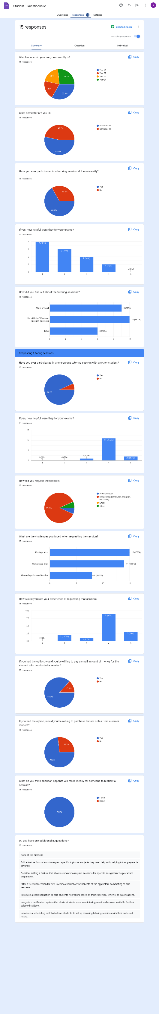

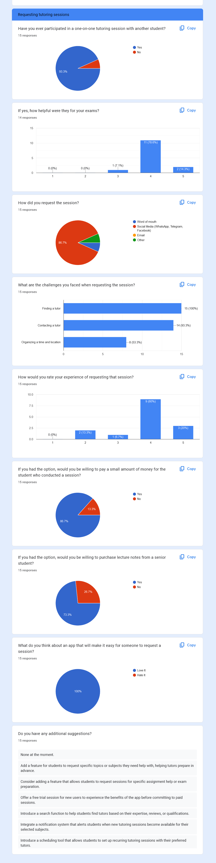

* Questionnaire Results - Tutor

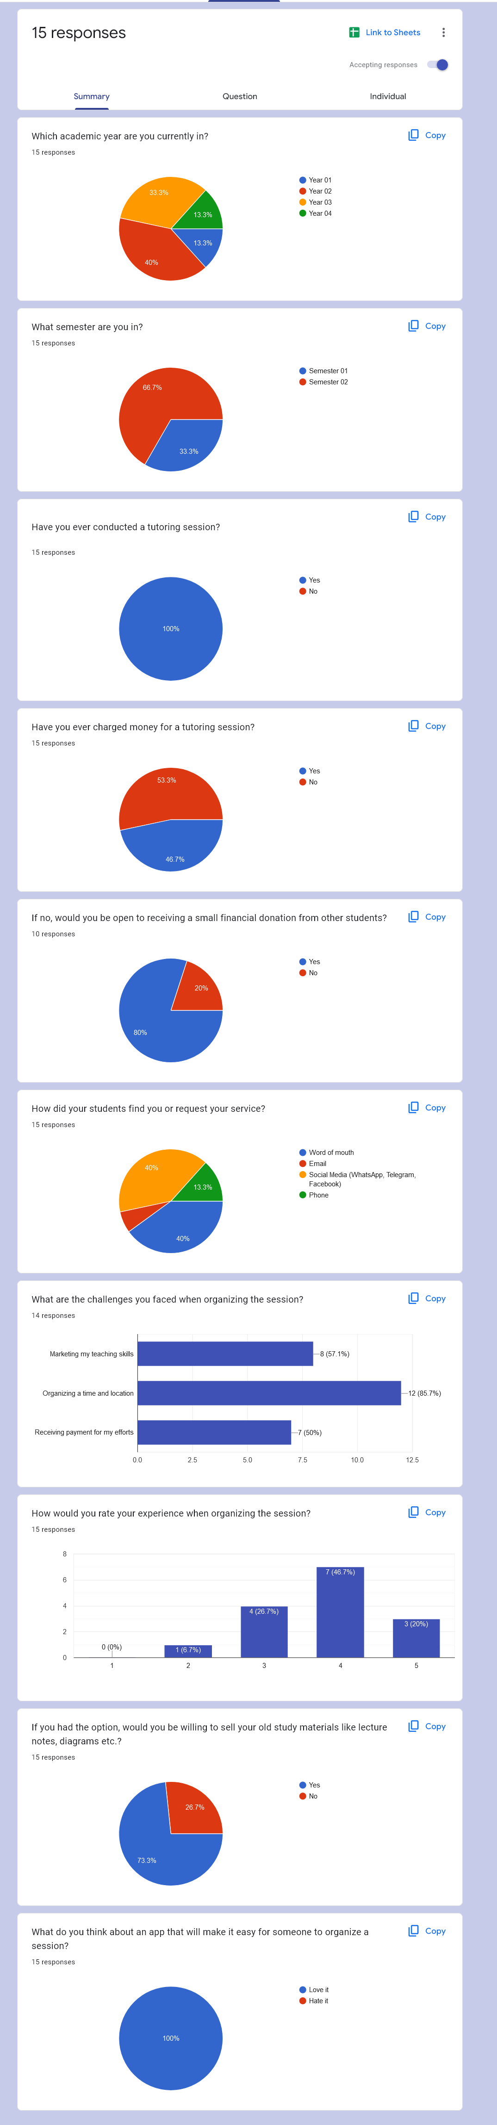

# Milestone 3: Verify the key-user flow(s)

## 6.1 IT21118340

Fail Points

1. Tutors mention in the interview that they prefer to share study materials.
   * + Change the user flow by, modifying input details for the study materials.
2. Tutors mention in the interview that they want to add a thumbnail image for the study materials.
   * + Change the user flow by, adding a new step to upload a thumbnail image.
3. Students mention in the interview that the don't prefer to buy study materials.
   * + Change the user flow by, removing the buying and payment processes and adding downloading process.

Previous User Flow – Tutor → Upload study materials

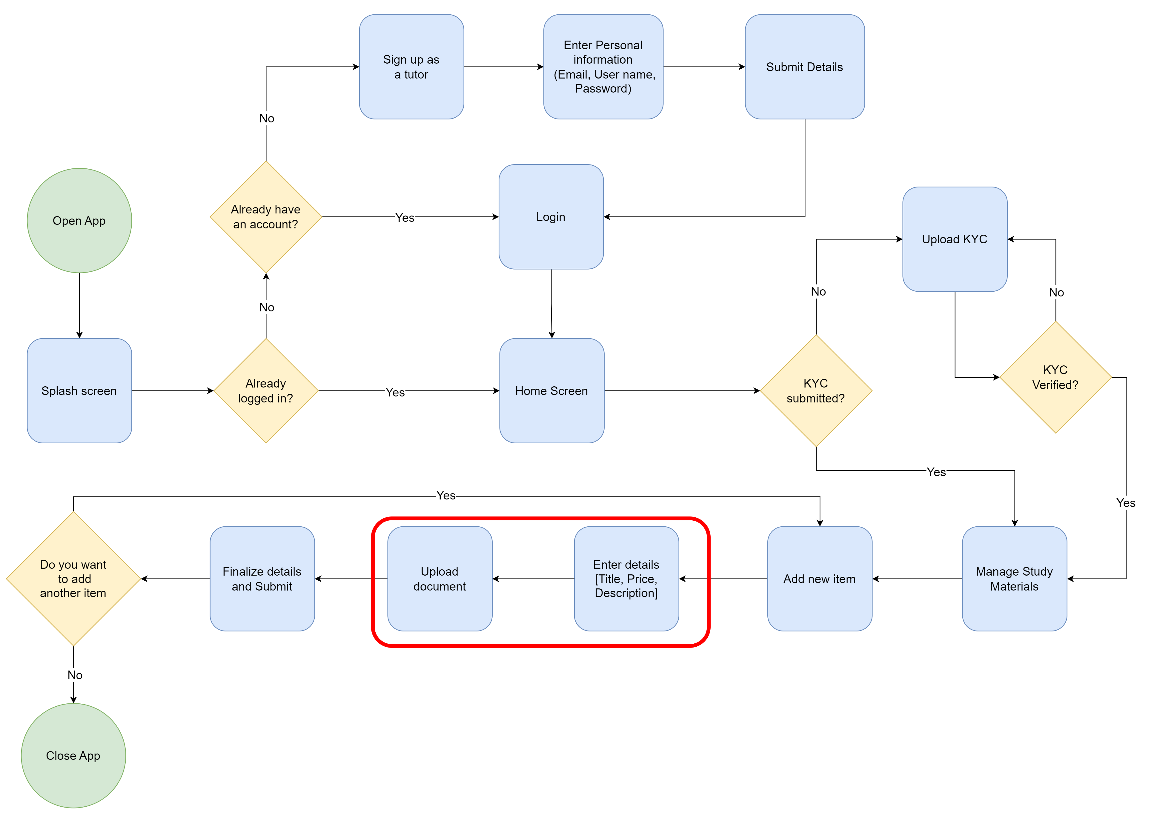

Modified User Flow (Fail points 01 & 02)

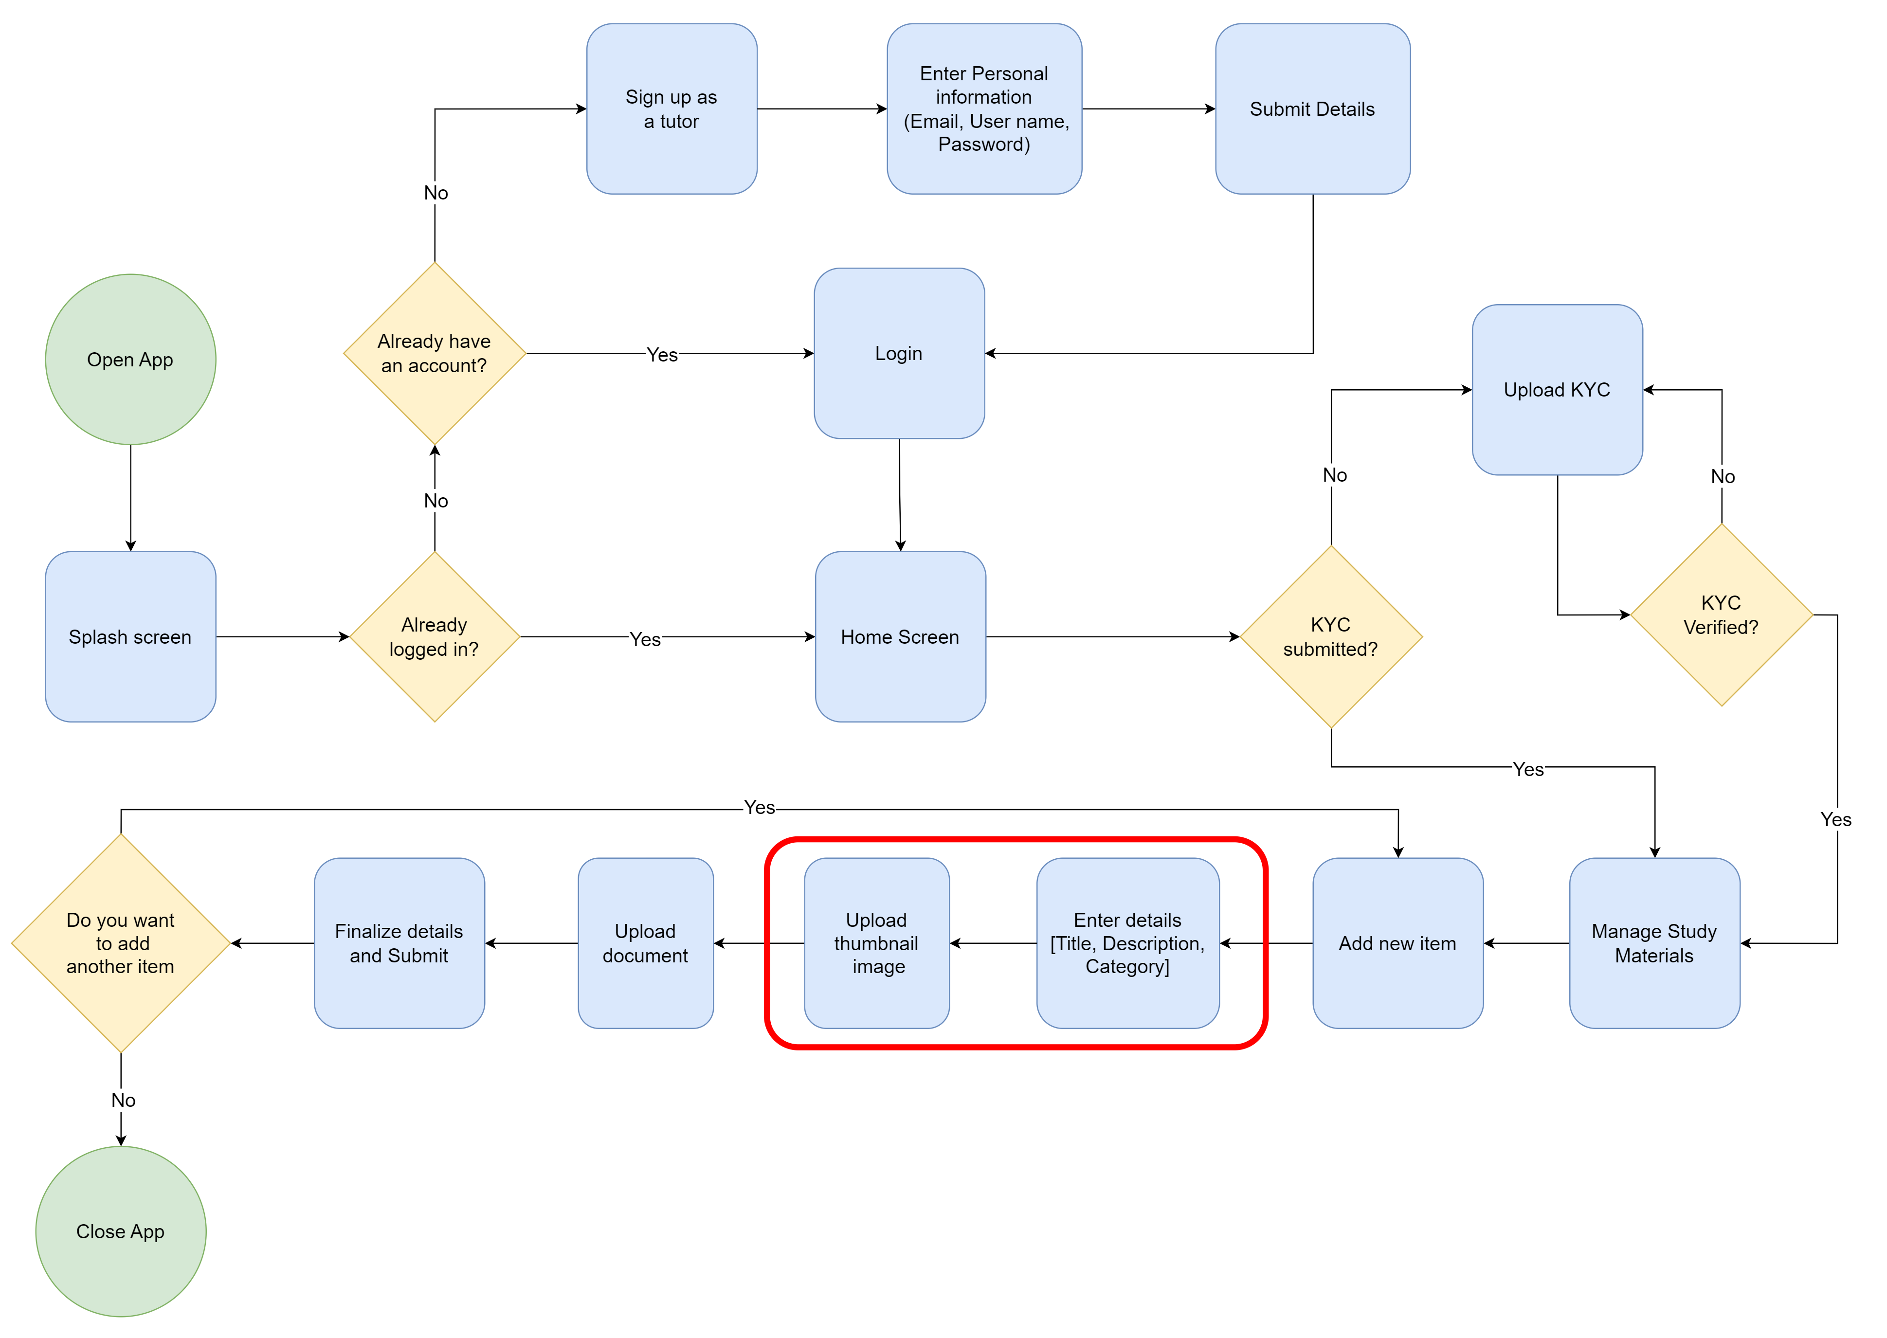

Previous User Flow – Student → Download study materials

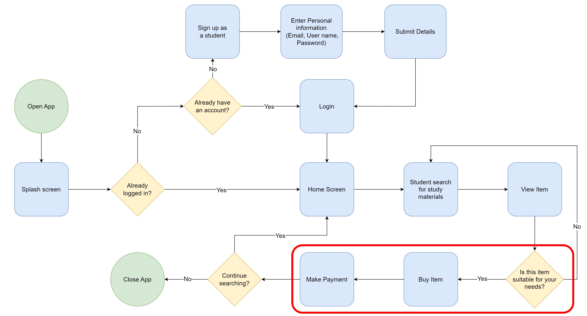

Modified User Flow (Fail point 03)

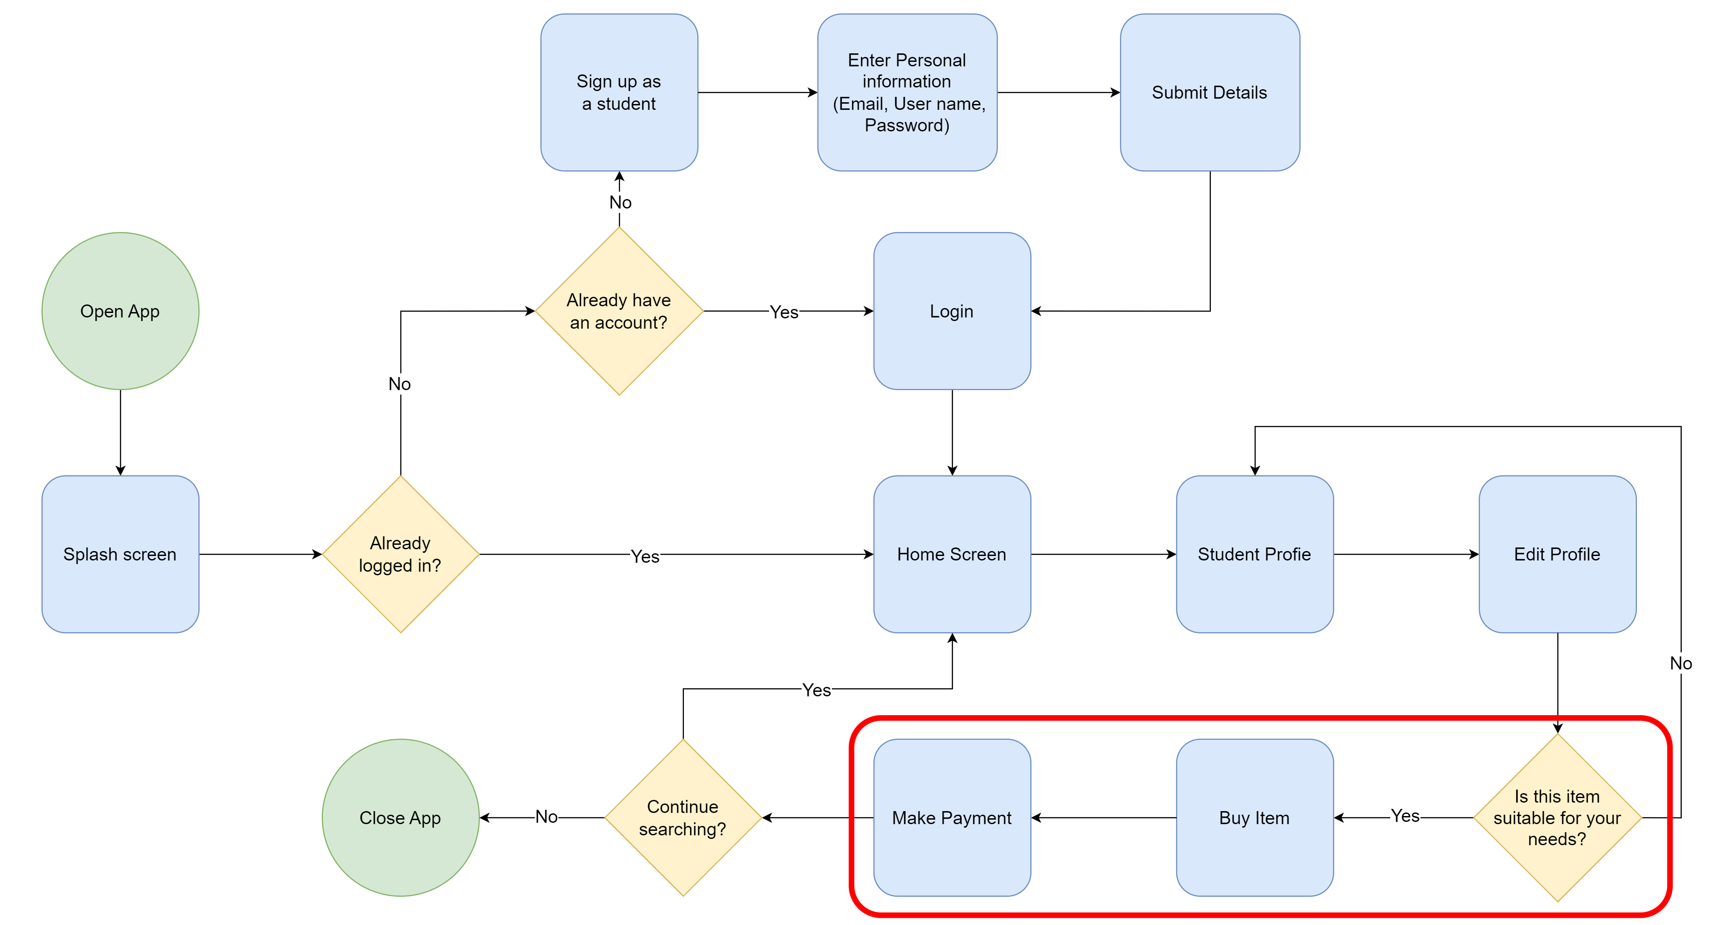

## Other User Flows

Tutor → Update study materials

K

Student → Update profile

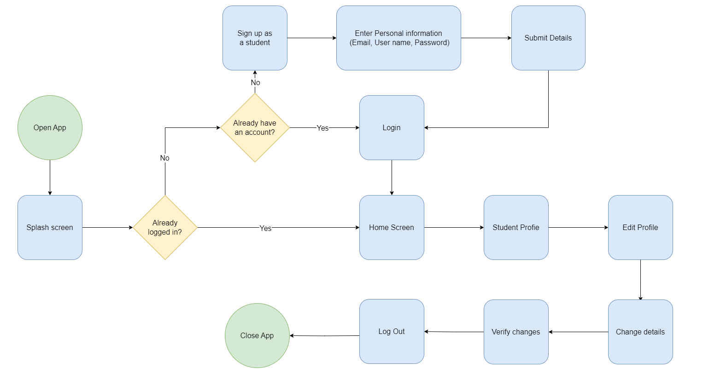

## 2 IT21291364

Fail Points

1. Tutors asked to make the registration process shorter.
   * + Change the user flow by, removing the path where user needs enter OTP, to register to the app.
2. Tutors asked to make the login process shorter.
   * + Change the user flow by, removing the path where user needs to fill a captcha, to log into the app.

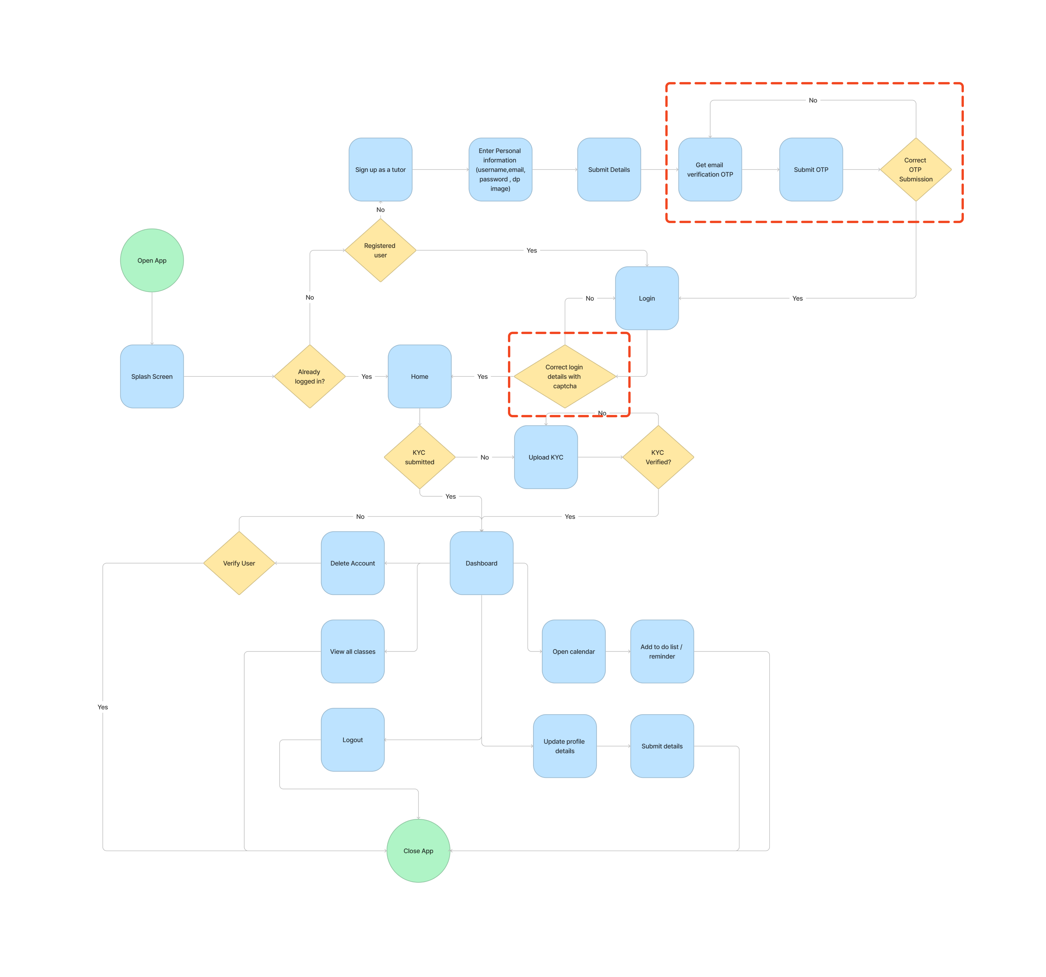Previous User Flow – Tutor

Modified User Flow – Tutor (Fail points 04 & 05)

Other User Flows

Tutor → Manage tutor (With reset password feature)

## 3 IT21267772

Fail Points

1. Students asked for a feature that allows them to view the reasons for rejection.
   * + Change the user flow by, adding the path where user can view reason for rejection.
2. Student asked for a feature that allows them to enter additional details when requesting the session.
   * + Change the user flow by, adding the path where user can enter additional details.
3. Student asked for a feature that allows them to cancel session.
   * + Created a new user flow where user can cancel sessions.

****Previous User Flow – Student

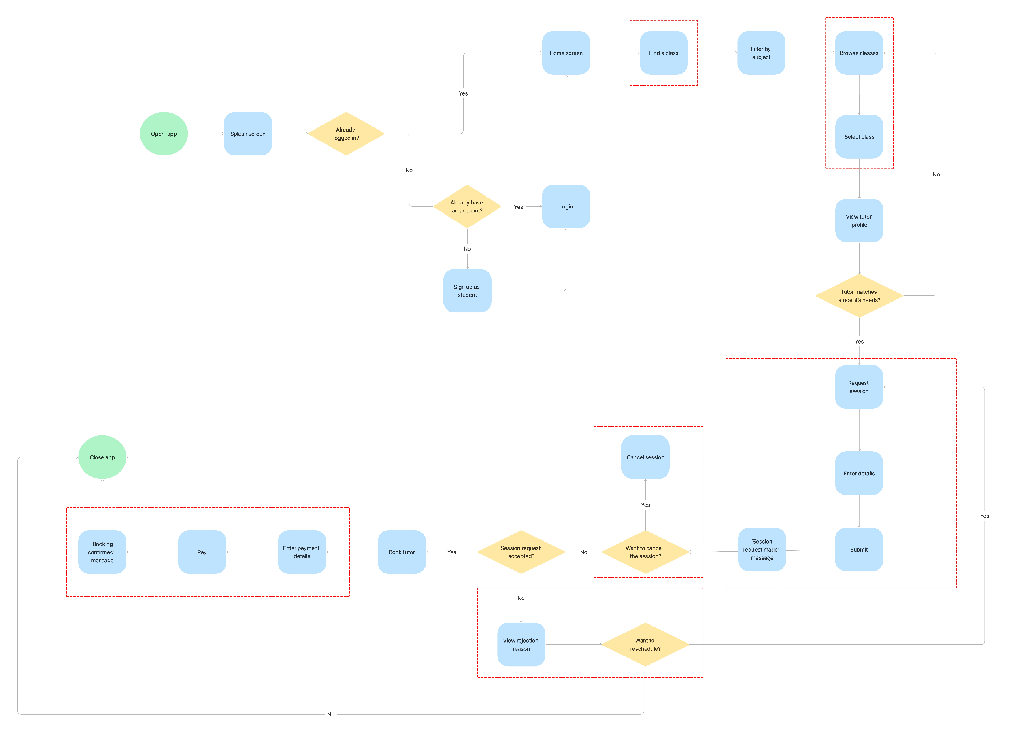Modified User Flow – Student

Other User Flows

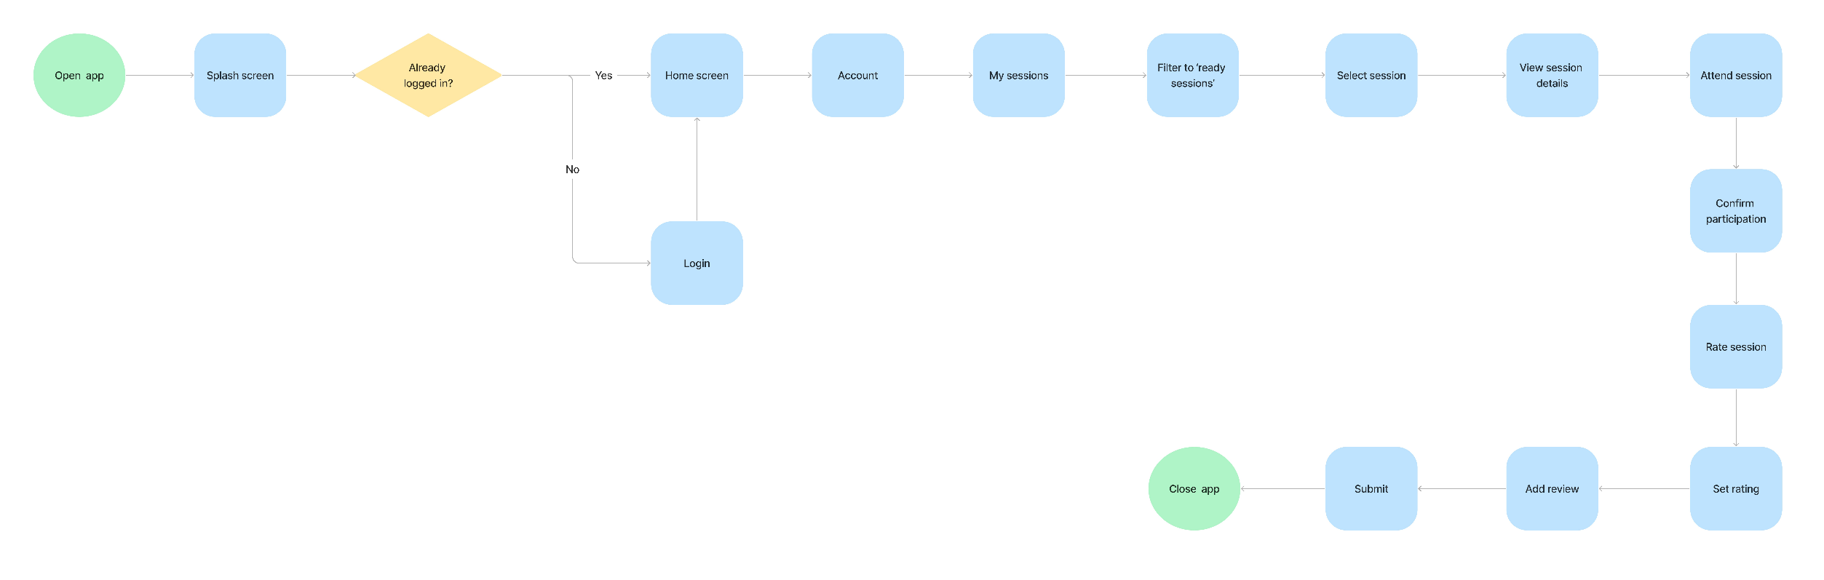Student → Rate tutor

Student → Cancel session



## 4 IT21388934

Fail Points

1. Tutors mention in the interview that they want to enter more details when publishing the class.
   * + Change the user flow by, expanding the *add class details* step.
2. Tutors mention in the interview that they want to add multiple time slots for a class.
   * + Change the user flow by, expanding the *set sessions* step.

Previous User Flow – Tutor

Modified User Flow – Tutor (Fail point 09 & 10)



Other User Flows

Tutor → Accept or decline session request



# Competitor Analysis

|  |  |  |
| --- | --- | --- |
| **Competitor** | **Advantages** | **Disadvantages** |
| MyTutor1 | Large user baseName recognition | Mainly focus on O/L and A/L examsNo Mobile ApplicationNo Online Payment feature |
| Siplo2 | Mobile paymentParental monitoring | Mainly focus on O/L and A/L examsNo Mobile ApplicationCurrently inactive |
| OnlineTuition.lk3 | Large user base | Mainly focus on O/L and A/L examsNo Mobile Application |

## TABLE 5. Competitor Analysis

# Milestone 4: Sketching & Wireframes

8.1 Sketches

8.1.1. IT21118340

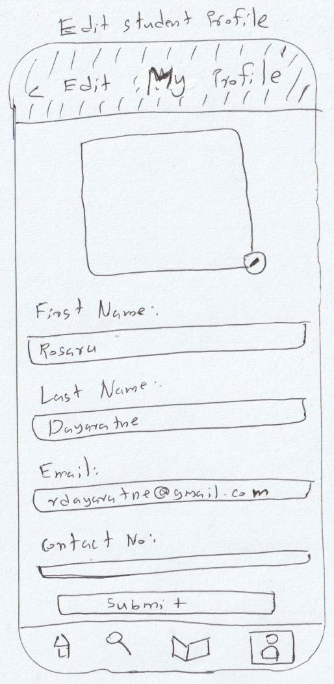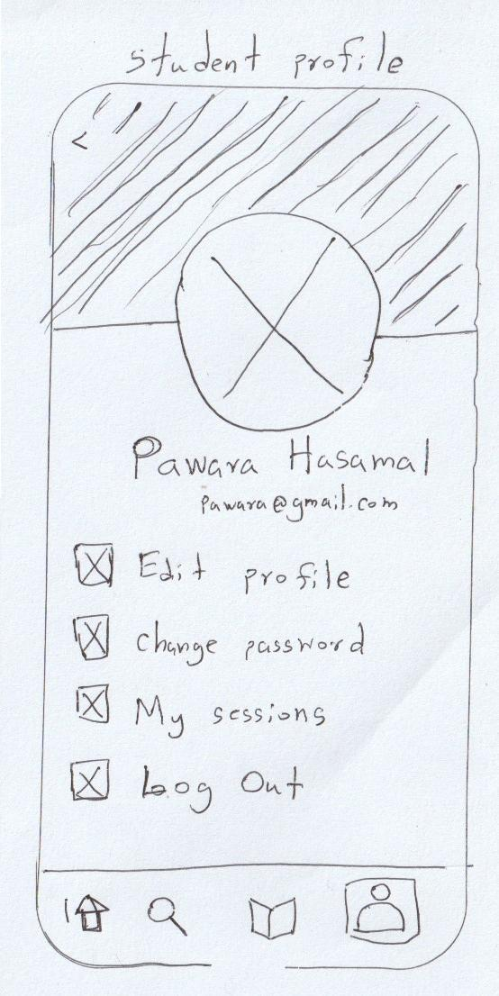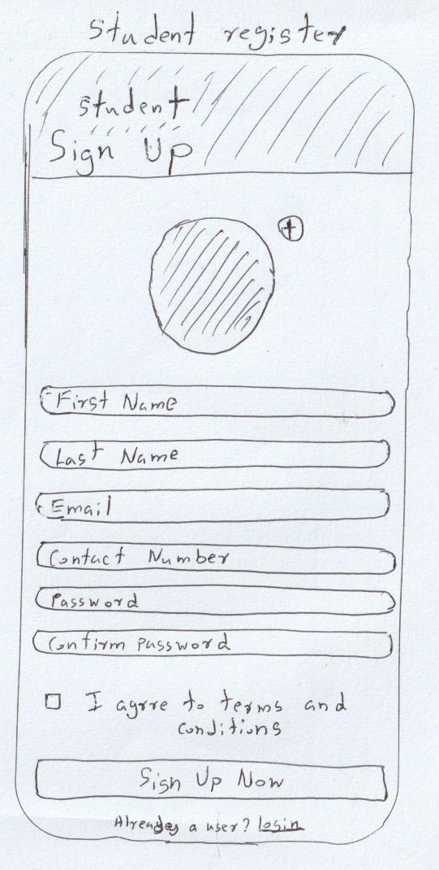

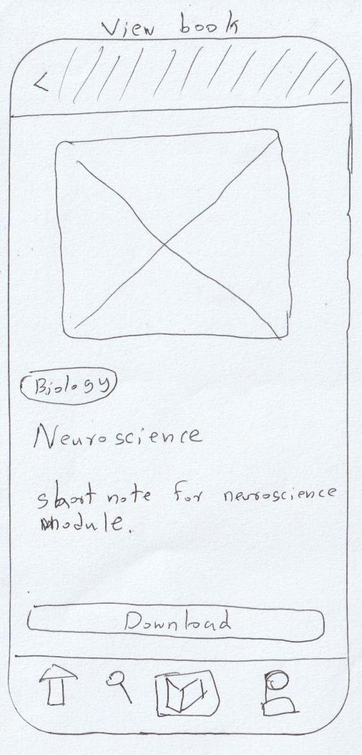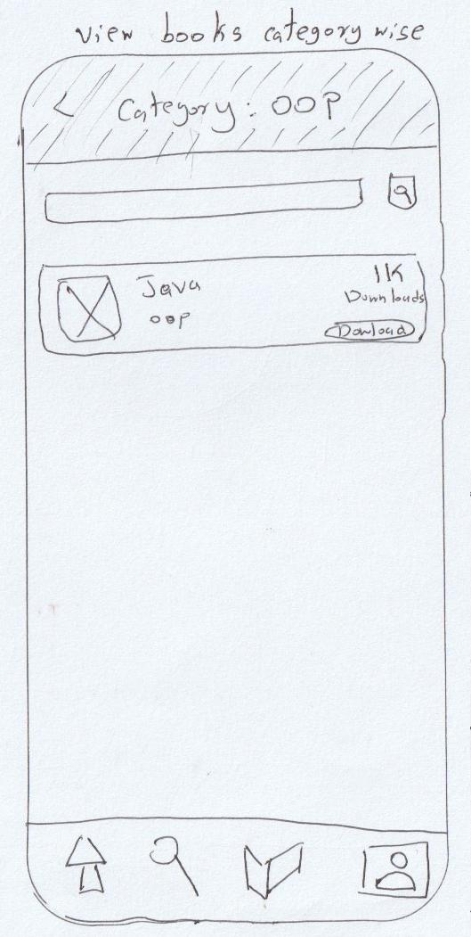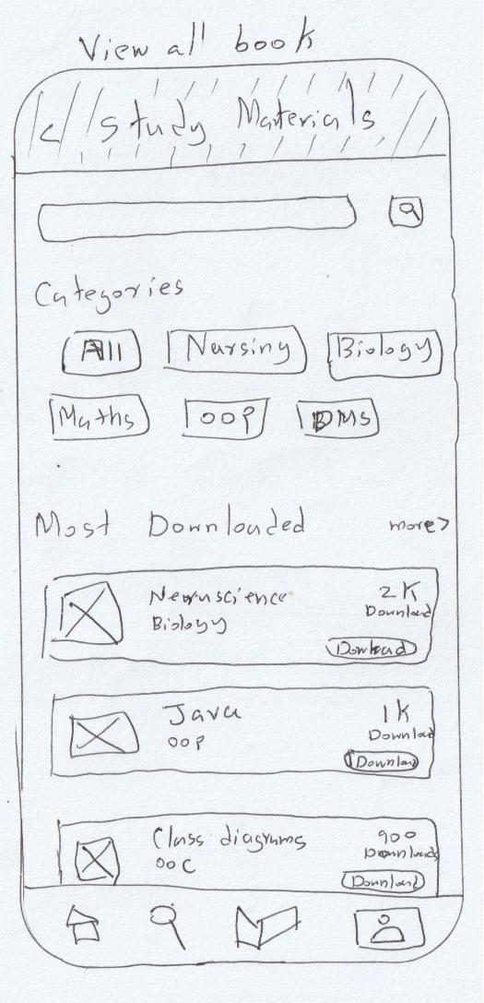

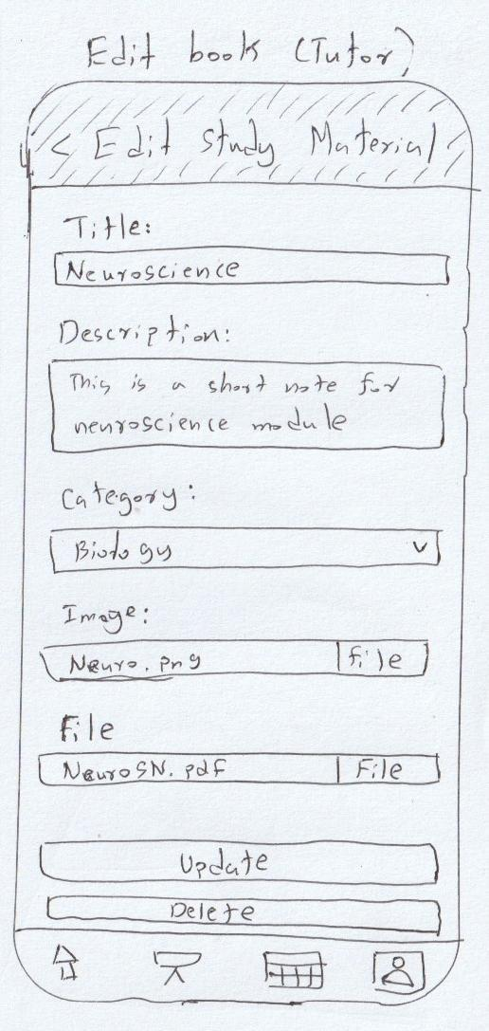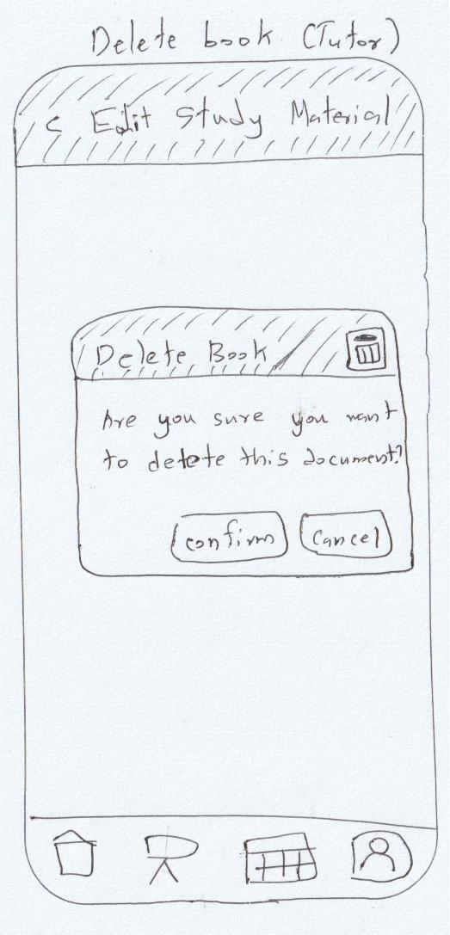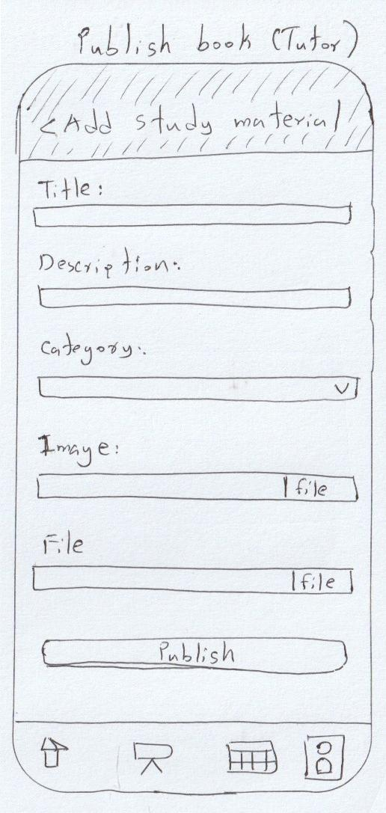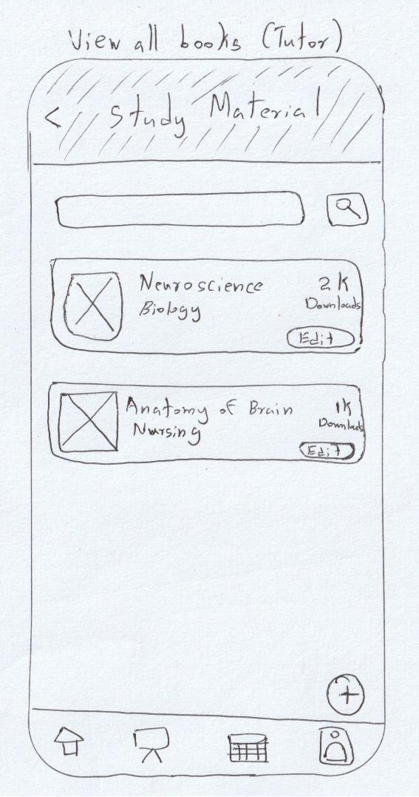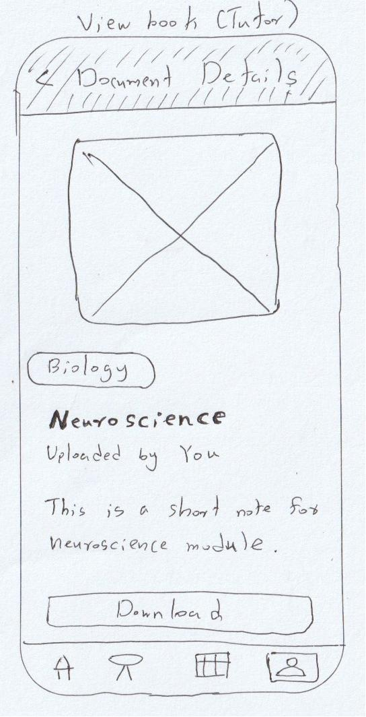

8.1.2. IT21291364

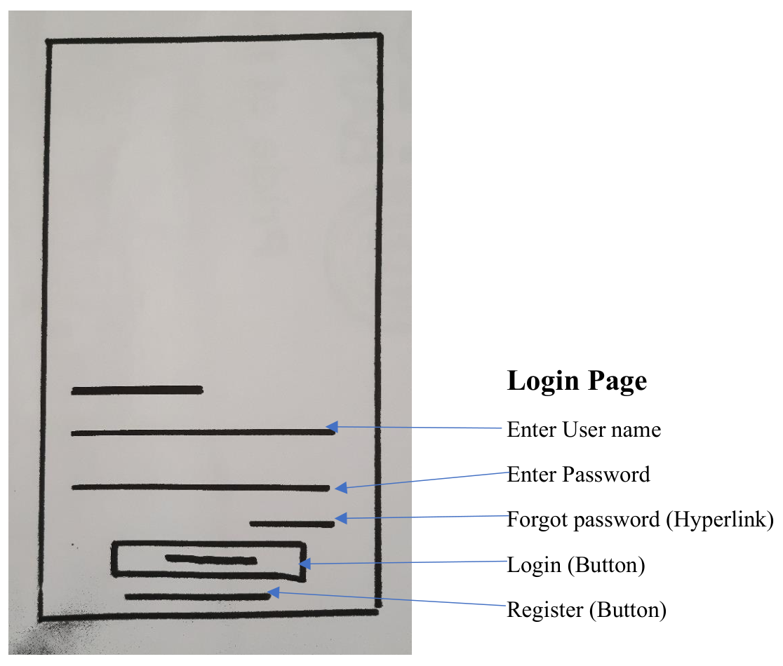

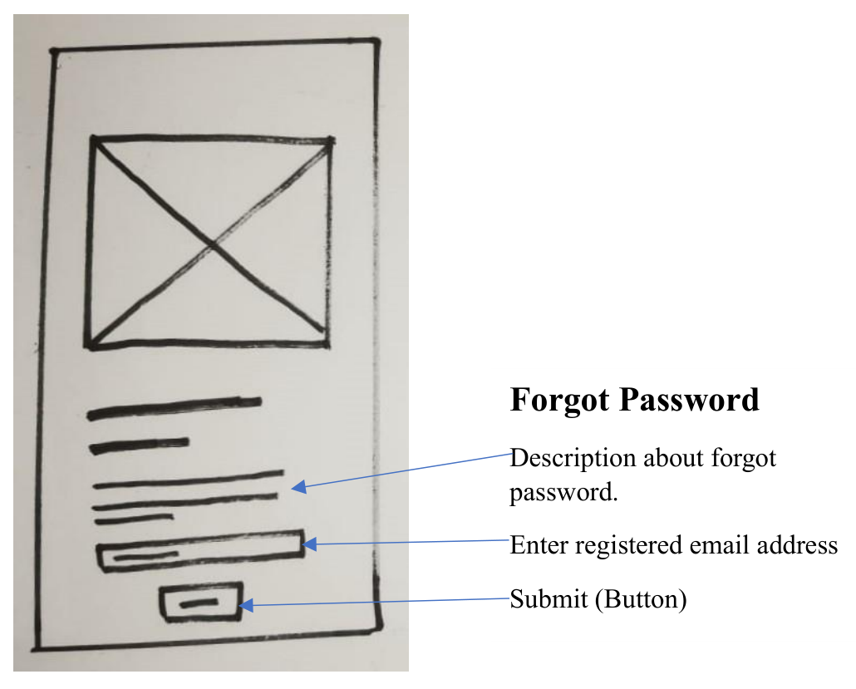

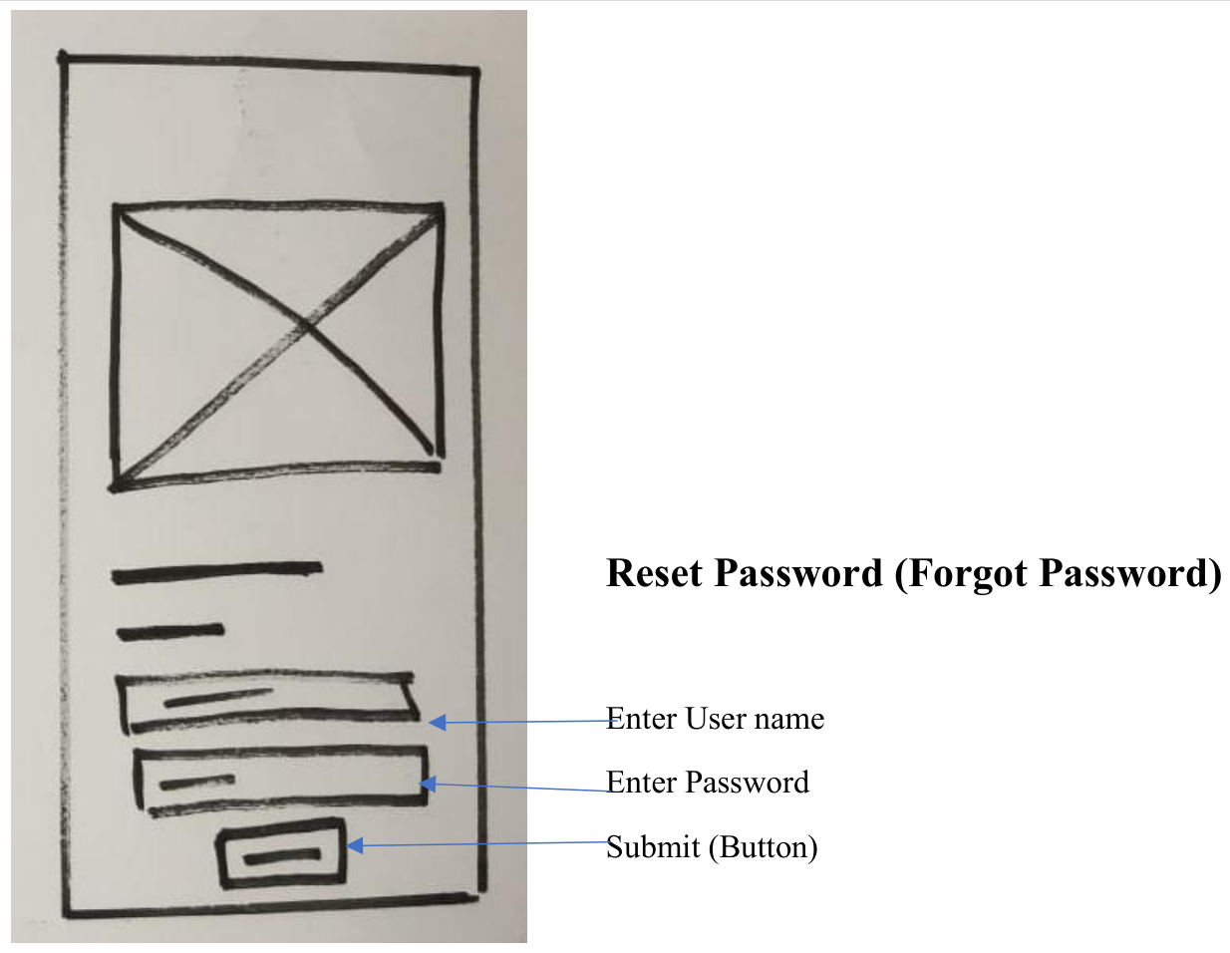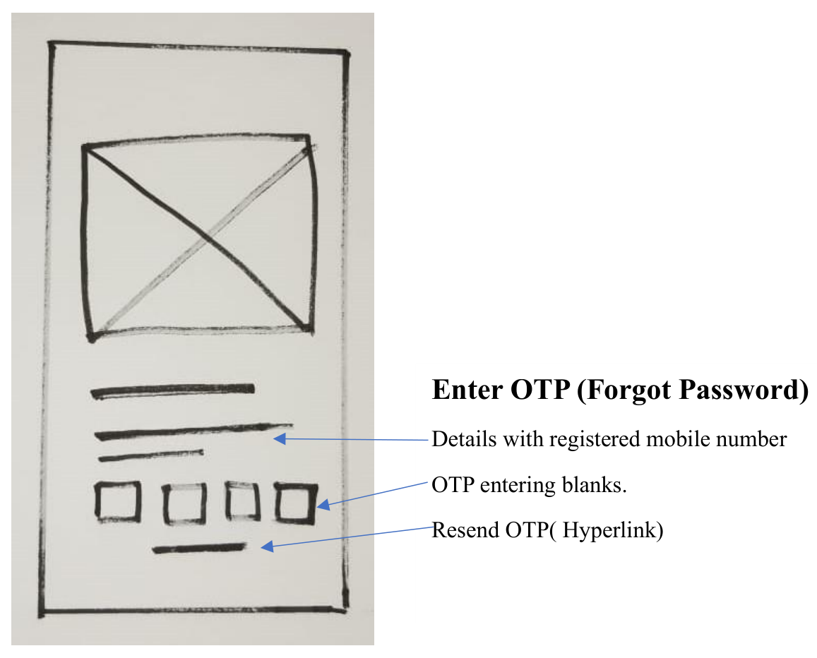

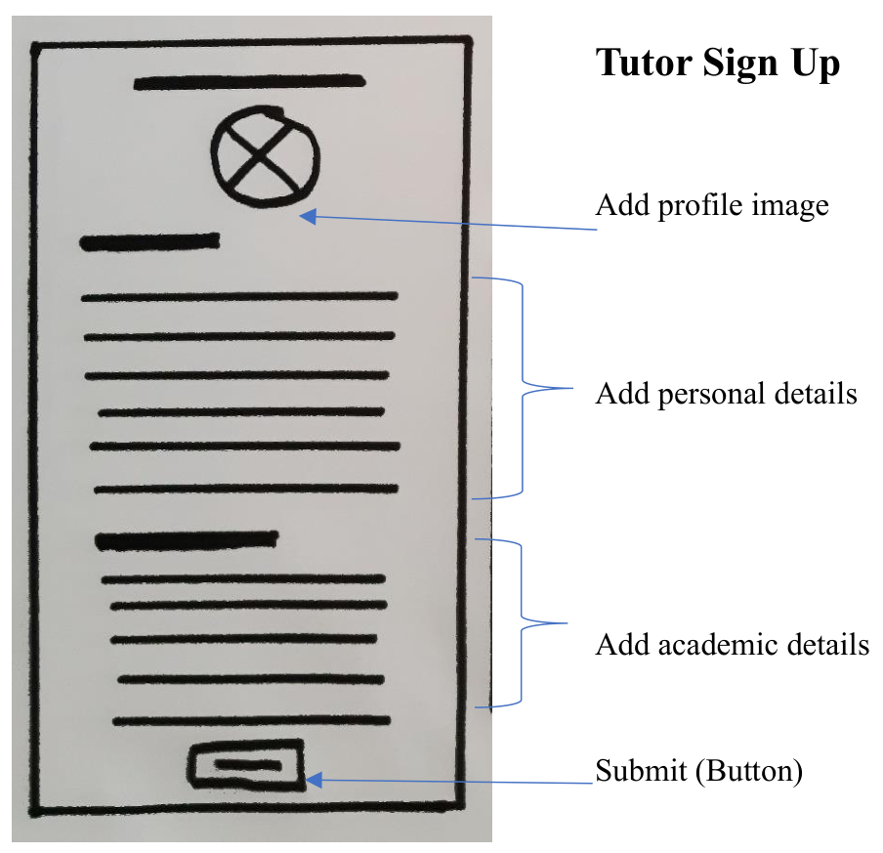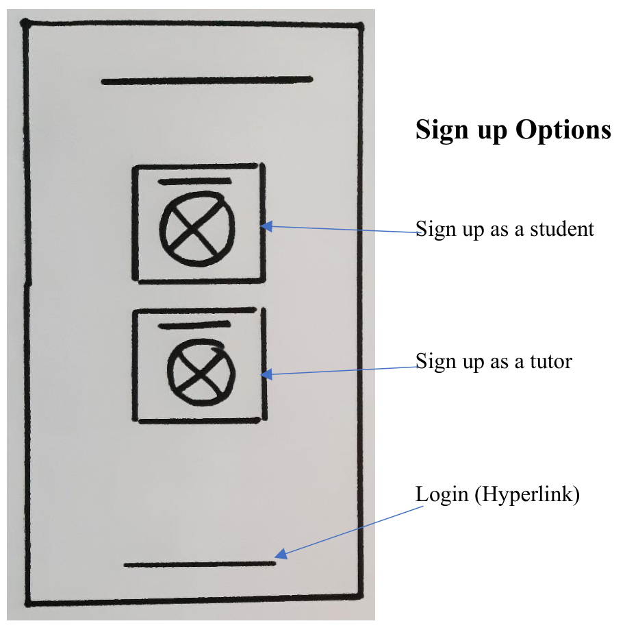

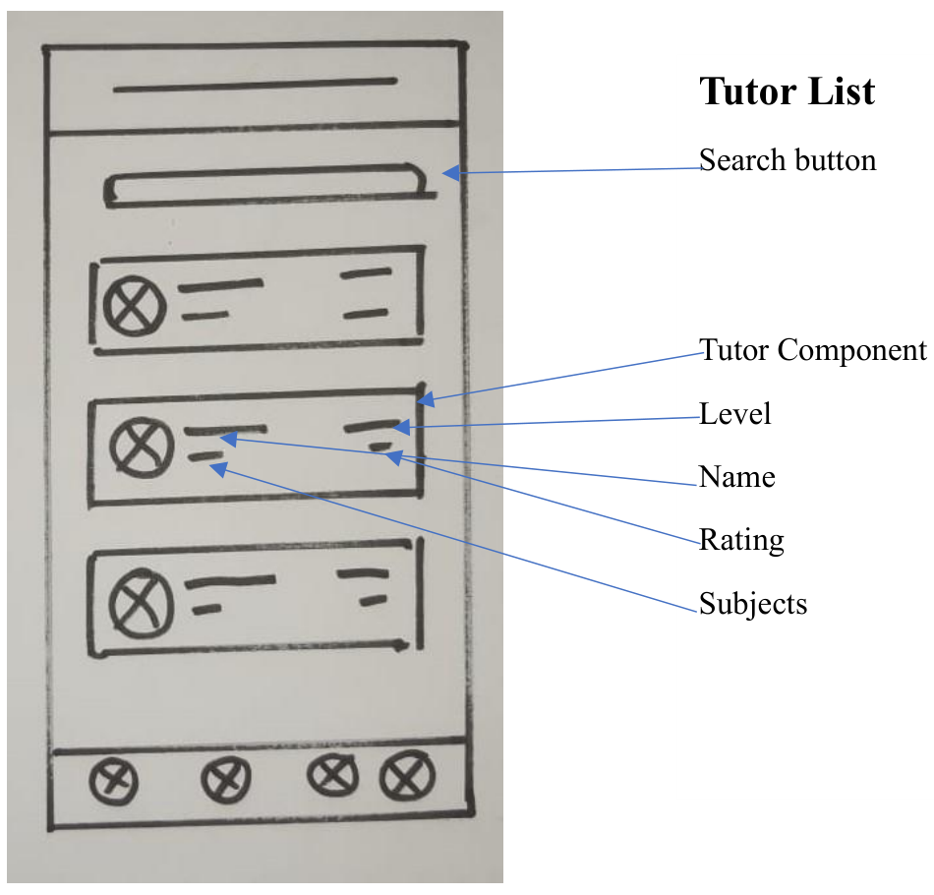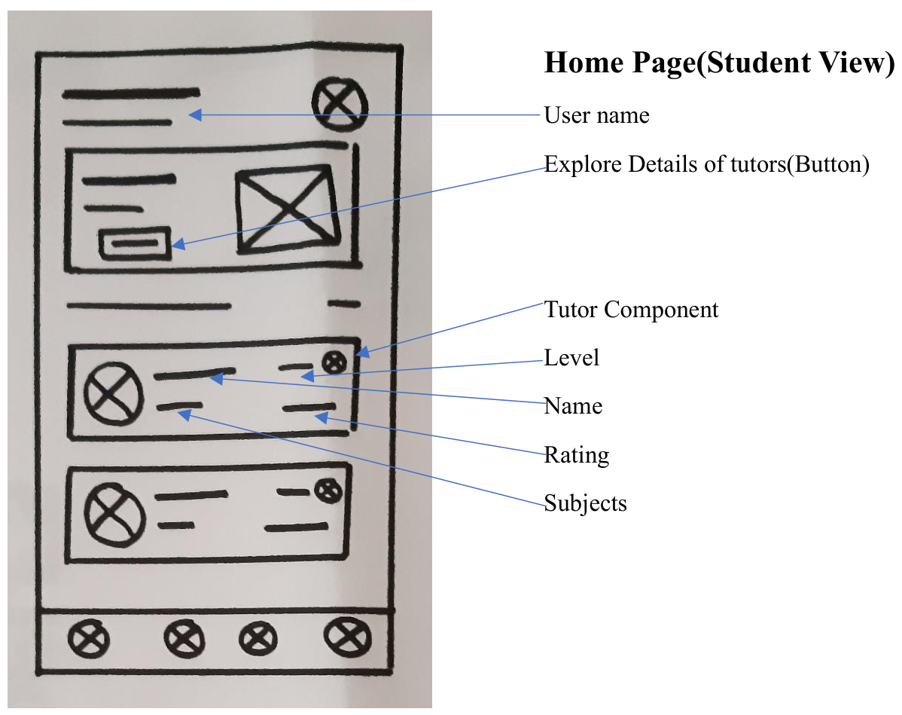

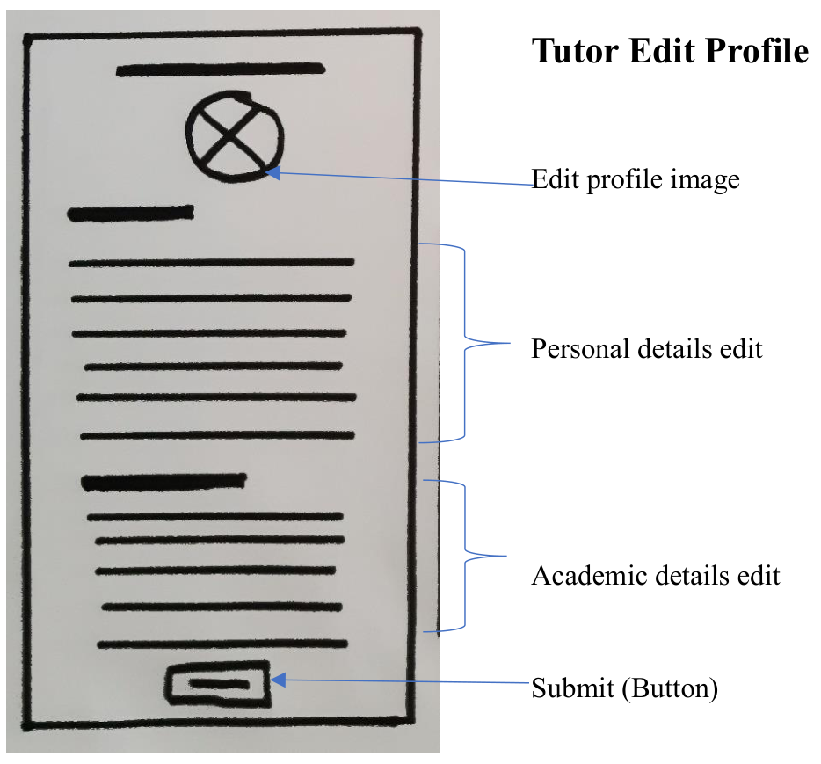

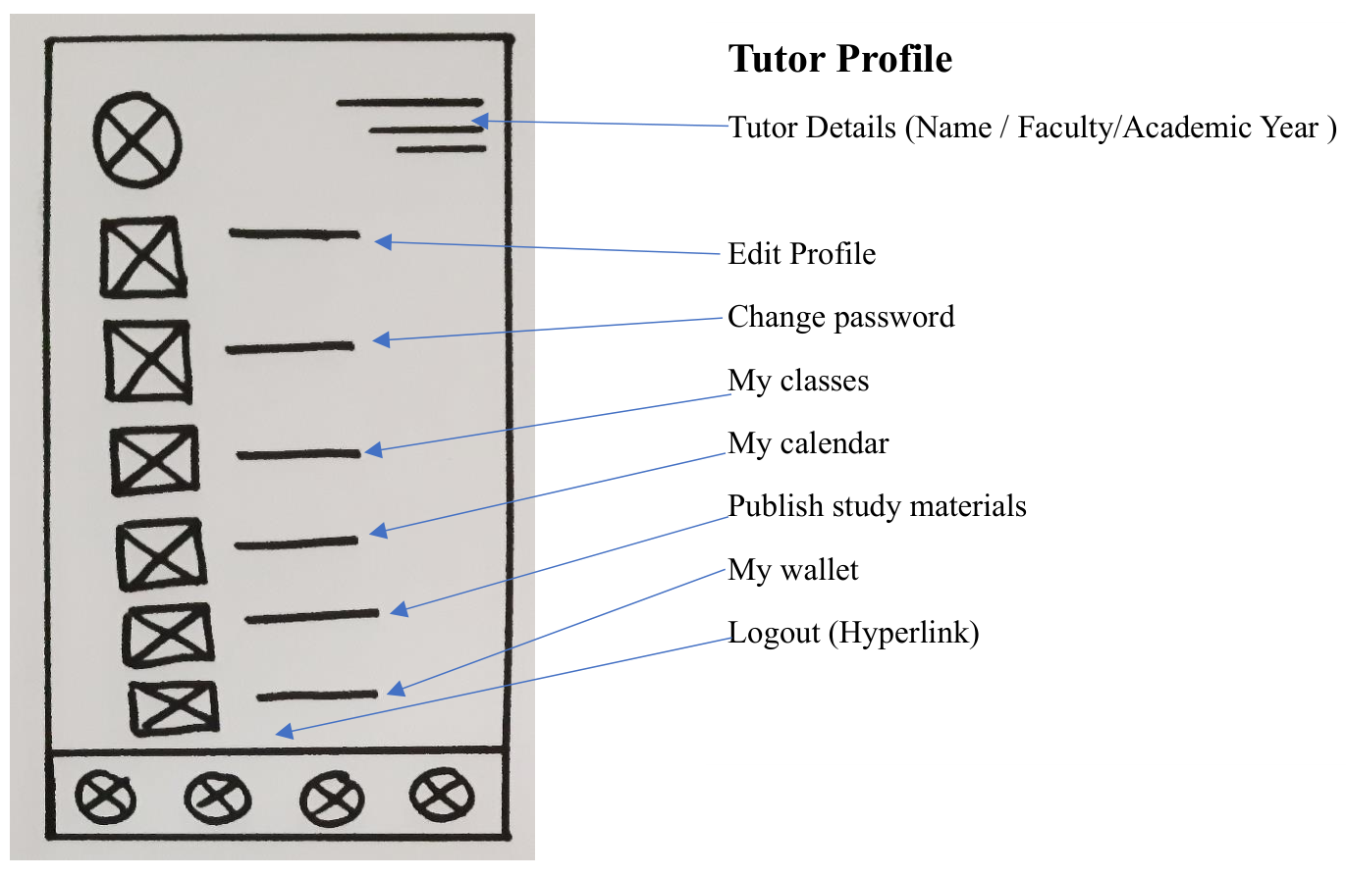

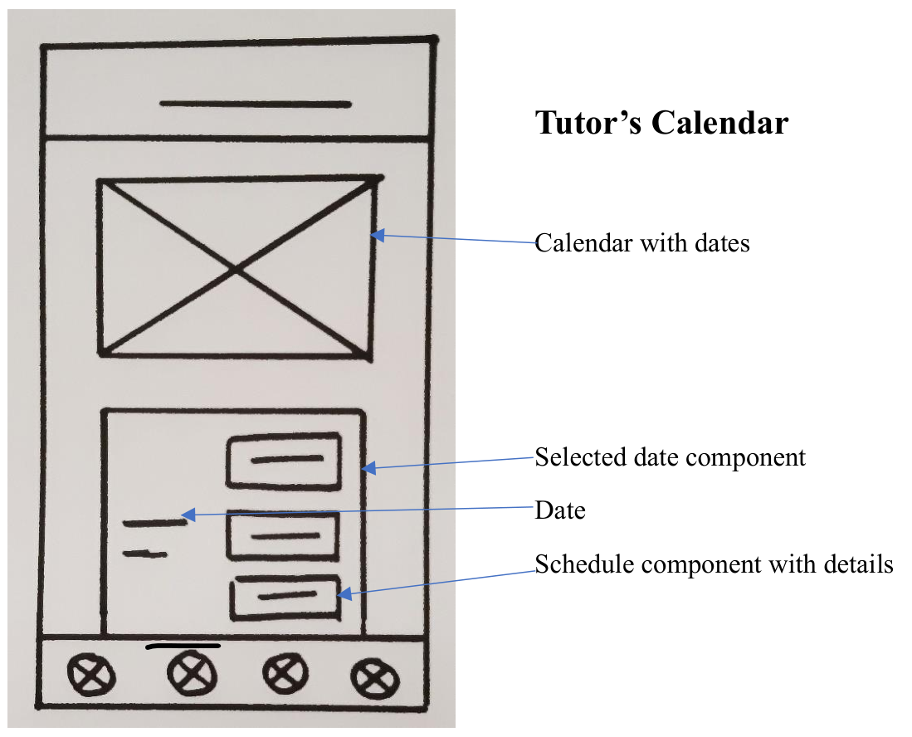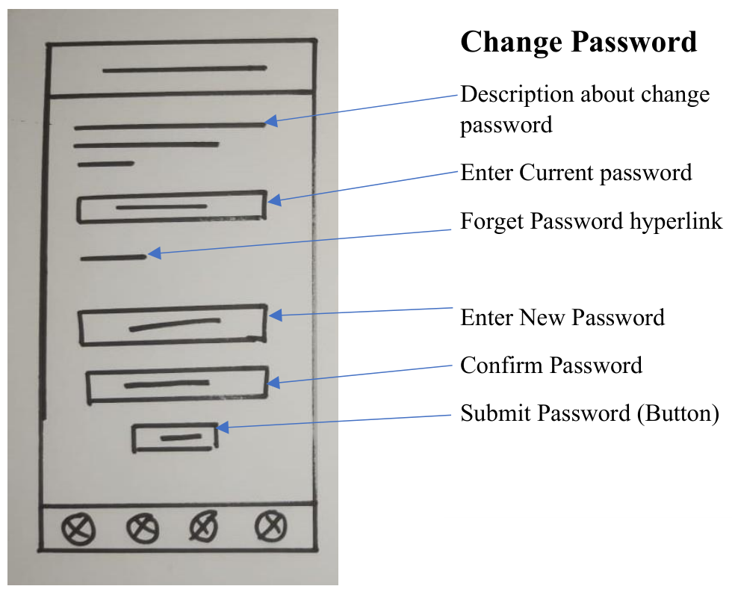

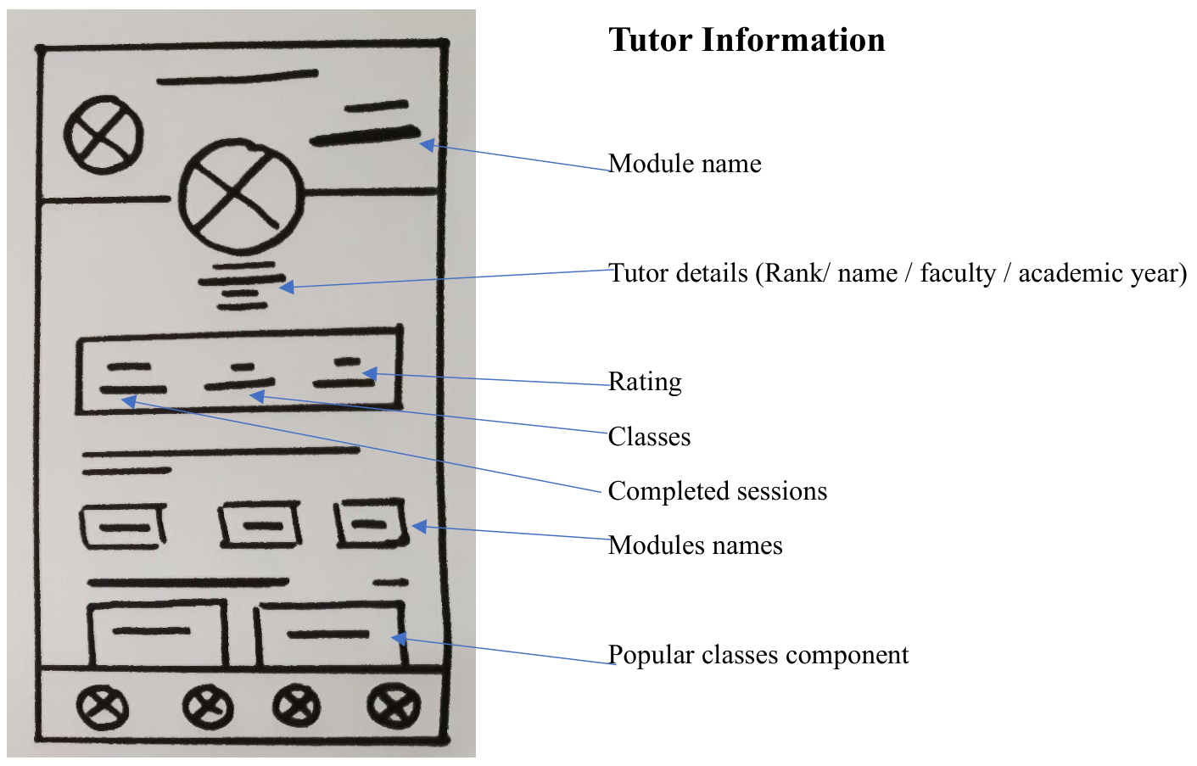

8.1.3. IT21267772

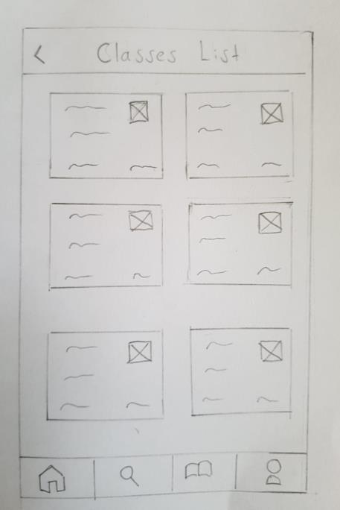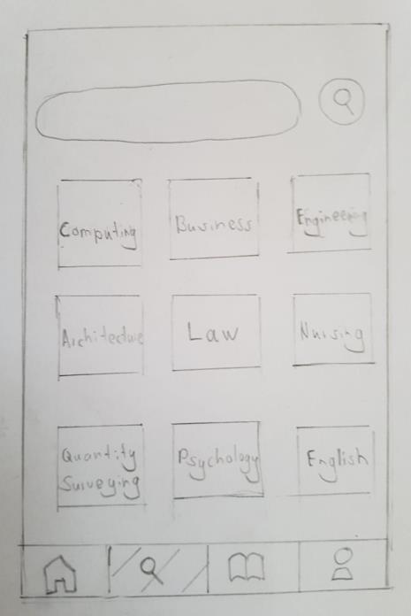

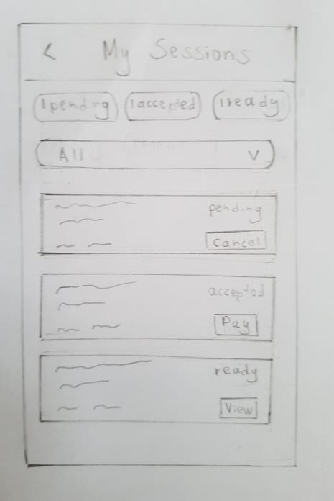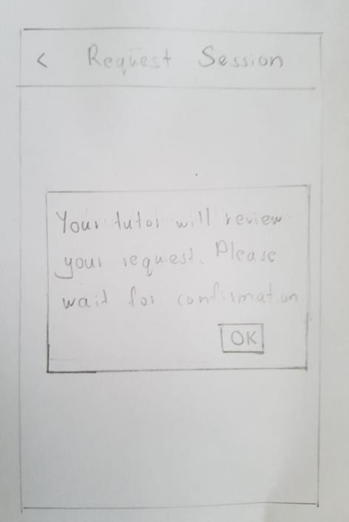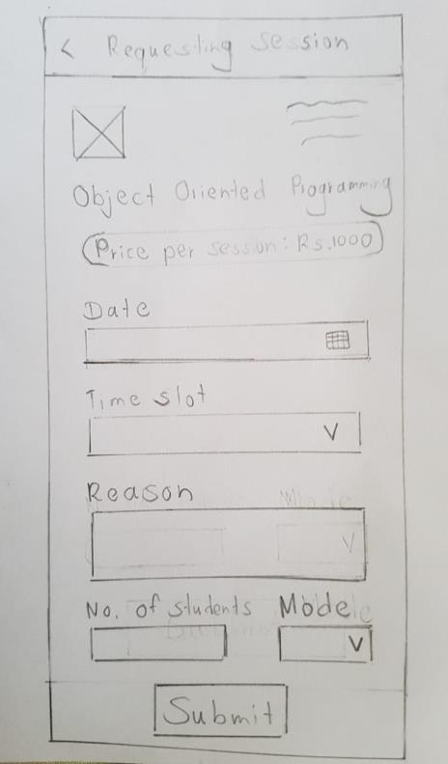

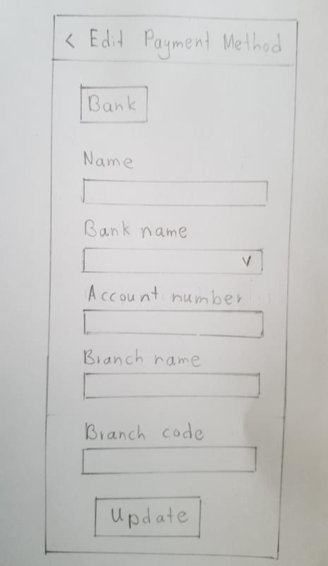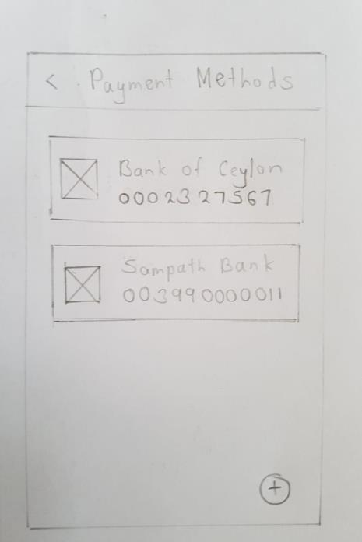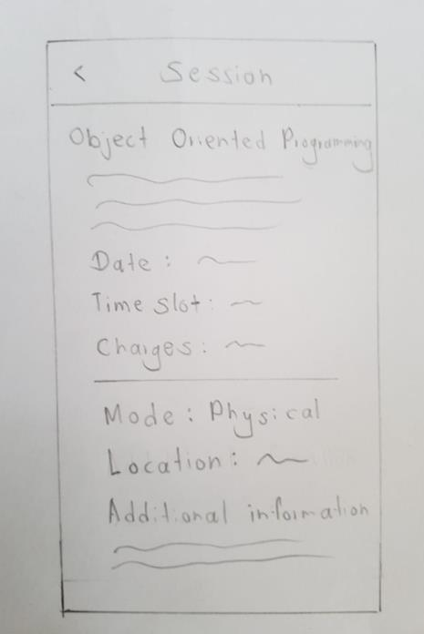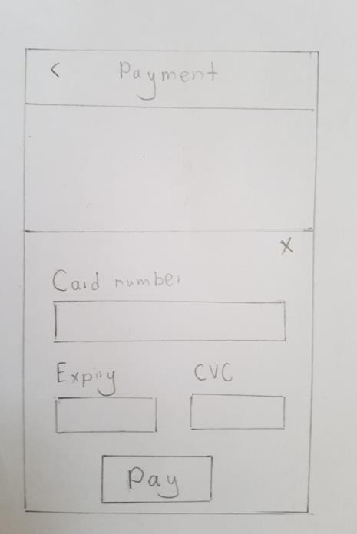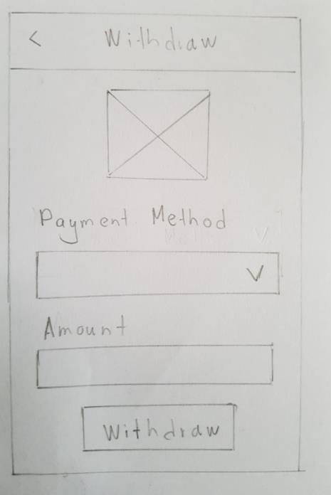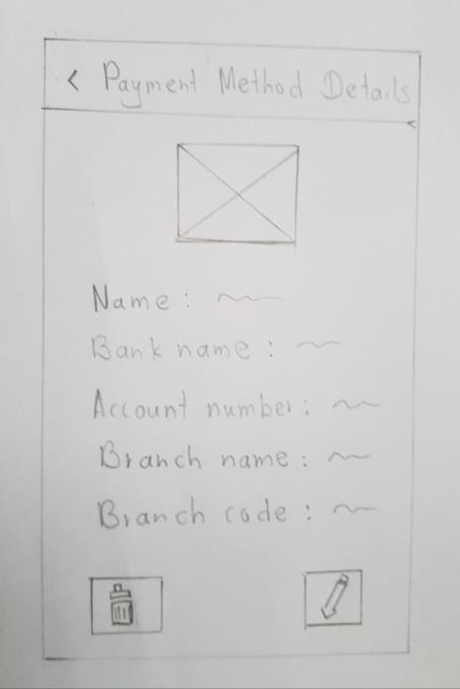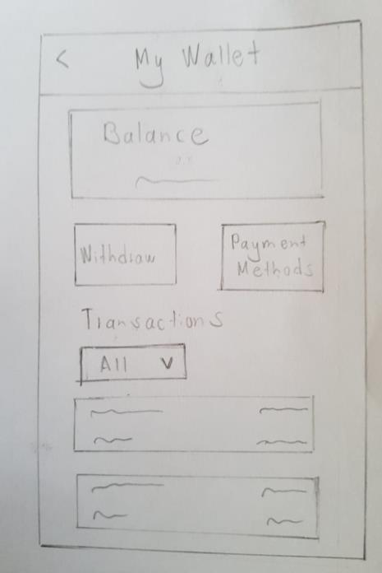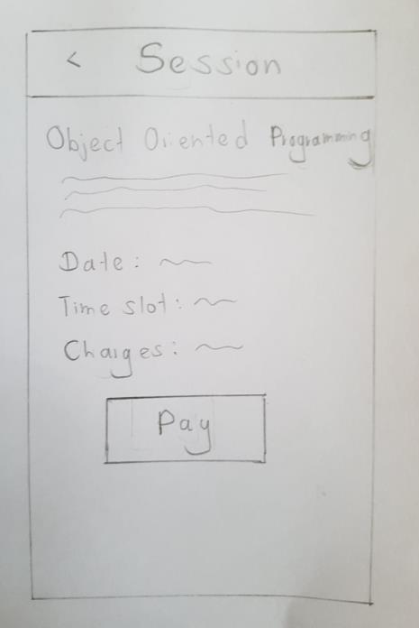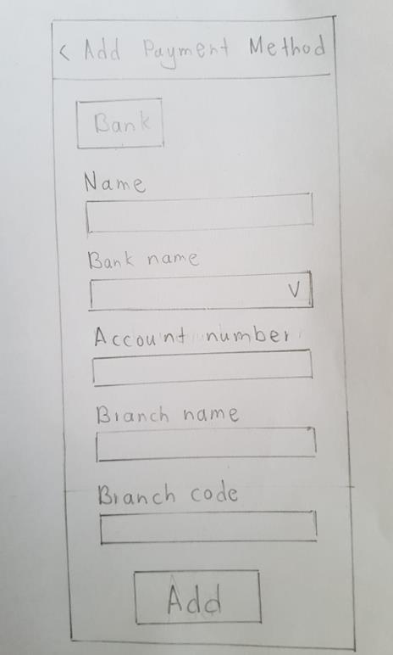

8.1.4. IT21388934

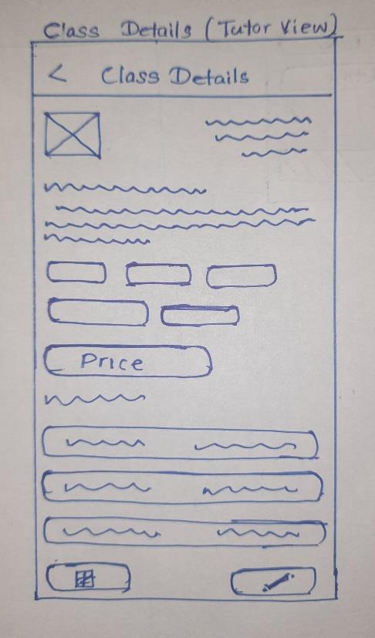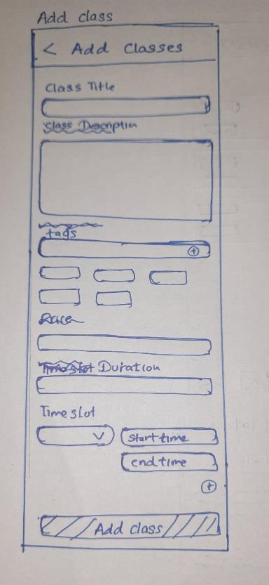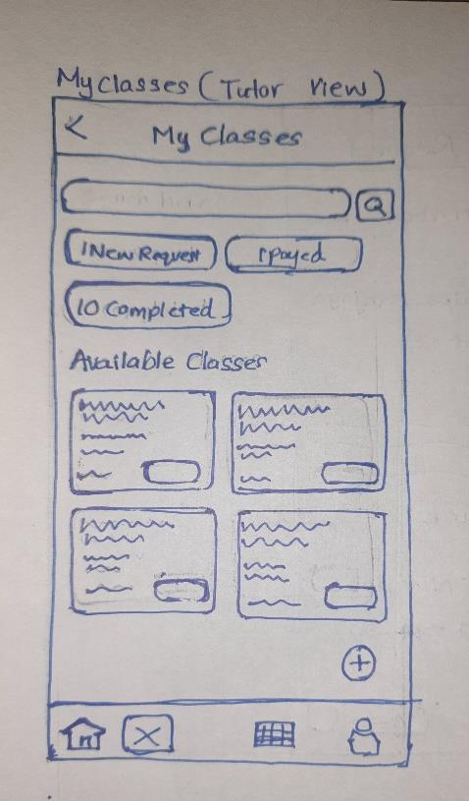

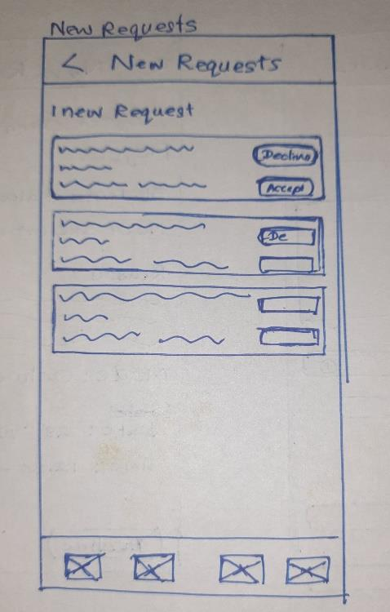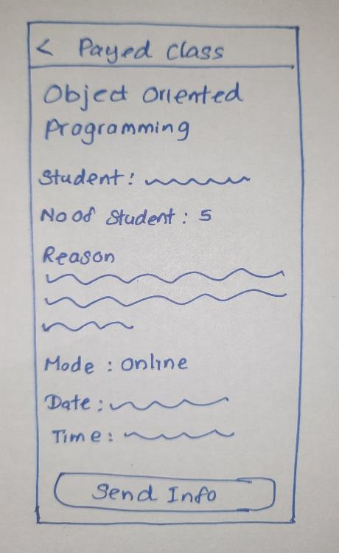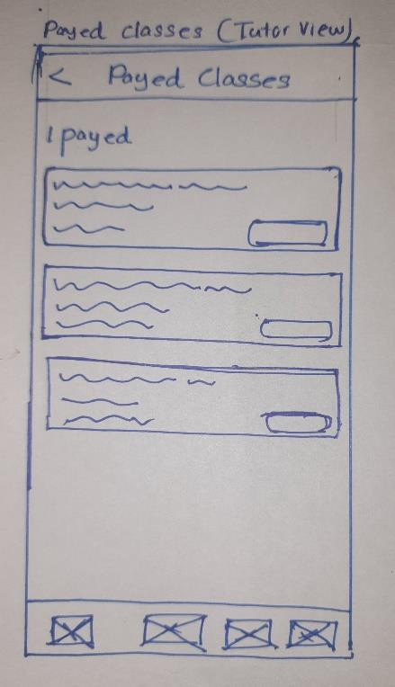

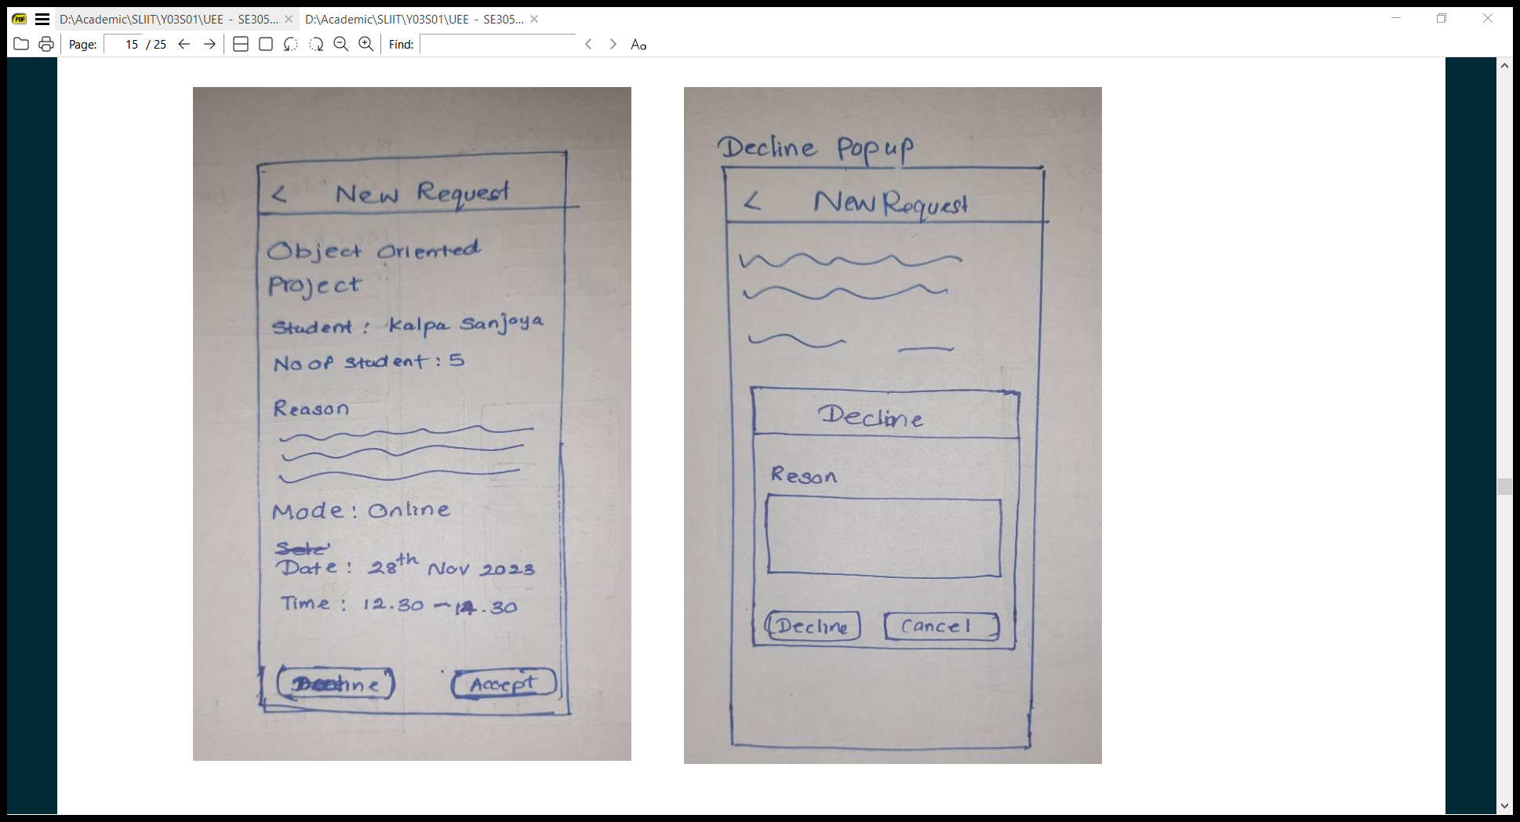

8.2 Wireframes

8.2.1. IT21118340

* Student Profile (Register, View profile, Edit profile)

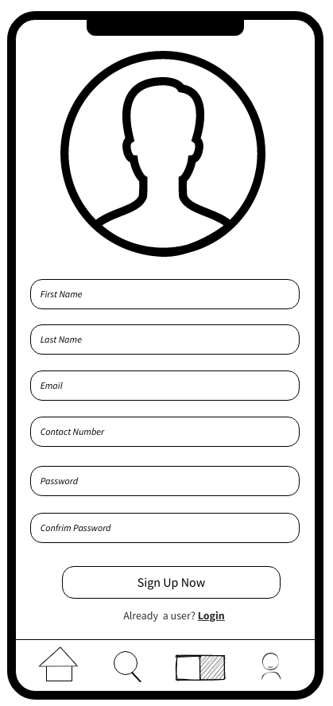- Register - View profile - Edit profile

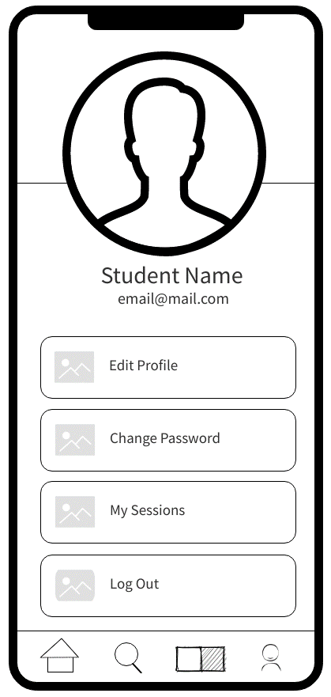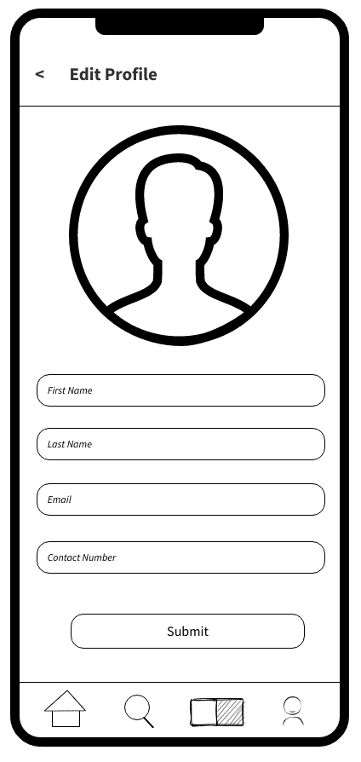

* Student view of study materials

- 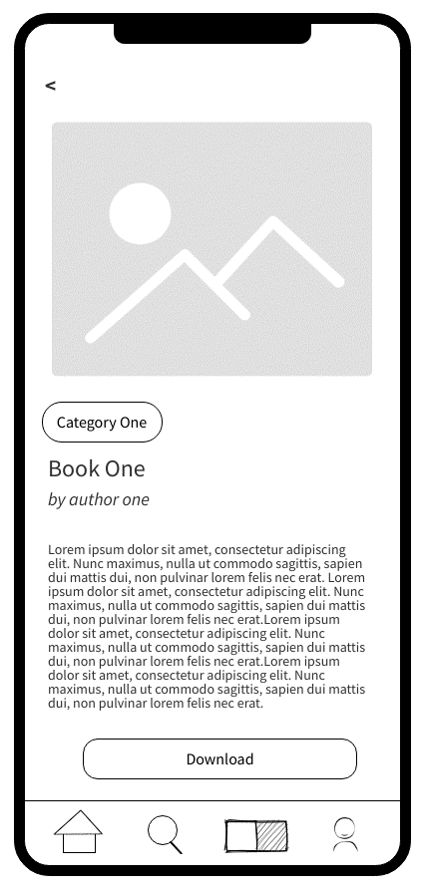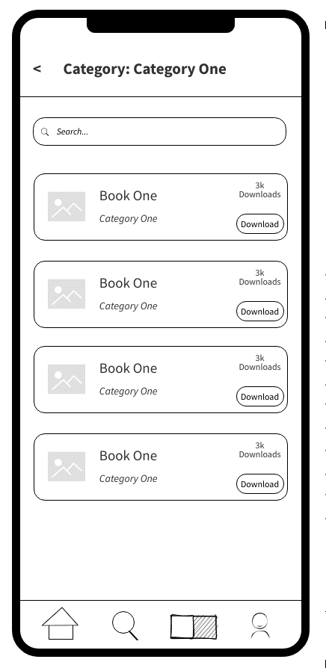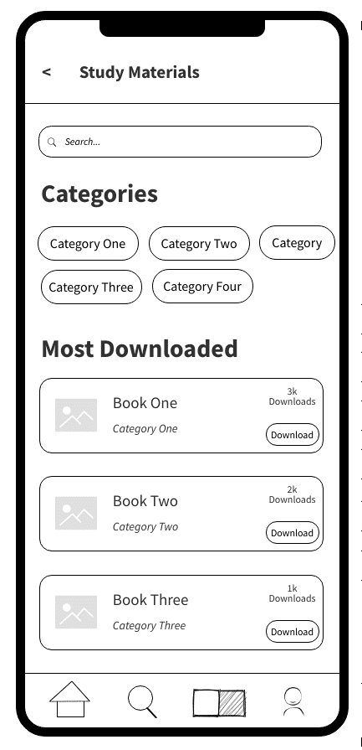Search - Category - View & Download

Tutor view of study materials

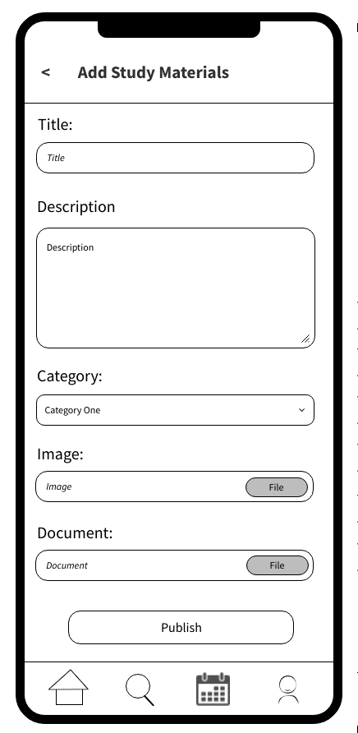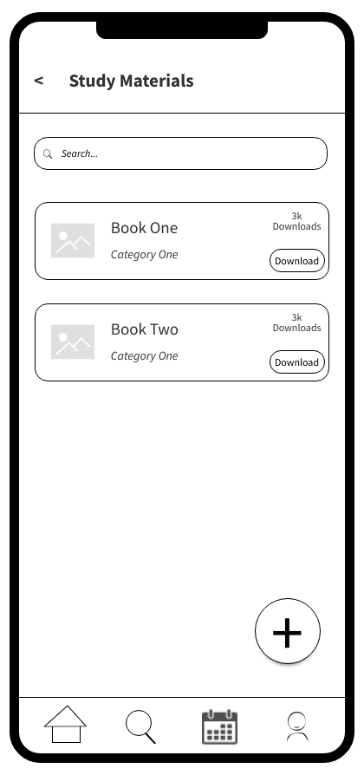 - View all study materials - Add study material - Edit study material

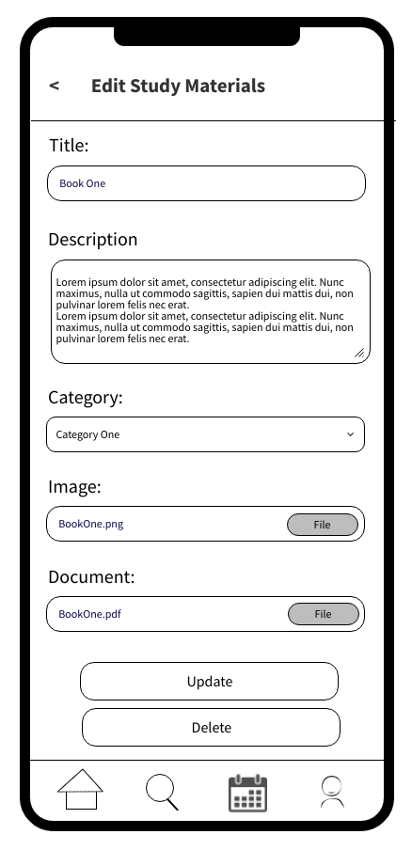

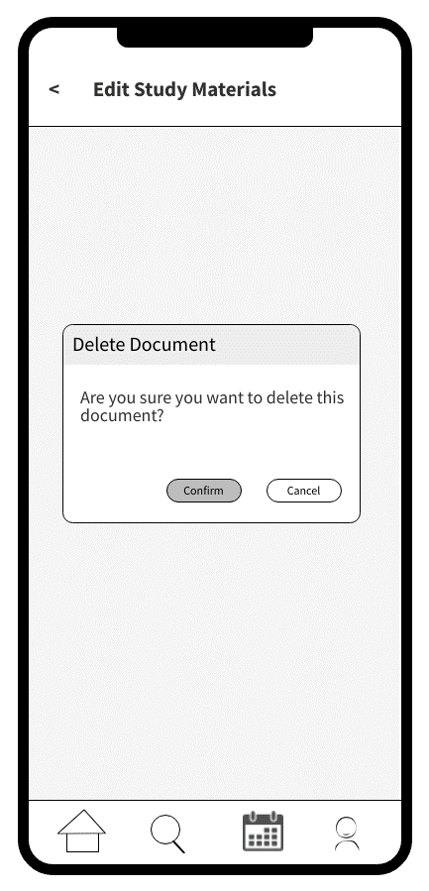 - View & Download study materials - Delete study material

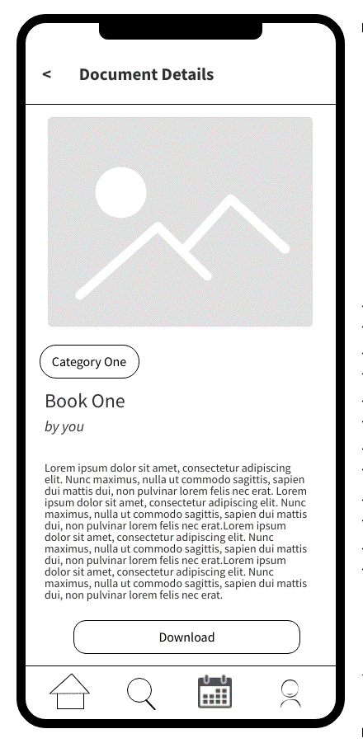

8.2.2. IT21291364

* Tutor Login, sign up and Forgot password

- Sign Up Options - Tutor Sign Up - Login

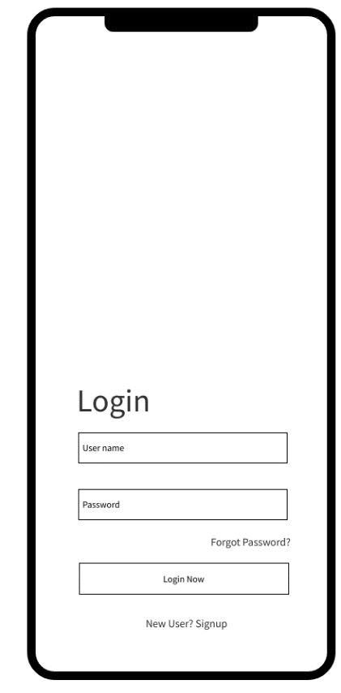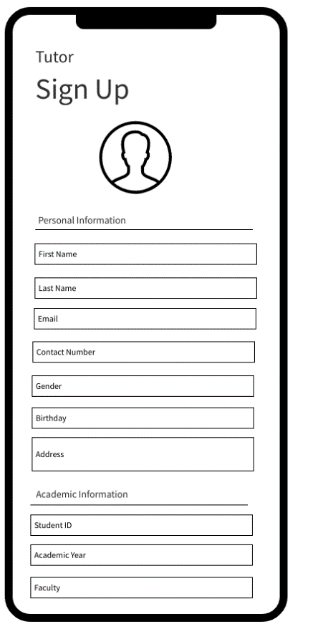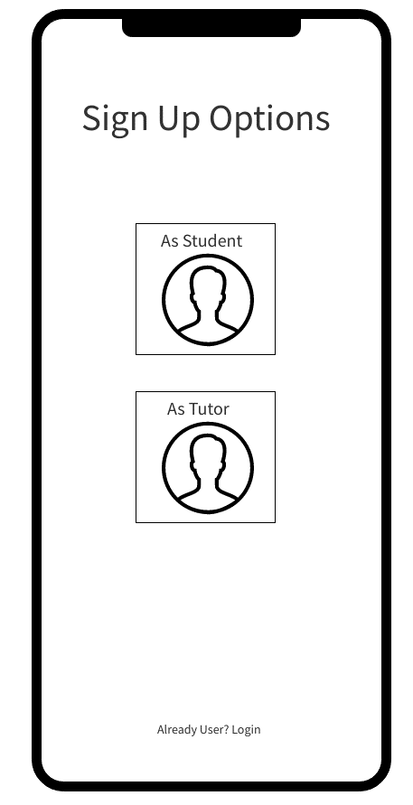

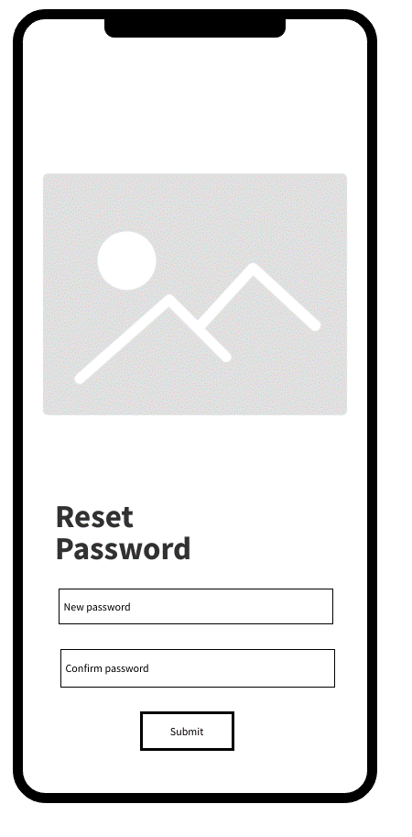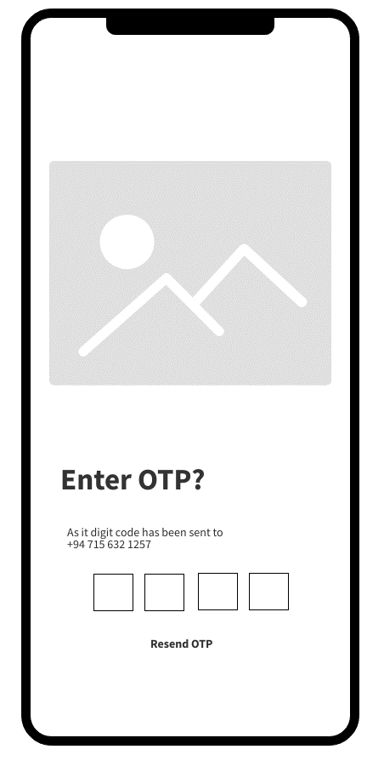 - Forgot Password - Enter OTP - Reset Password

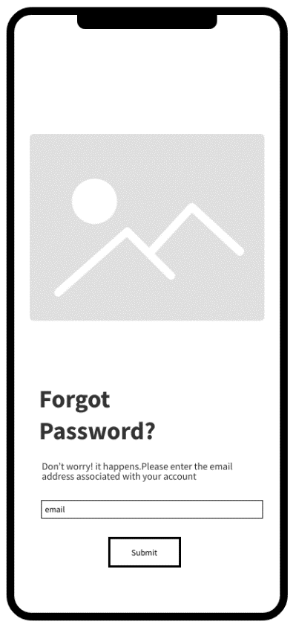

* Student view of tutors’ list

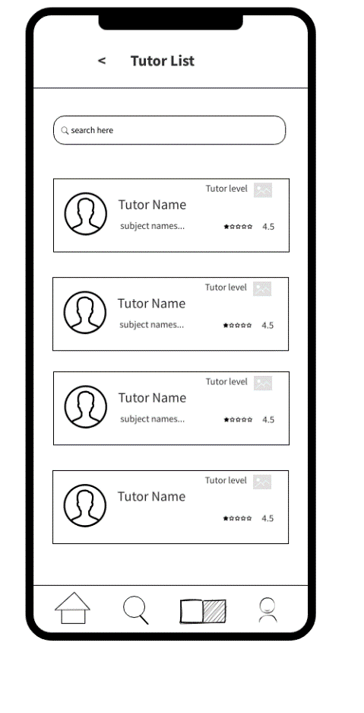 - Home Page - Tutor List

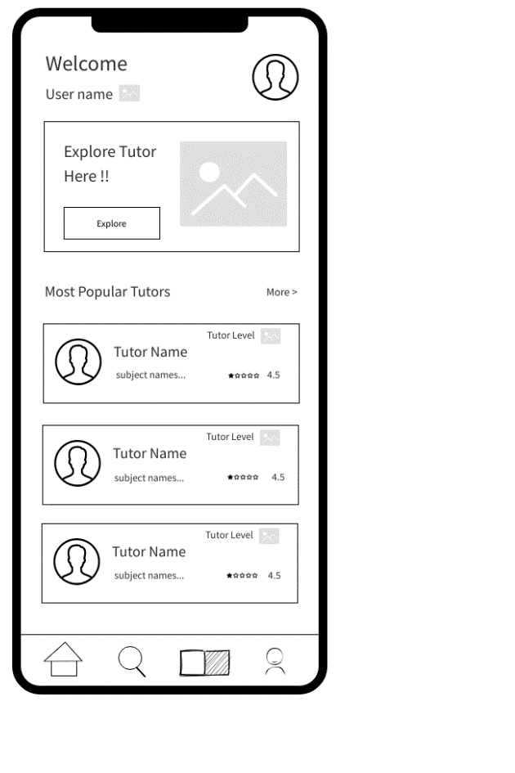

* Tutor view of tutor’s profile

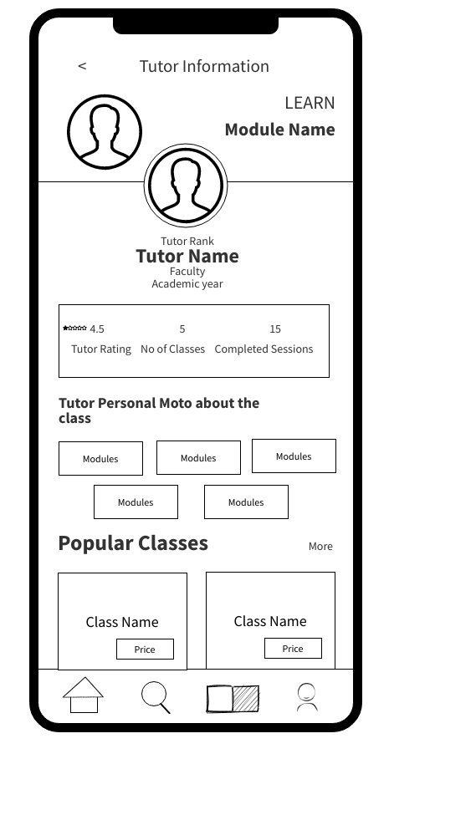

* Tutor edits profile, change password and calendar

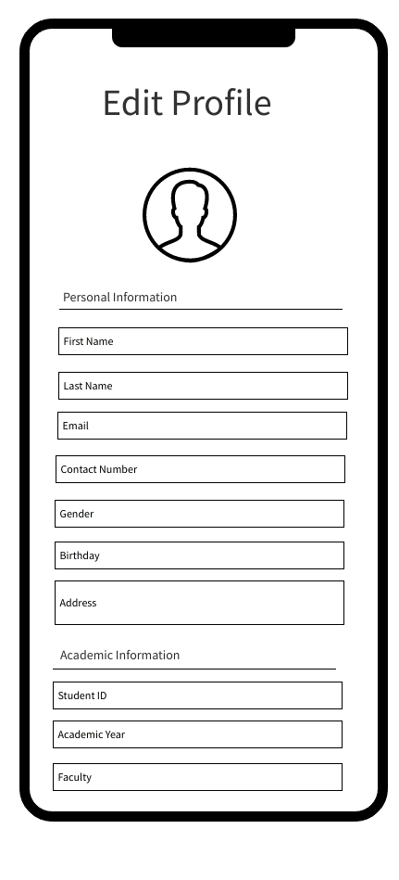 - Tutor Profile - Edit Profile - Change Password

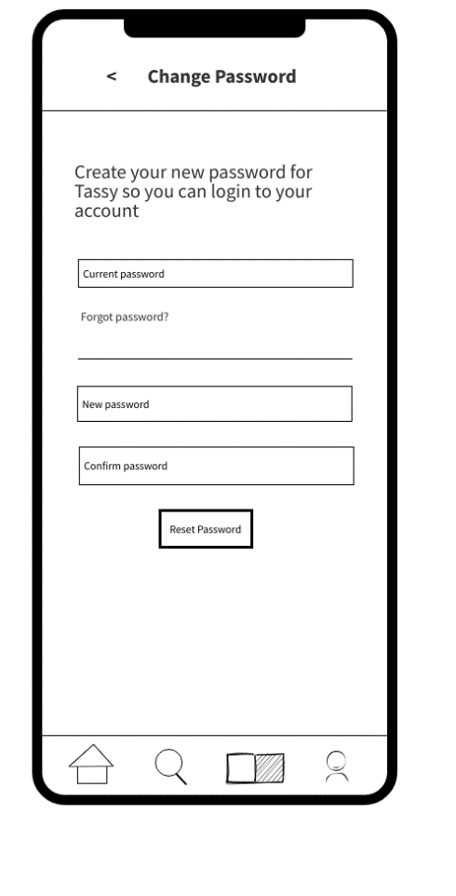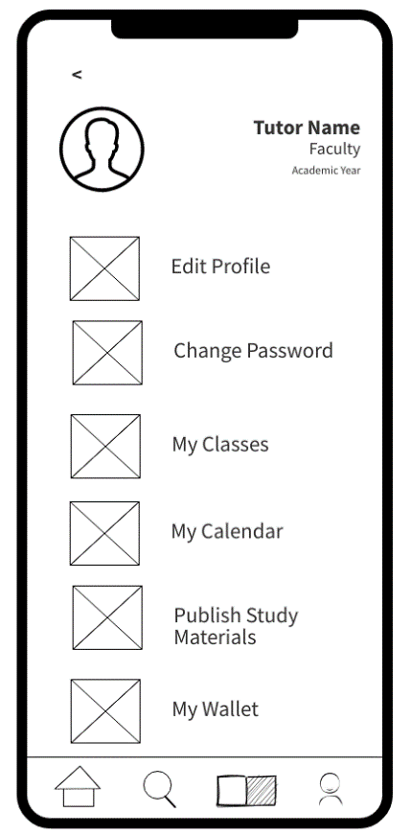

- Tutor Calendar

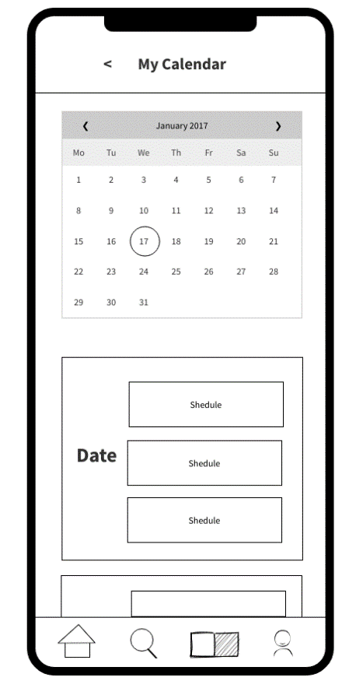

8.2.3. IT2126772

* Student selects subject, find relevant tutor, and book a class

- Categories - Class List - Class Details

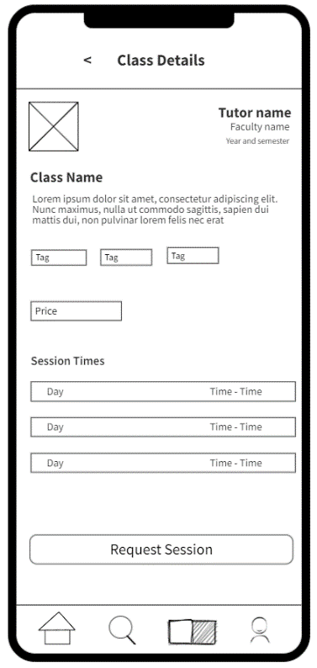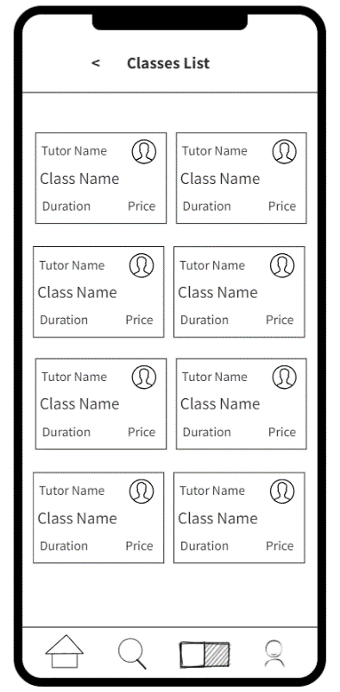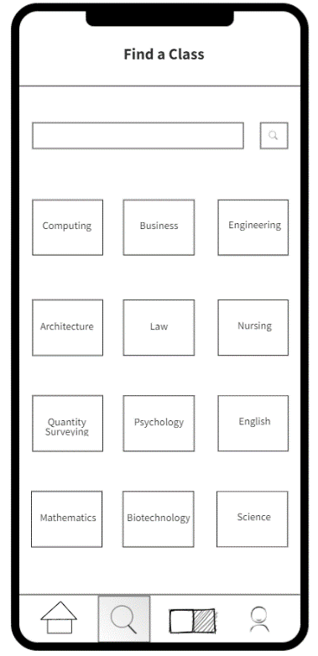

- Sessions List - Requesting Sessions - Session Request

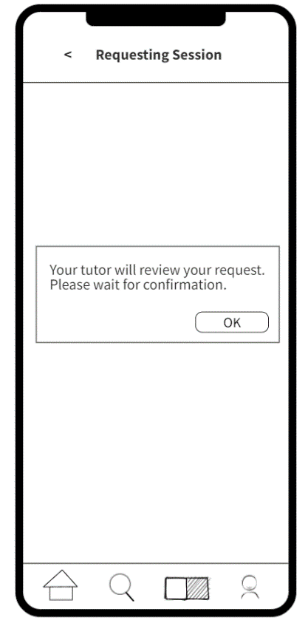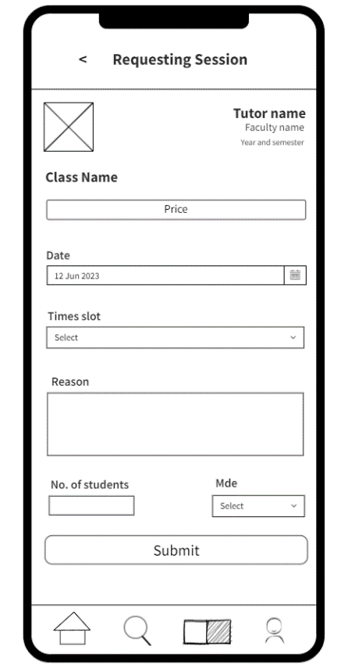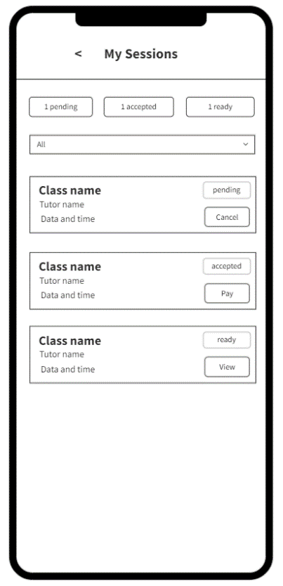

* Student makes payment to a tutor accepted class

- Session Payment Info - Payment Page - Session Location Info

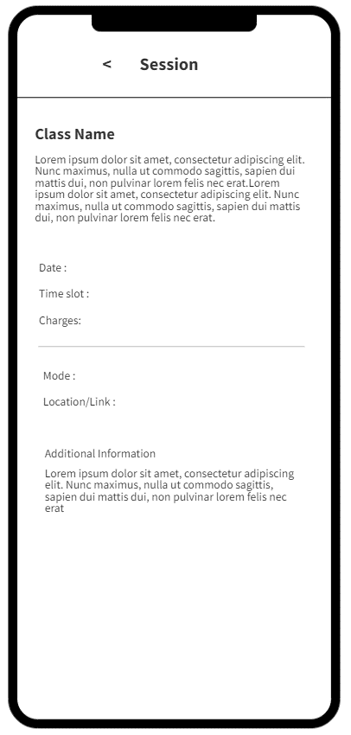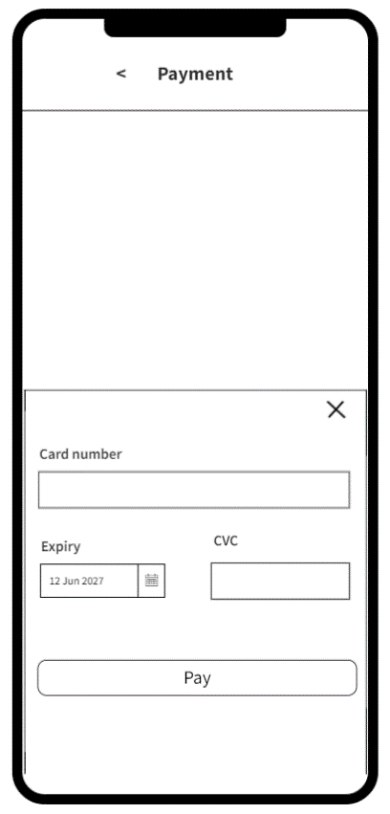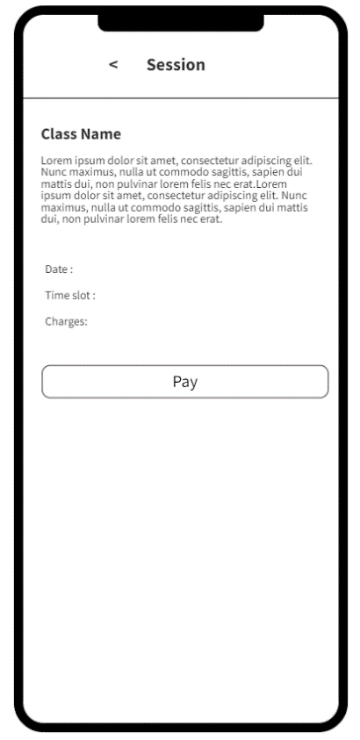

* Tutor withdraws money, add payment method, and edit payment method.

- My Wallet - Withdraw - Manage Payment Methods

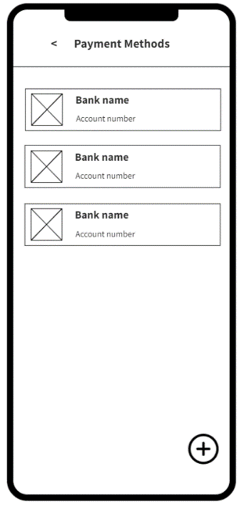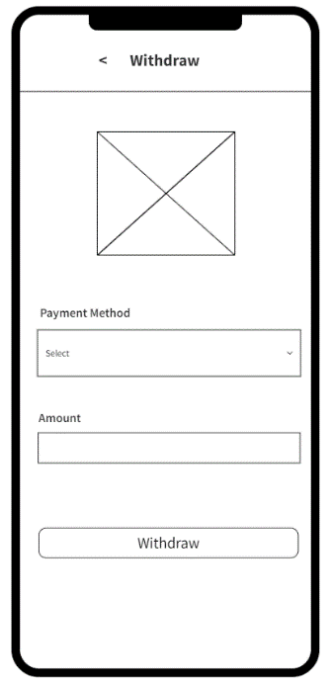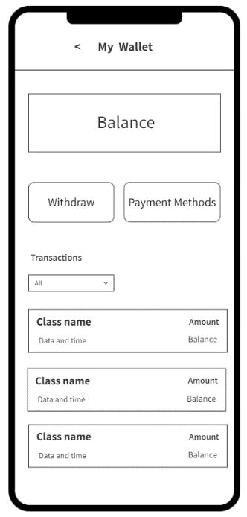

- Add Payment Methods - View Payment Method Details - Edit Payment Methods

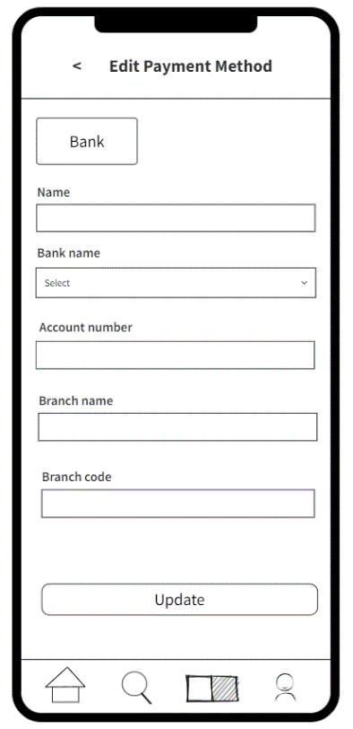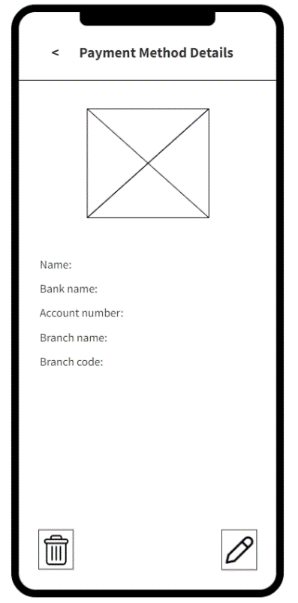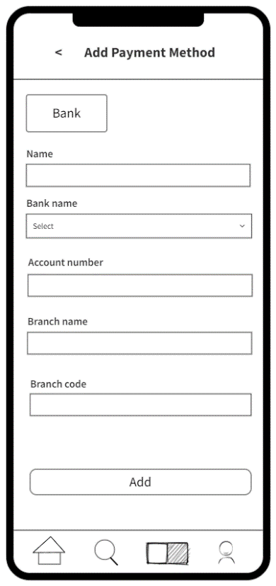

8.2.4. IT21388934

* Tutor view, add and edit class details

- My Classes - Add Class - View Class Details

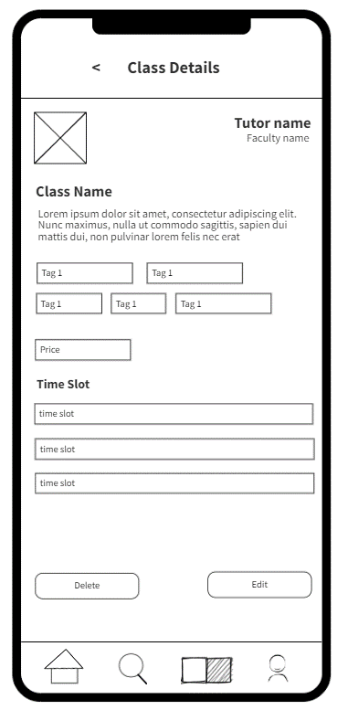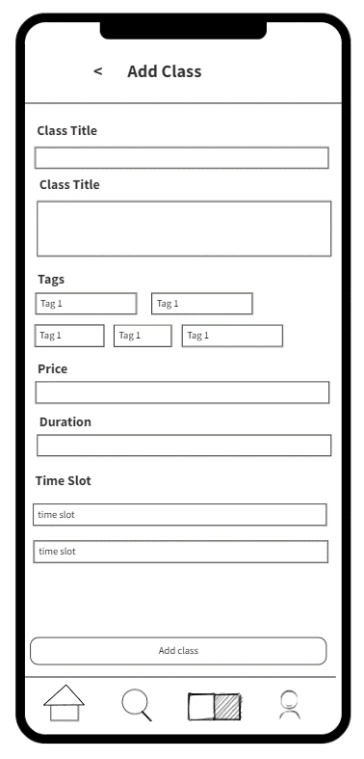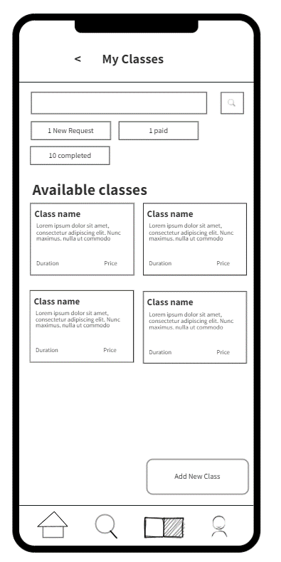

* Tutor view accept and decline new requests.

- View All New Request - New Request - Accept/Decline Request

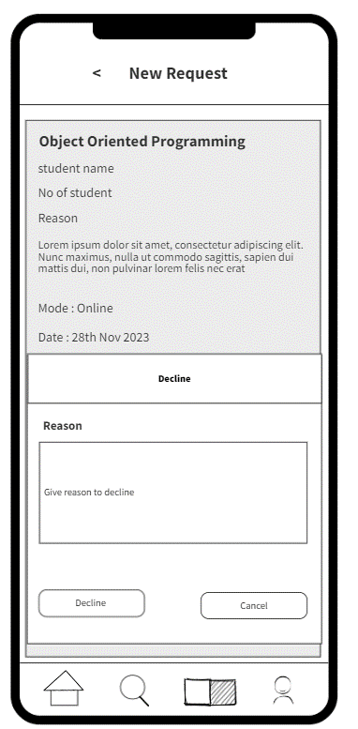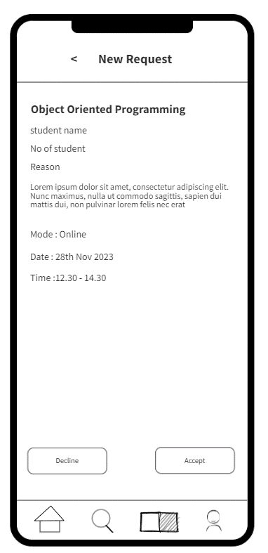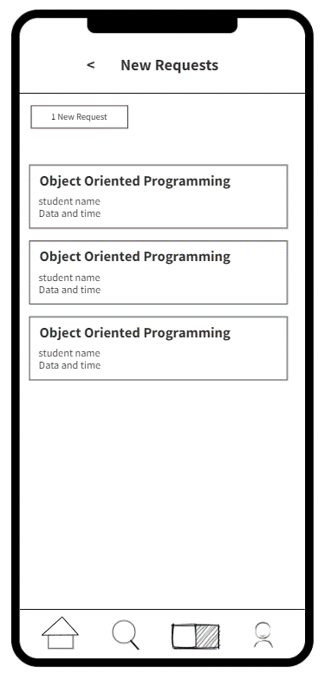

* Tutor view paid classes and send info to student

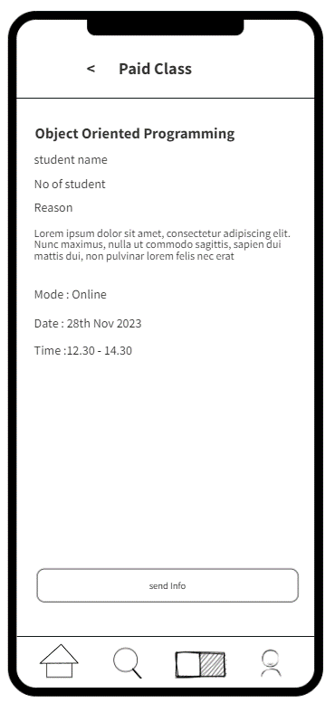 - View Paid Classes - Send Info to Paid Class

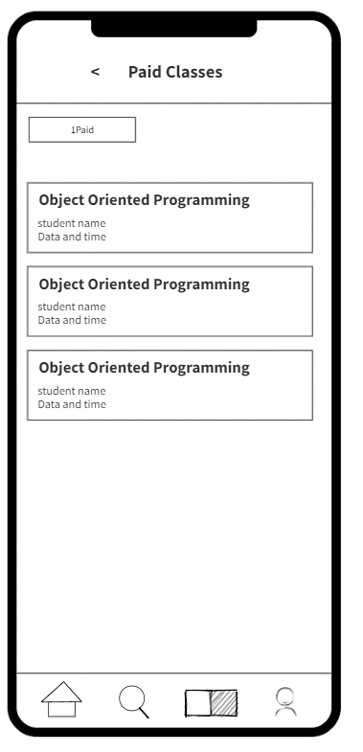

# Milestone 5: Figma Prototype

## 1 Design 01

* Figma Prototype Link
  + <https://www.figma.com/file/BPs3YBFWPxrInxWtXNTfMH/TutorMe?type=design&node-id=0-1&mode=design&t=K8DLdL03gNRmdlyQ-0>
* 9.1.1. IT21118340
  + Student Management - Student Signup, Student Profile, Edit Profile

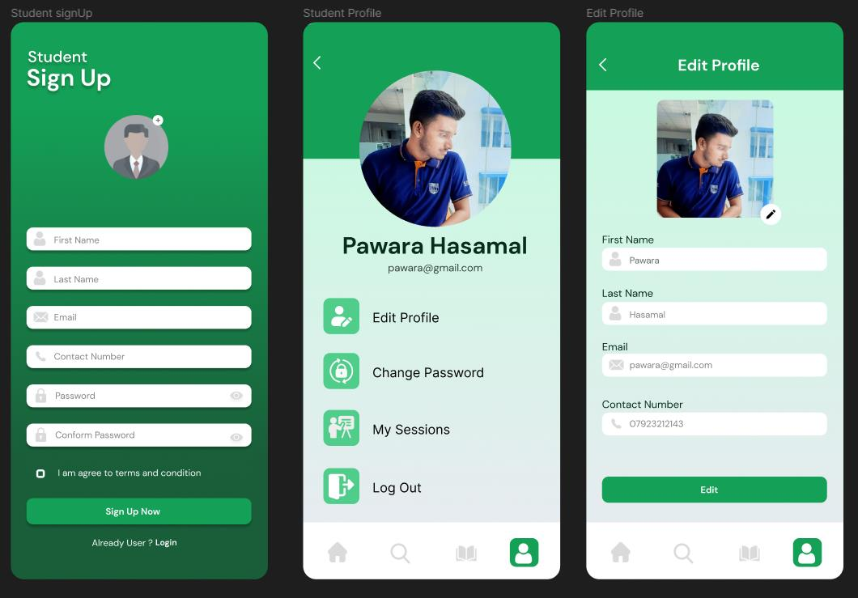

* + Study Materials (User Role: Student) - Search study materials, View study materials by category, View & Download study materials.

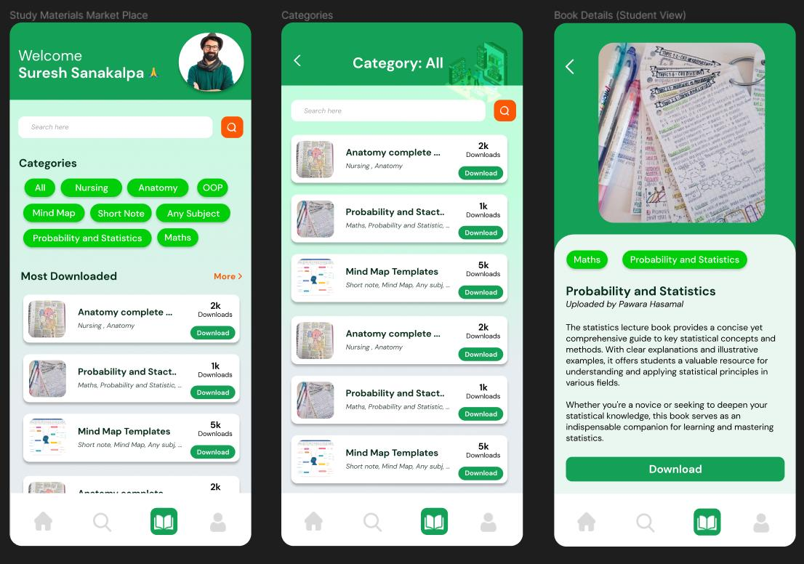

* + Study Materials Management (User Role: Tutor) - View all study materials, Add study materials, Edit & Delete study materials

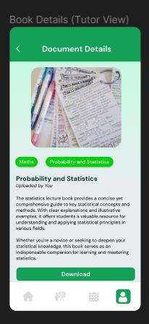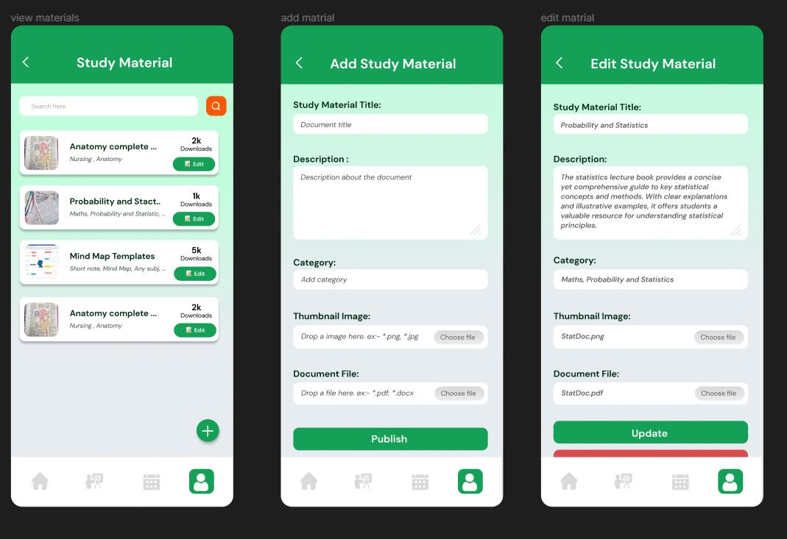

* 9.1.2. IT21291364

* + Tutor Management (User role: Tutor) – Tutor sign up, Tutor account, Tutor profile, Edit Tutor profile

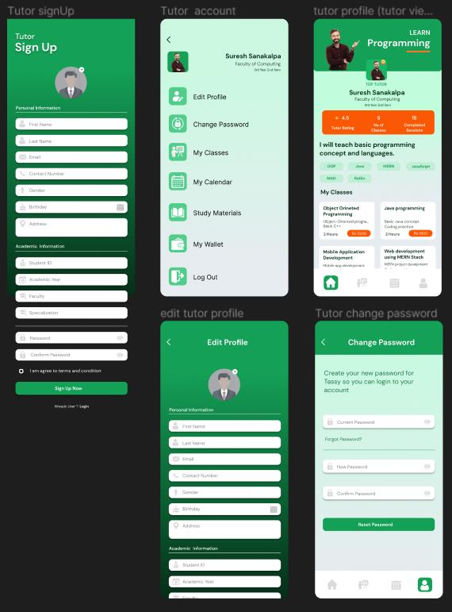

* + Calendar – (User role: Tutor)

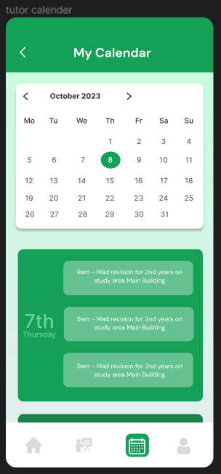

* + Tutor Management (User role: Student) – View and Search Tutor.

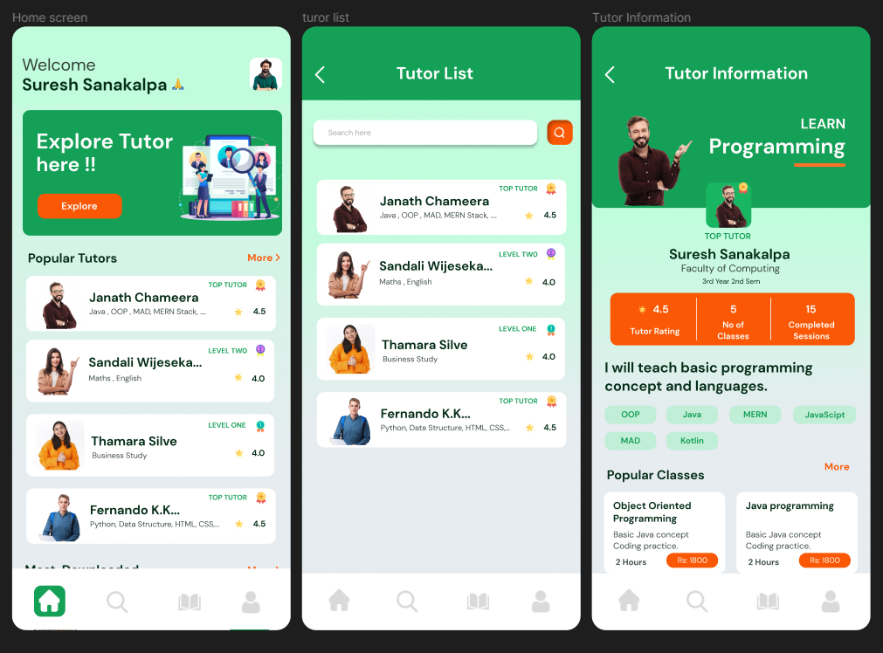

* + Login & Forgot password

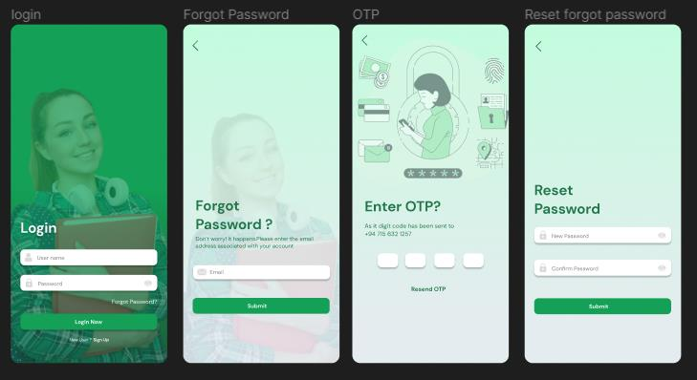

* 9.1.3. IT21267772
  + Request and booking (User role: Student) – Search classes, Request class, Book class, View student sessions

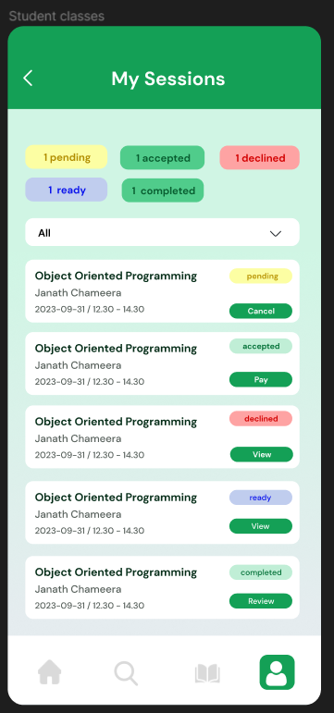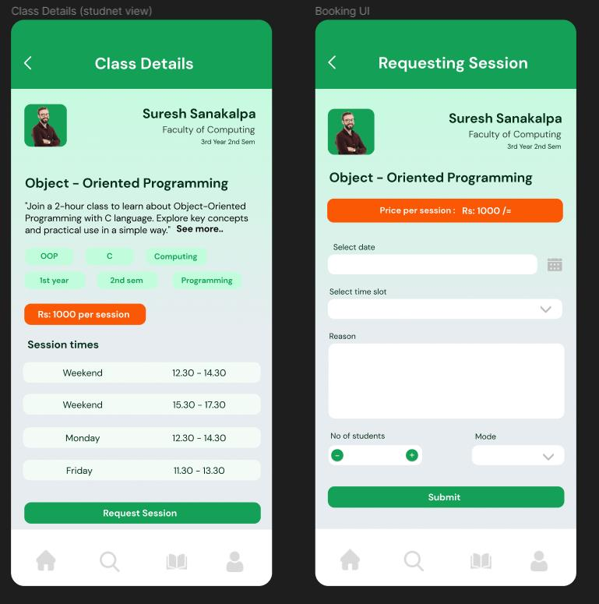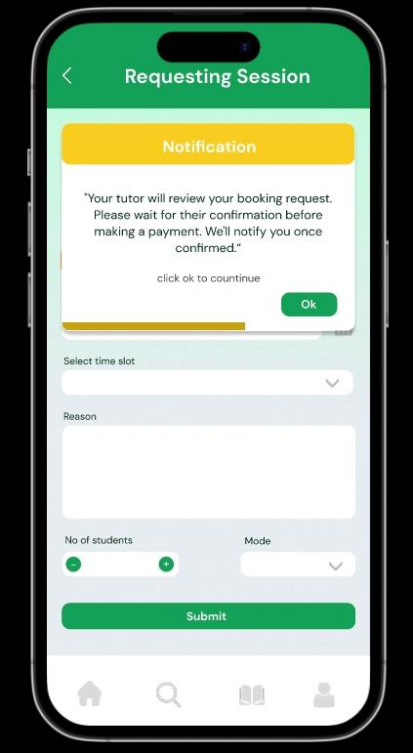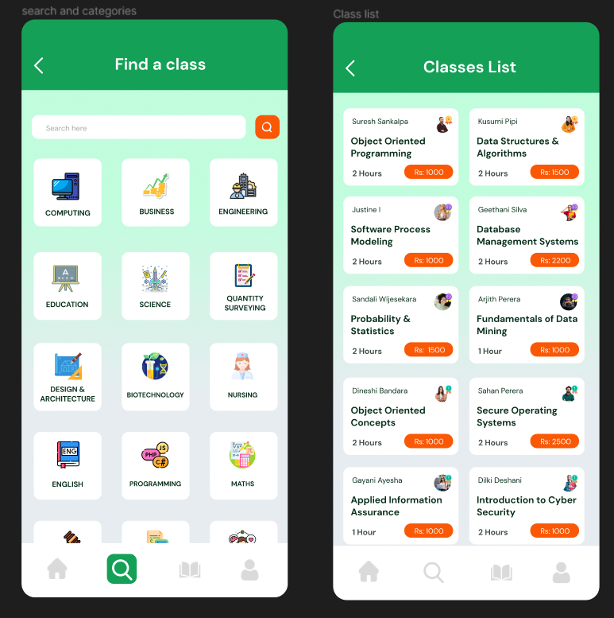

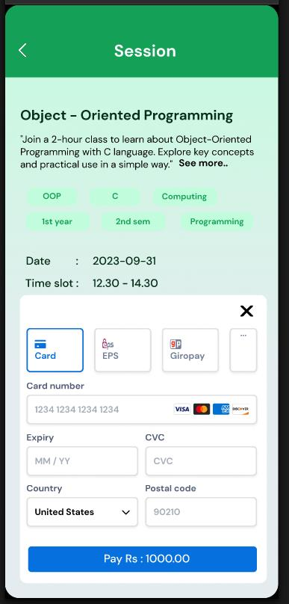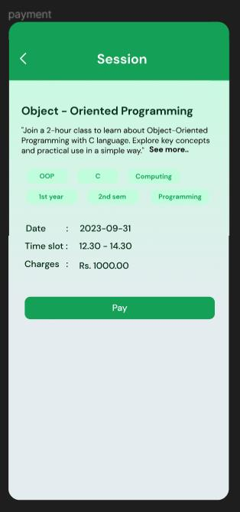

* Payment Options (User role: Tutor) – Add payment option, View payment options

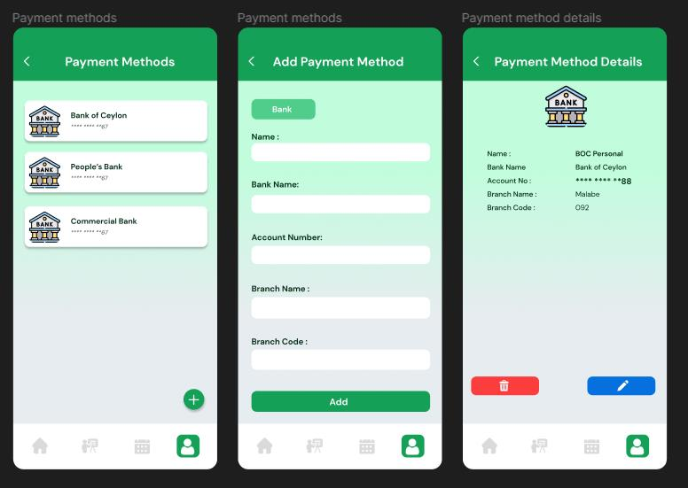

* 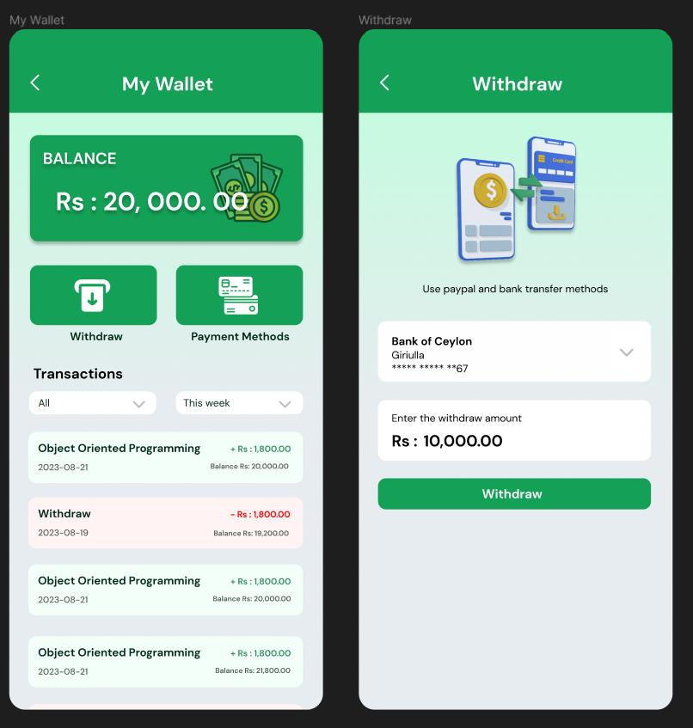Withdrawal (User role: Tutor) – Tutor wallet and Withdrawal
* 9.1.4. IT21388934
* Class Management (User role: Tutor) – View classes

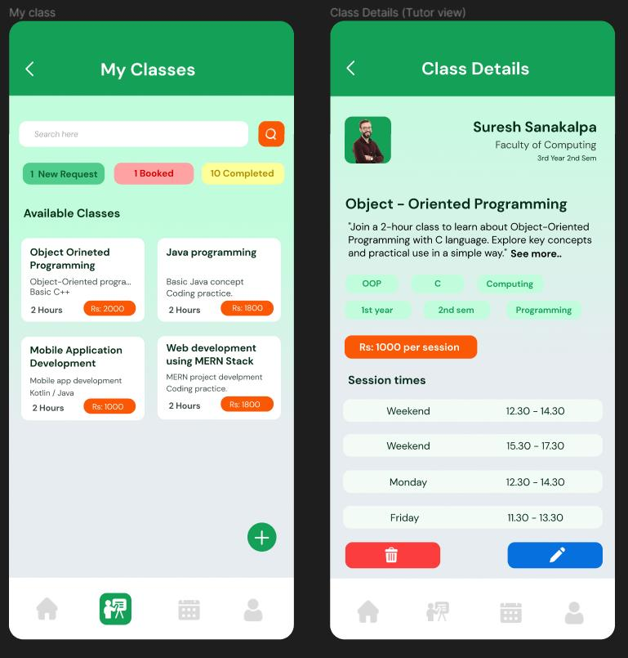

* Class Management (User role: Tutor) - Add class, Edit & Delete class

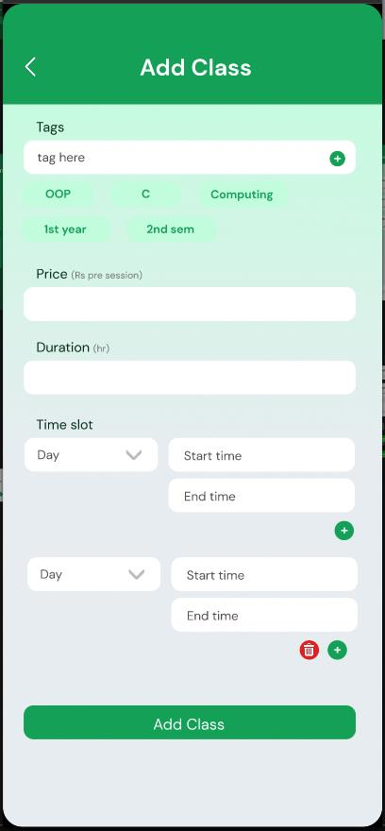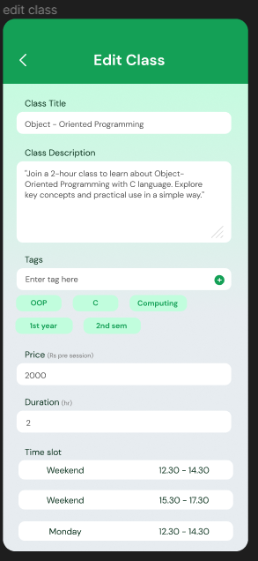

* Class Management (User role: Tutor) - New Request and Booked Classes view, Decline new request

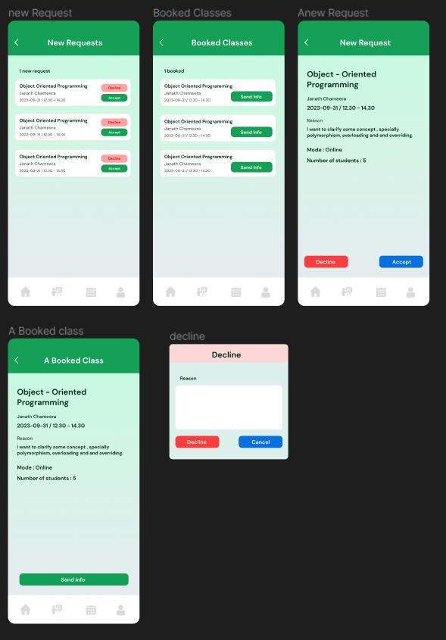

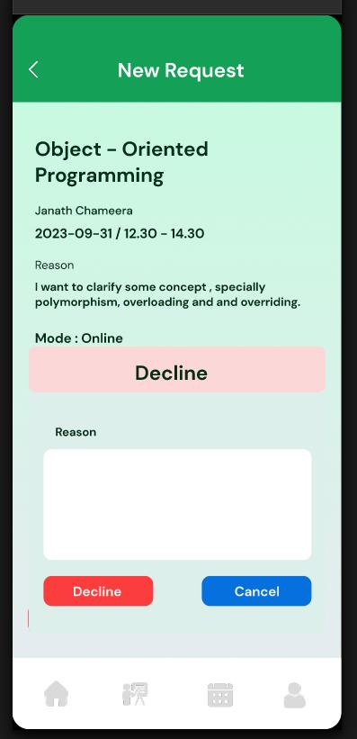

* Class Management (User role: Tutor) - Decline popup

## 2 Design 02 (Accepted Version)

* Figma Prototype Link
  + <https://www.figma.com/file/Usv4uPDQUBHi0N4bQVU3cG/TutorMe-(Version2)?type=design&mode=design&t=CKLuP4SFwCJChV6U-1>

# Milestone 6: User Feedback for your Prototype

10.1 Participant Profiles

The table below provides a breakdown of the participants selected for video interview:

|  |  |  |
| --- | --- | --- |
| **Name** | **Demography** | **Date & Time** |
| Sathsarani Wijeratne | * Undergraduate * Between age under 20 - 25 * Student at SLIIT. * Specialization in Information Technology. | 2023-09-20 18.30 |
| Sasini Nimesha | * Undergraduate * Between age under 20 - 25 * Student at KDU. * Specialization in Computer Science. | 2023-09-22 18.30 |
| Rosara Dayaratne | * Undergraduate * Between age under 20 - 25 * Student at SLIIT. * Specialization in Software Engineering. | 2023-09-23 10.30 |
| Dananjaya Siriwardhana | * Undergraduate * Between age under 20 - 25 * Student at SLIIT. * Specialization in Data Science. | 2023-09-21 18.30 |

TABLE 6. Participant Profile

10.2 Interview

All Interviews Link: <https://drive.google.com/drive/folders/1It7_XEsuAzOBSU0OnGVB_mGOKA-zAMH2?usp=drive_link>

10.2.1 Interview 01

**Video Link:** <https://drive.google.com/file/d/1wOm5RJo3WOZa0FkfvND0jR4Mp4NLRahe/view>

**Participant**: Dananjaya Siriwardhana

**Description**: 4rd year Data Science student

**Role**: Tutor

**Duration**: 0.5 hour

**Transcript:**

Team Member - Dilru: Hey Dananjaya ayye, Thank you for participating in this interview. So as u already know, We're developing an app that will help university students connect with tutors. So in this interview we are going to show u our prototype app and then u have to give us feedback about the app as u use it. U ready?

Interviewee - Dhananjaya: Yes. Let's start.

Team Member - Rumesh: So this is a prototype of our app. As soon as we open the app, we can see the splash screen. After a few seconds, it will redirect to the login page. If you are a new user, you can press the signup link at the bottom of the screen.From that page, you can select the sign-up option.Then you should fill out this form to sign up. After pressing the signup button, you will be directed to the login page. After the login, your home screen will open. On the home screen, you can see a banner slider, the most popular tutor list, and the most popular study materials. The navigation session is visible at the bottom of the screen. First navigation for the search option. From there, you can find a tutor or filter by category.By clicking on a tutor card, you can navigate to the full tutor information page. From here, you can see tutor academic information, ratings, what classes the tutor conducts, tutor expertise, and reviews. By pressing on one class, you can see whole-class information, including price and available session times.By pressing the booking button, you can navigate to the booking page. After filling out the form, you can click on the book button. Then notifications will appear. Second navigator for viewing study materials. From there, you can see search options, categories, and the most downloaded study materials.By clicking on a category, you can view study materials that are related to that category. You can download the note by pressing the download button. If you want further information, you can click on the material card. last navigator for the user account. You can edit your profile, view your classes, and logout. In My classes, you can see the status of the class. If the class is accepted, you can make the payment. You can open the payment gate by clicking the pay button. Finally, you can logout form the application. By clicking the log-out button, the application requests confirmation. If you do not need to log out, you can cancel. If you want to log out, you can click logout. It will redirect to the login page.

Interviewee - Dhananjaya: So, the app seems to be geared towards both university students. One feature I really like, is how it helps in organizing classes. You can schedule, reschedule, and keep track of your classes easily. This feature alone saves a lot of trouble for me.

Interviewee - Dhananjaya: Another great thing is how students can easily find and contact tutors. The search functionality seems pretty good. You can filter tutors by subject, availability, and even ratings. So, It's a big time-saver for them.

Interviewee - Dhananjaya: And also tutors can get feedback from students. This will help tutors improve thier teaching style and It adds a layer of trust and transparency to the whole process.

Interviewee - Dhananjaya: Another feature I really like is the easier payment process. You can handle payments within the app, making it convenient and secure. No need for cash or worrying about payment logistics.

Interviewee - Dhananjaya: Finally, the option to share old notes and lecture slides directly through the app is fantastic. It fosters a sense of community and collaboration among students. I can see it being really helpful when preparing for exams.

Team Member - Manuka: That's great feedback. So, On a scale of 1 to 10, how likely would you be to use this app based on the features you've described?

Interviewee - Dhananjaya: I'd say around 9. It seems like a comprehensive solution that caters to the needs of both students and tutors. The only reason I'm not giving it a 10 is because I haven't seen the actual app in action yet.

Team Member - Rumesh: Thank you for your valuable input. Lastly, is there anything you think could be improved or added to make this app even better?

Interviewee - Dhananjaya: Well, The app looks really great. Although I have a small suggestion, Can u add a feature that will allow users to link our google account with the app? It will make it more easier for user to register for the app.

Team Member - Dilru: Yes. We will definitely consider about it. Thank you so much for taking the time to do this interview. We genuinely appreciate it!

Interviewee - Dhananjaya: Thank you guys for having me. I wish you all the best.

10.2.2 Interview 02

**Video Link:** <https://drive.google.com/file/d/10Fgh22GtTVcAPZxZuiwaEp0p8YYdCCmq/view>

**Participant**: Sathsarani Wijeratne

**Description**: 3rd year Software Engineering student

**Role**: Tutor

**Duration**: 0.5 hour

**Transcript:**

Team Member - Dilru: Hey Sathsarani akke, Thank you for participating in this interview. So as u already know, We're developing a mobile application that will help university students connect with tutors. So in this interview we are going to show u our prototype app and then u have to give us feedback about the app as u use it. And if u have any questions regarding the app, u can ask from Us. So r u ready?

Interviewee - Sathsarani: Yes. Let's start.

Team Member - Rumesh: So this is a prototype of our app. As soon as we open the app, we can see the splash screen. After a few seconds, it will redirect to the login page. If you are a new user, you can press the signup link at the bottom of the screen.From that page, you can select the sign-up option.Then you should fill out this form to sign up. After pressing the signup button, you will be directed to the login page.

Team Member - Rumesh: So that is all about the app. So do u have any questions or anything u want to clarify?

Interviewee - Sathsarani: No, Everything is clear.

Team Member - Dilru: Now, we're going to give you 3 tasks to do, and you just need to finish them and let us know what you think.

Team Member - Dilru: So the first task is to register for the app and create a class. the second task is to upload a study material. and third task is to make a withdrawal. And as u complete the process u can ask us any questions or speak your thoughts.

Interviewee - Sathsarani: << Completes the tasks >>

Interviewee - Sathsarani: Okay. Both tasks are completed.

Team Member - Isuru: Alright, now that you've tried out our prototype and finished some tasks on your own, do you have any thoughts or suggestions for us?

Interviewee - Sathsarani: So, aesthetic wise, App has nice UI. And I also like the color theme. Green is suitable color for educational app. As for app functionality, one thing I really like, is how easy it is to organizing classes. You can schedule, and keep track of your classes easily. Another feature I really like is the easier payment process. You can handle payments within the app, it is really convenient for busy people like me. And I also like that app has a feature to share old lecture notes. I'm sure that will be big help for lot of students.

Team Member - Manuka: That's great feedback. So, On a scale of 1 to 10, how likely would you be to use this app based on the features you've described?

Interviewee - Sathsarani: I'd say around 8. It seems like it is a really good app.

Team Member - Rumesh: Thank you for your valuable input. Lastly, is there anything you think could be improved or added to make this app even better?

Interviewee - Sathsarani: Yes, I have a one suggestion. It would be great if you could simplify the tutor registration process. I understand that you need a lot of information to to validate tutors. But, current process might feel a bit overwhelming to first time users, especially it they aren't tech-savvy. Maybe try dividing them into smaller sections, so users don't have to deal with a lot of questions, all at once.

Team Member - Dilru: Yes. We will definitely consider about it. Thank you so much for taking the time to do this interview. We genuinely appreciate it!

Interviewee - Sathsarani: Thank you guys for having me. I wish you all the best.

10.2.3 Interview 03

**Video Link:** <https://drive.google.com/file/d/1HvstrN0RfK90cpn0Su4S6jmJ5N0kGViB/view>

**Participant**: Sasini Nimesha

**Description**: 3rd year Software Engineering student

**Role**: Student

**Duration**: 0.5 hour

**Transcript:**

Team Member - Dilru: Hey Sasi, Thank you again for participating in this interview. So as u know, We're developing an mobile application that will help university students connect with tutors. First, we'll show you our app's early version and how it works. While we explain, please ask any questions or share your thoughts. After that, we'll give you a task and ask questions as you use the app. It's important to know we're testing the app, not you. There are no wrong answers. Feel free to tell us if you like or don't like something, if you're confused, or anything else. Are you ready?. So a r u ready?

Interviewee - Sasini: Okay. Let's start.

Team Member - Rumesh: So this is a prototype of our app. As soon as we open the app, we can see the splash screen. After a few seconds, it will redirect to the login page. If you are a new user, you can press the signup link at the bottom of the screen.From that page, you can select the sign-up option.Then you should fill out this form to sign up. After pressing the signup button, you will be directed to the login page. After the login, your home screen will open. On the home screen, you can see a banner slider, the most popular tutor list, and the most popular study materials. The navigation session is visible at the bottom of the screen. first navigation for the search option. From there, you can find a tutor or filter by category.By clicking on a tutor card, you can navigate to the full tutor information page. From here, you can see tutor academic information, ratings, what classes the tutor conducts, tutor expertise, and reviews. By pressing on one class, you can see whole-class information, including price and available session times.By pressing the booking button, you can navigate to the booking page. After filling out the form, you can click on the book button. Then notifications will appear. Second navigator for viewing study materials. From there, you can see search options, categories, and the most downloaded study materials.By clicking on a category, you can view study materials that are related to that category. You can download the note by pressing the download button. If you want further information, you can click on the material card. last navigator for the user account. You can edit your profile, view your classes, and logout. In My classes, you can see the status of the class. If the class is accepted, you can make the payment. You can open the payment gate by clicking the pay button. Finally, you can logout form the application. By clicking the log-out button, the application requests confirmation. If you do not need to log out, you can cancel. If you want to log out, you can click logout. It will redirect to the login page.

Team Member - Rumesh: So that is all about the app. So do u have any questions or anything u want to clarify?

Interviewee - Sasini: Yes, I've got a quick question. I noticed that some details from the booking page, like the reason or how many students, are missing on the payment page. Do you think it would be a good idea to include them on the payment page?

Team Member - Dilru: Now, we're going to give you 2 tasks to do, and you just need to finish them and let us know what you think. Is it easy or hard? Is there anything that could be made better? Okay?

Team Member - Dilru: So the first task is to register for the app, then you have to select a tutor and book a session with them. And the second task is to go to study material market place section and download a document. And as u complete the process u can ask us any questions or speak your thoughts.

The first task is to sign up for the app. then you have to login and book a session with a tutor. The second task is to visit the study material section and download a document. As you finish these task, you can ask us any questions. Okay?

Interviewee - Sasini: << Completes the tasks >>

Interviewee - Sasini: Okay. Both tasks are completed.

Team Member - Isuru: Alright, now that you've tried out our prototype and finished some tasks on your own, do you have any thoughts or suggestions for us?

Interviewee - Sasini: Yes, one thing I really appreciate is that we can quickly get in touch with tutors. We can also check their ratings and what other students say about them. Plus, I can see how much a session costs upfront, so I know what to expect. Also, being able to find and download old study notes and lecture slides on the app is great for studying. But I didn't see a way to write reviews. If you guys can add that, it would be awesome!"

Team Member - Manuka: That's great feedback. We'll work on adding a way for students to write reviews. So, On a scale of 1 to 10, how likely would you be to use this app based on the features you've described?

Interviewee - Sasini: I'd say around 9. It seems like a good app.

Team Member - Dilru: Thank you for your valuable input. And We genuinely appreciate u taking the time to do this interview.

Interviewee - Sasini: Thank you guys for having me. I wish you all the best.

10.2.4 Interview 04

**Video Link:** <https://drive.google.com/file/d/1lTJ53-lLUVK3R4zZT6rnV2klSJpfpAux/view>

**Participant**: Rosara Dayaratne

**Description**: 2nd year Software Engineering student

**Role**: Tutor

**Duration**: 0.5 hour

**Transcript:**

Team Member - Dilru: Hello Rosara, Thank you again for participating in this interview. So as u know, We're developing an mobile application that will help university students connect with tutors. First, we'll show you our app's early version and how it works. While we explain, please ask any questions or share your thoughts. After that, we'll give you a task and ask questions as you use the app. It's important to know we're testing the app, not you. There are no wrong answers. Feel free to tell us if you like or don't like something, if you're confused, or anything else. Are you ready?. So a r u ready?

Interviewee - Rosara: Yes. Let's start.

Team Member - Rumesh: So this is a prototype of our app. As soon as we open the app, we can see the splash screen. After a few seconds, it will redirect to the login page. If you are a new user, you can press the signup link at the bottom of the screen.From that page, you can select the sign-up option.Then you should fill out this form to sign up. After pressing the signup button, you will be directed to the login page. After the login, your home screen will open. On the home screen, you can see a banner slider, the most popular tutor list, and the most popular study materials. The navigation session is visible at the bottom of the screen. first navigation for the search option. From there, you can find a tutor or filter by category.By clicking on a tutor card, you can navigate to the full tutor information page. From here, you can see tutor academic information, ratings, what classes the tutor conducts, tutor expertise, and reviews. By pressing on one class, you can see whole-class information, including price and available session times.By pressing the booking button, you can navigate to the booking page. After filling out the form, you can click on the book button. Then notifications will appear. Second navigator for viewing study materials. From there, you can see search options, categories, and the most downloaded study materials.By clicking on a category, you can view study materials that are related to that category. You can download the note by pressing the download button. If you want further information, you can click on the material card. last navigator for the user account. You can edit your profile, view your classes, and logout. In My classes, you can see the status of the class. If the class is accepted, you can make the payment. You can open the payment gate by clicking the pay button. Finally, you can logout form the application. By clicking the log-out button, the application requests confirmation. If you do not need to log out, you can cancel. If you want to log out, you can click logout. It will redirect to the login page.

Team Member - Rumesh: So that is all about the app. So do u have any questions or anything u want to clarify?

Interviewee - Rosara: No, Everything is clear.

Team Member - Dilru: Now, we're going to give you 3 tasks to do, and you just need to finish them and let us know what you think. And as u complete the process u can ask us any questions or speak your thoughts.

Team Member - Dilru: So the first task is to register for the app and create a class. Please let us know once u complete the task. Can u share ur screen?

Interviewee - Rosara: first task is completed.

Interviewee - Rosara: << Completes the task the task >>

Team Member - Dilru: Okay, The second task is to upload a study material.

Interviewee - Rosara: << Completes the task >>

Interviewee - Rosara: second task is completed.

Team Member - Dilru: third task is to make a withdrawal.

Interviewee - Rosara: << Does the task >>

Interviewee - Rosara: third task is completed.

Team Member - Isuru: Alright, now that you've tried out our prototype and finished some tasks on your own, do you have any thoughts or suggestions for us?

Interviewee - Rosara: So, design wise, App has a nice UI. and As for app functionality, one thing I really like, is how easy it is to organizing classes. Another feature I really like is the easier payment process. You can handle payments within the app, it is really convenient. And I also like that app has a feature to share old lecture notes. It will be big help for lot of students.

Team Member - Manuka: That's great feedback. So, On a scale of 1 to 10, how likely would you be to use this app based on the features you've described?

Interviewee - Rosara: I'd say around 9. It seems like it is a really good app.

Team Member - Rumesh: Thank you for your valuable input. Lastly, is there anything you think could be improved or added to make this app even better?

Interviewee - Rosara: Yes, I have a some suggestions. If u can consider adding a single main category for documents instead of using tags, that might be better. If you could modify the color of the price tag on the Classes page, it would improve clarity of the UI.

Team Member - Dilru: Yes. We will definitely consider about it. Thank you so much for taking the time to do this interview. We genuinely appreciate it!

Interviewee - Rosara: Thank you guys for having me. I wish you all the best.

* 1. Questionnaire

**For Tutors**

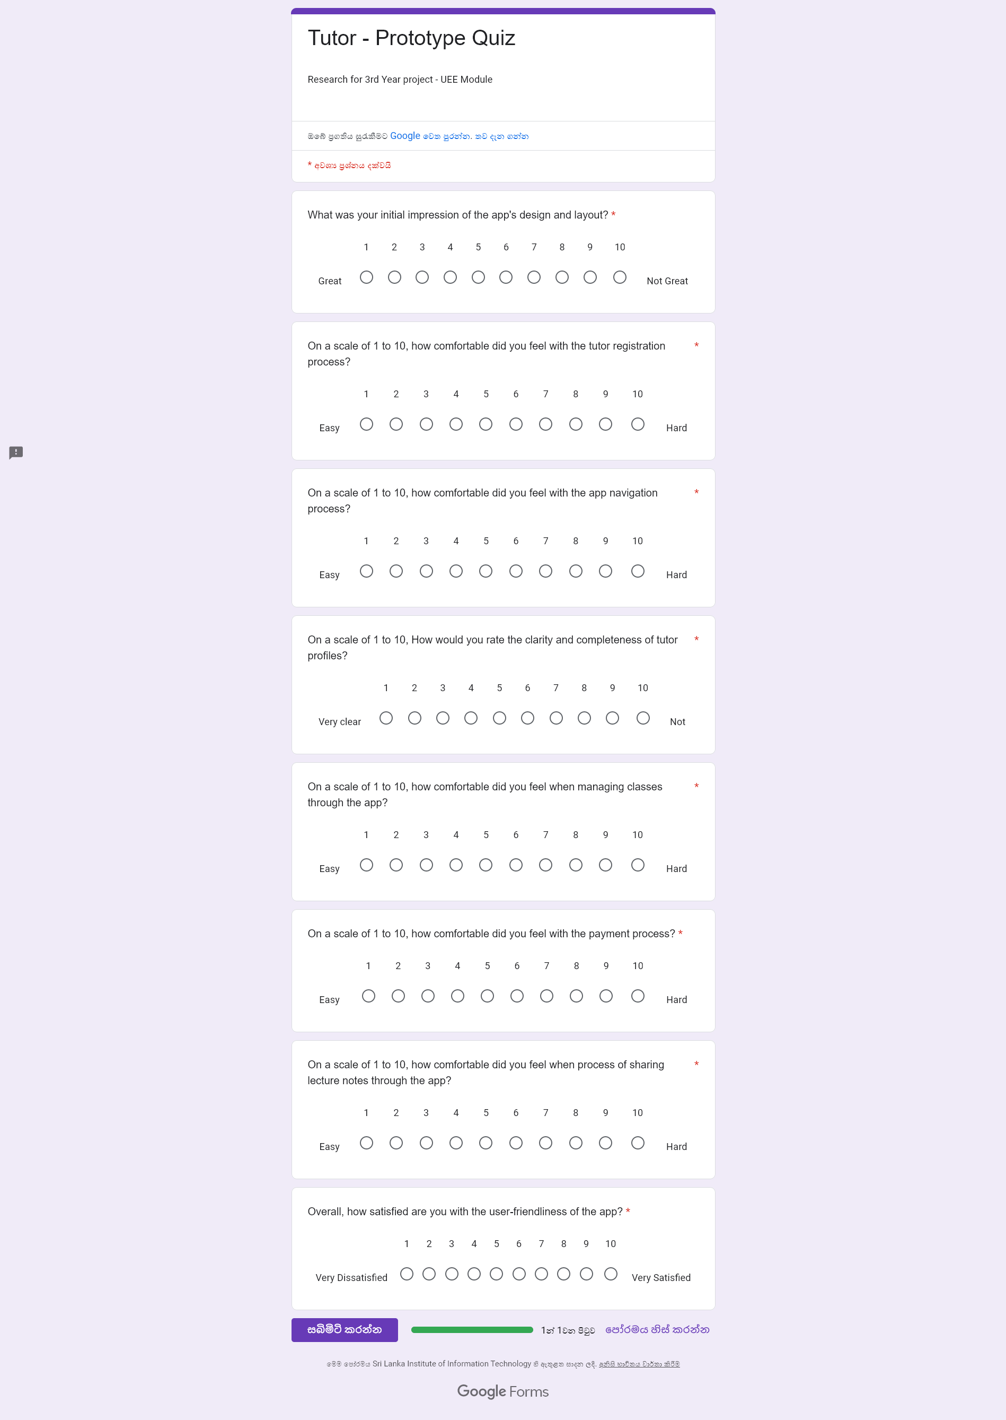

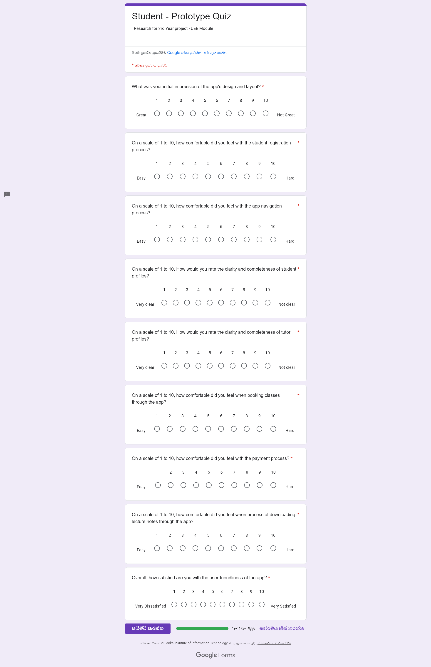**For Students**

* 1. Plan for Data Analysis

10.4.1 Questionnaire results

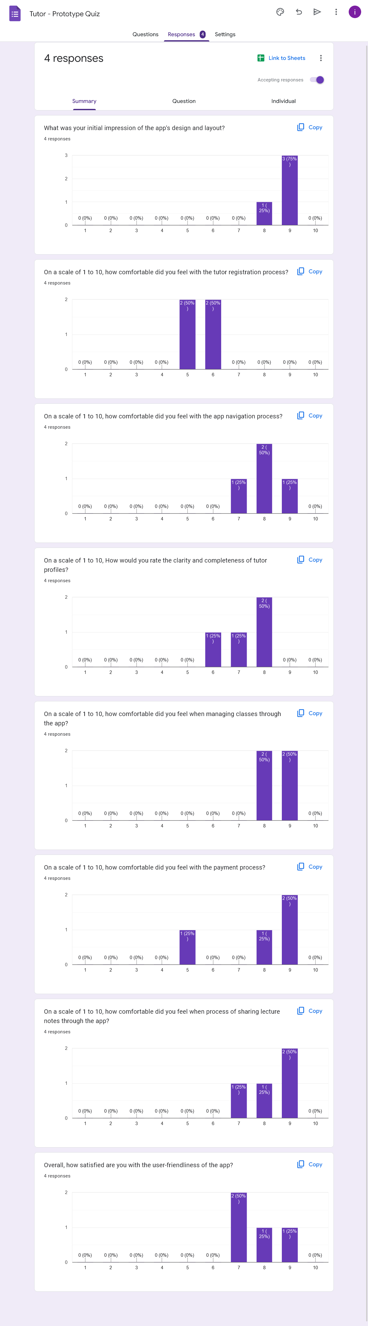**For Tutors**

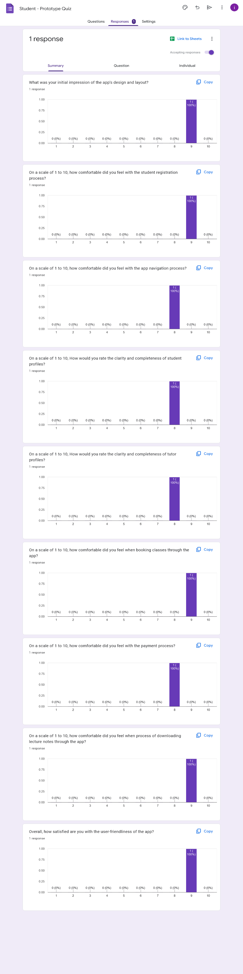**For Students**

10.5 User Requests

1. Simplify the tutor registration process

2. One category for study materials instead of using tags

3. Improve the functionality to calendar component.

4. Added extra Information is to the payment page

5. Remove decline, accept and send info button, to reduce the complexity and prevent accidental touch.

* 1. Modifications Based on User Feedback

10.6.1. IT21118340

**Modification 01**

* Included a main category for book for study materials instead of tags, based on the suggestion of interviewed user.

**Modification 02**

* Changed style of the header for all the pages related to Study materials. For consistency.

**Version 01**

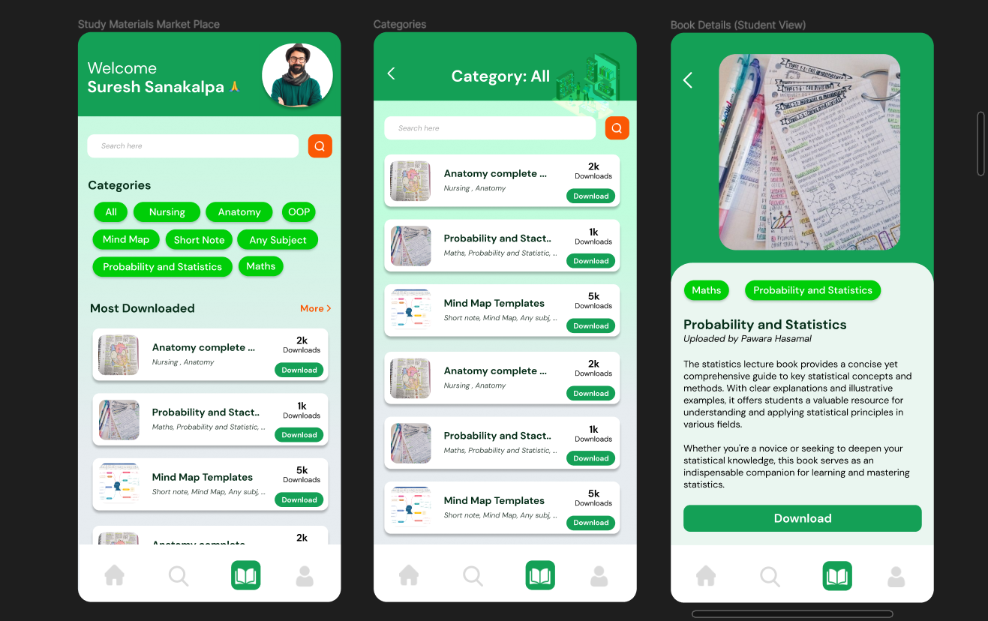

**Version 02 (Modified Version)**

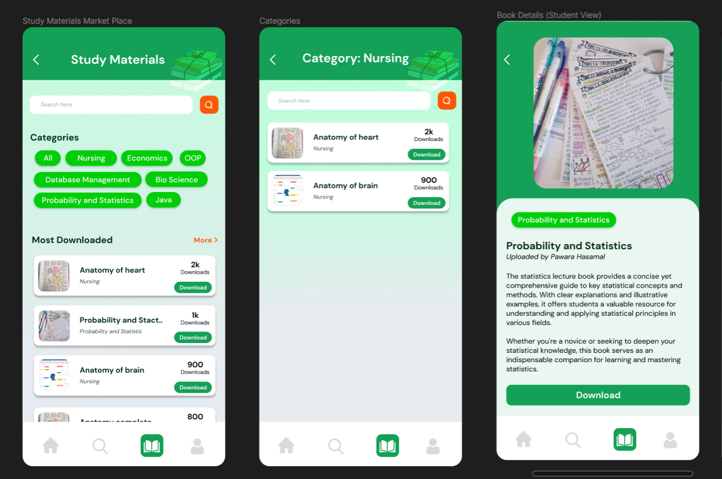

**Version 01**

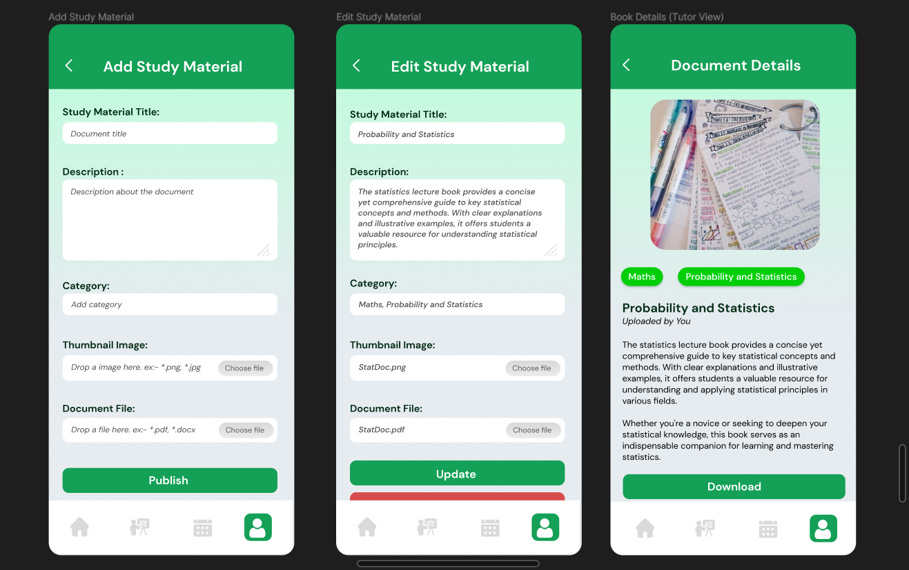

**Version 02 (Modified Version)**

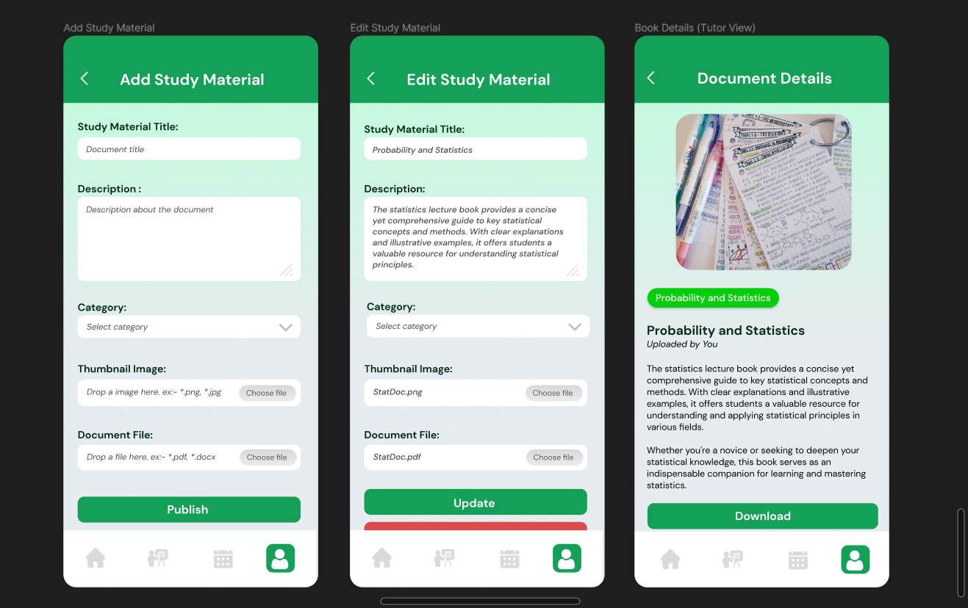

10.6.2. IT21291364

**Modification 01**

* Divided registration into several processes, based on the suggestion of interviewed user.

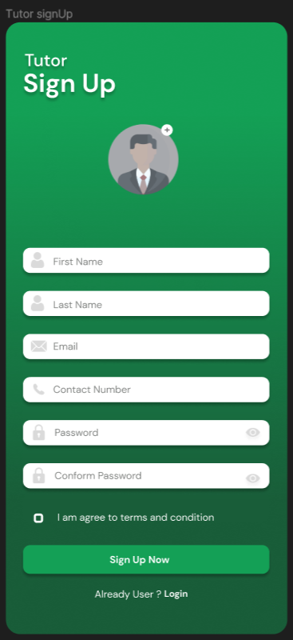**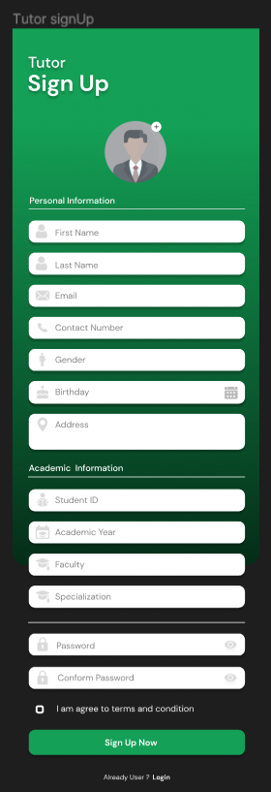Version 01 Version 02 (Modified Version)**

**Version 02 (Modified Version)**

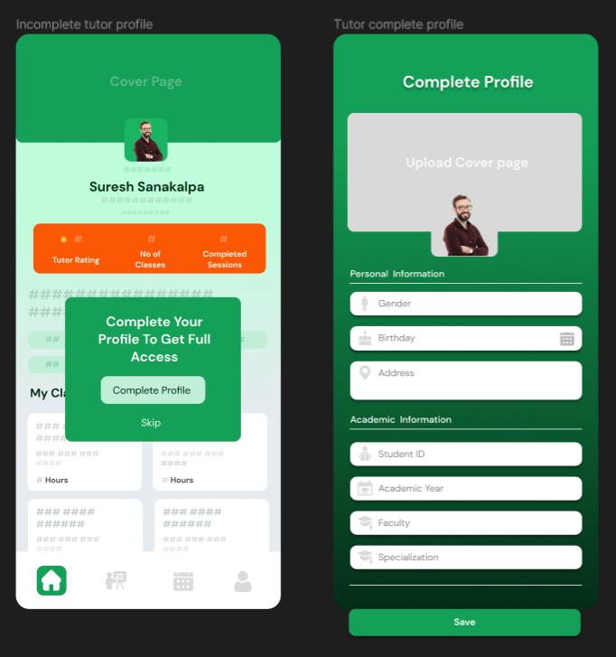

**Modification 02**

* Improve the functionality to calendar component. Included the feature to change schedule.

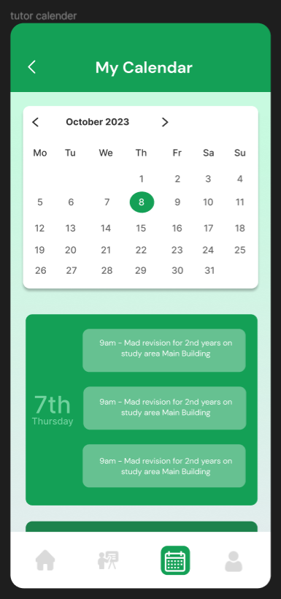**Version 01**

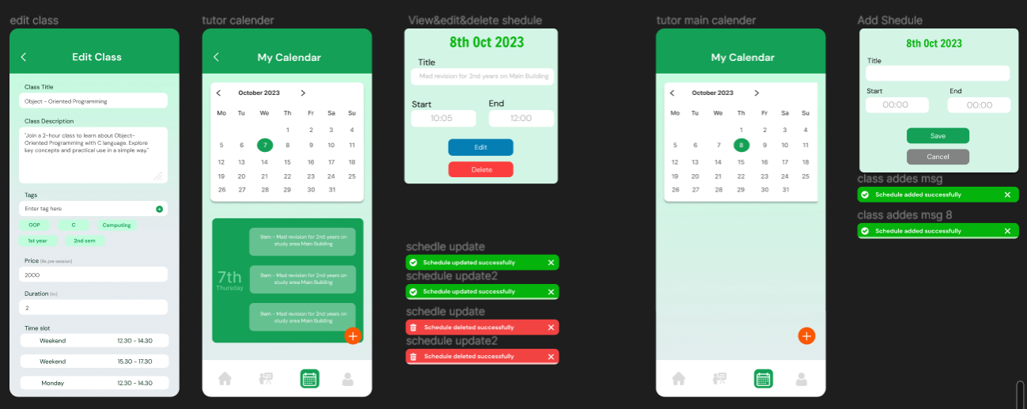**Version 02 (Modified Version)**

10.6.3. IT21267772

**Modification 01**

* Added extra Information is to the payment page, based on the suggestion of interviewed user.

**Version 01 Version 02 (Modified Version)**

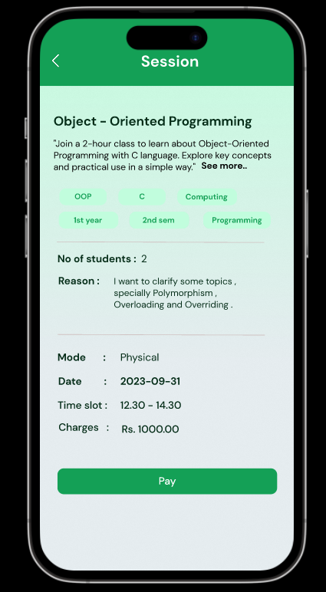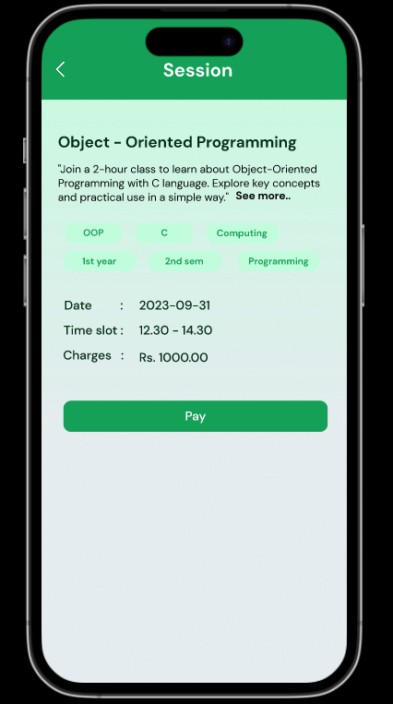

**Modification 02**

* Changed color of the price tag for more clarity, based on the suggestion of interviewed user.

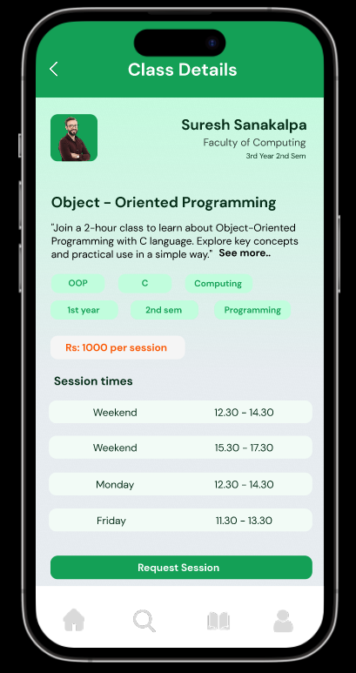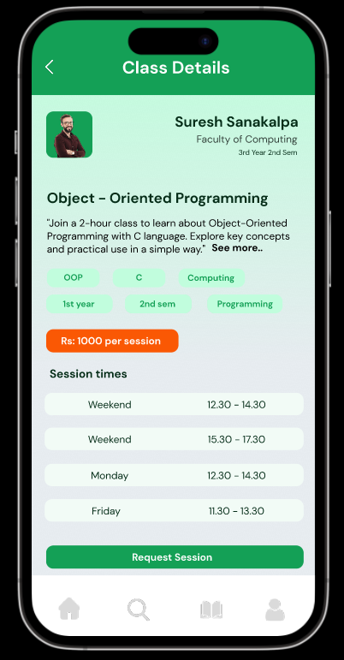**Version 01 Version 02 (Modified Version)**

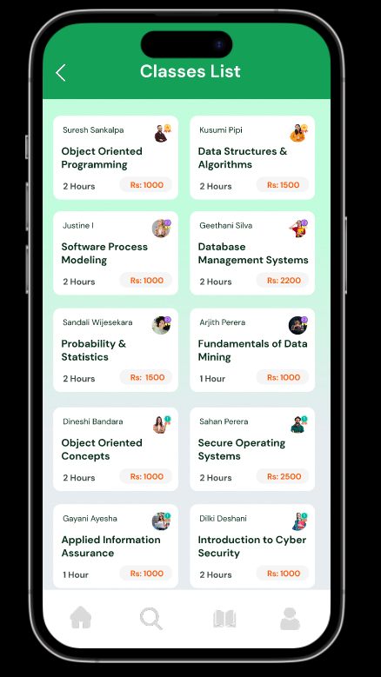**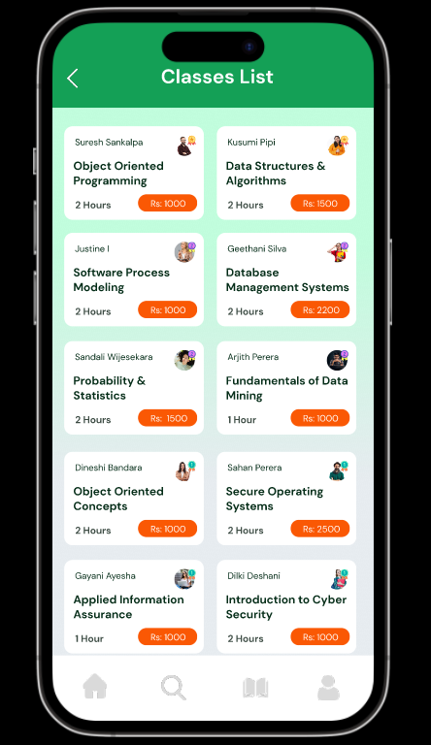Version 01 Version 02 (Modified Version)**

10.6.3. IT21388934

**Modification 01**

* Changed color of the price tag for more clarity, based on the suggestion of interviewed user.

**Version 01**

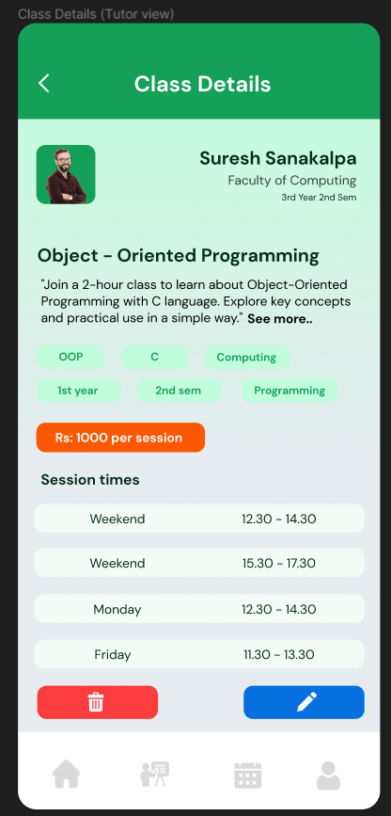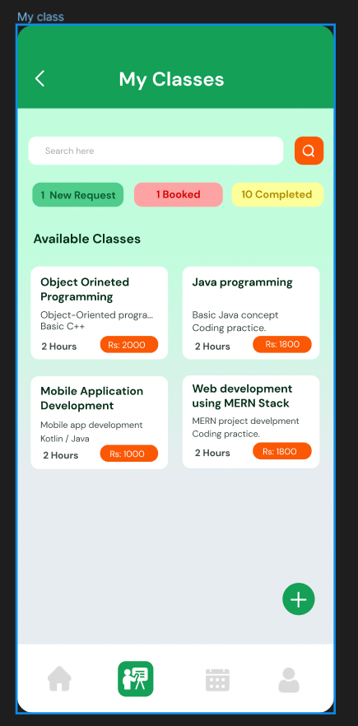

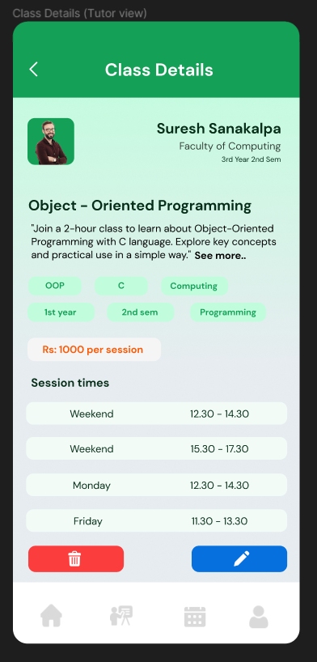**Version 02 (Modified Version)**

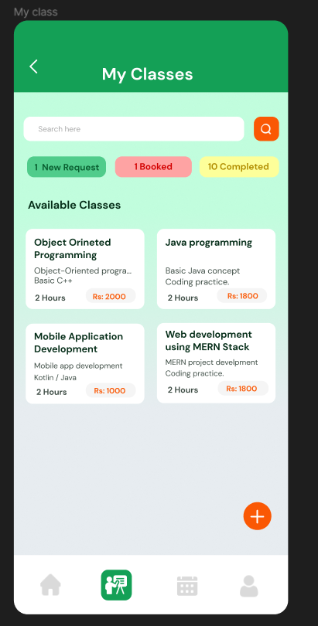

**Modification 02:**

* Remove decline, accept and send info button, to reduce the complexity and prevent accidental touch.

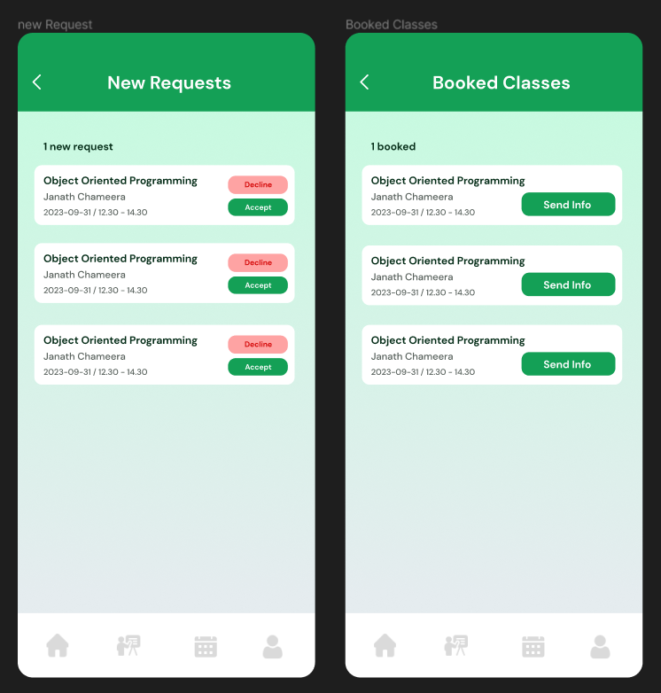**Version 01**

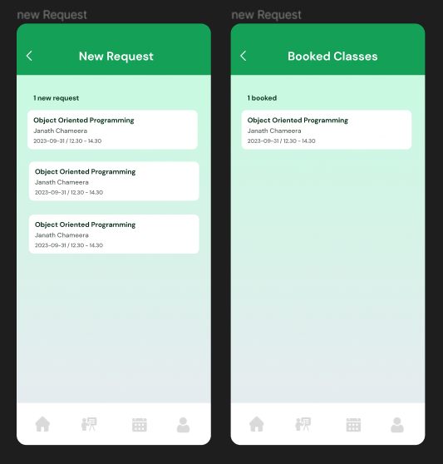**Version 02 (Modified Version)**

# Milestone 7: Implementation

**11.1 Github Implementation Link**

<https://github.com/IT21388934/TutorMe>

**11.2 Prototype Version 02 Link**

<https://www.figma.com/file/Usv4uPDQUBHi0N4bQVU3cG/TutorMe-(Version2)?type=design&mode=design&t=CKLuP4SFwCJChV6U-1>

**11.3 Prototype Version 02 – User Feedback**

**Tutor Questionnaire**

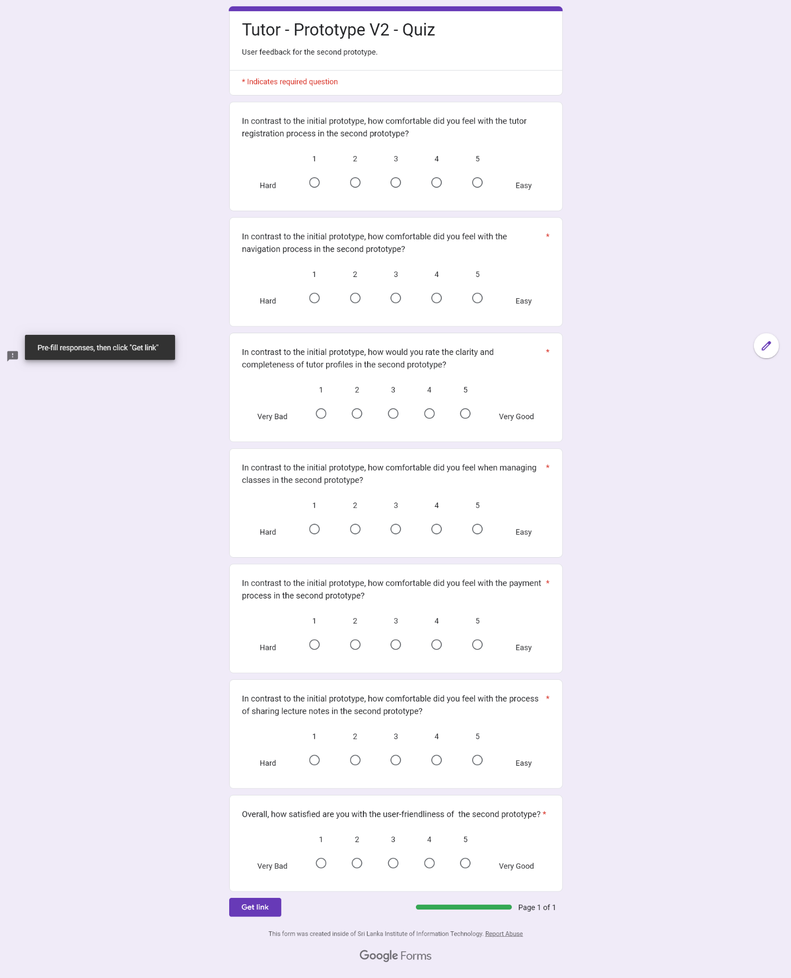

**Student Questionnaire**

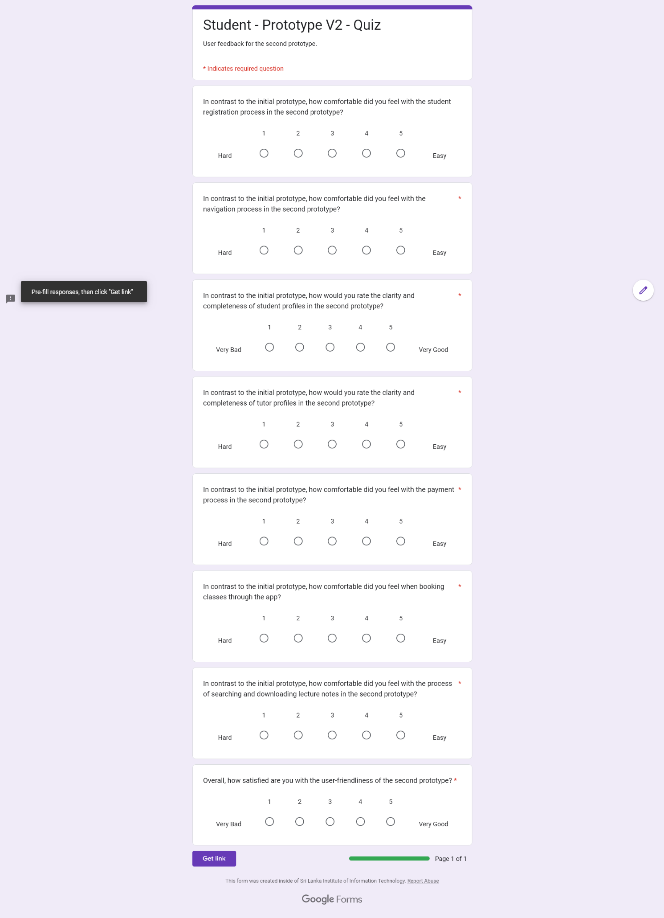

**Plan for Data Analysis**

**Tutor Questionnaire - Results**

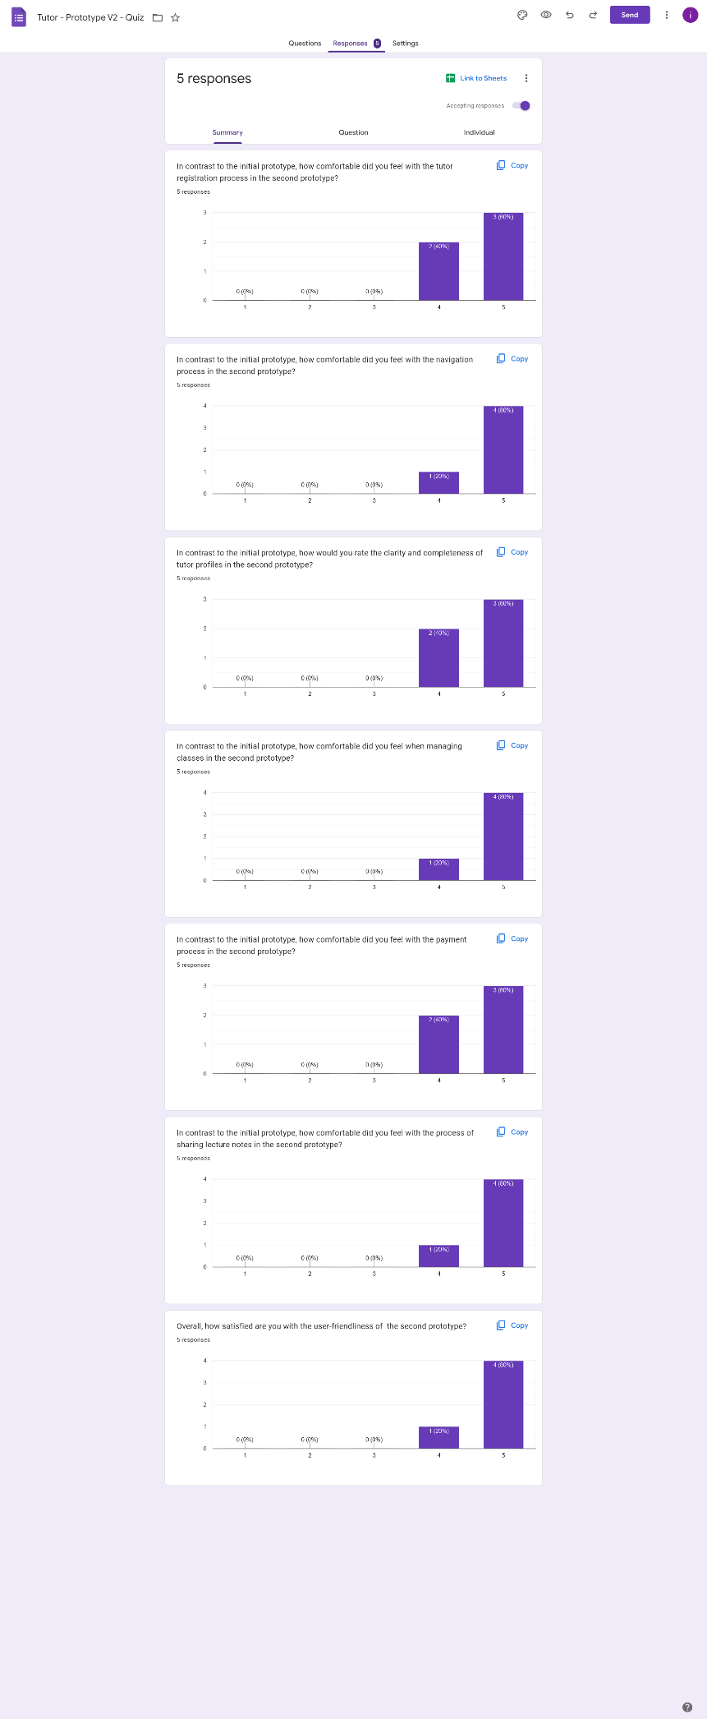

**Student Questionnaire - Results**

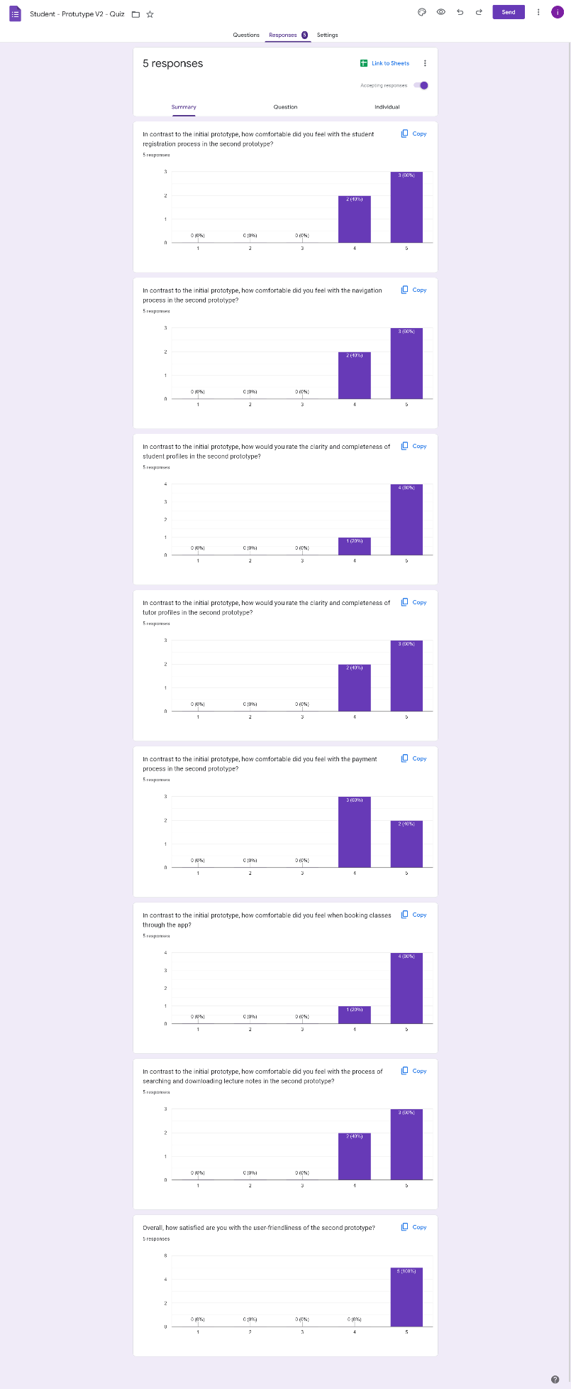

**11.4 Test Plan**

1. **Introduction**

* **Purpose**: To ensure the reliability, functionality, and performance of the application.
* **Scope**: This test plan covers functional, usability, security, and performance testing.

1. **Test Objectives**

* Verify that the app functions as intended.
* Identify and rectify any usability issues.
* Ensure the app is secure and data is protected.
* Assess the app's performance under various conditions.

**3. Test Environments**

* Devices: Android and iOS smartphones
* Operating Systems: iOS 14 and later, Android 10 and later
* Network: Different network conditions (Wi-Fi, 4G, 3G)
* Various screen sizes and resolutions

**4. Test Cases**

**4.1. Functional Testing**

|  |  |
| --- | --- |
| **Function** | **Task** |
| Login and Registration | * Verify that users can register with valid credentials. * Ensure users can log in using registered credentials. * Test for password reset functionality. |
| Profile Management | * Check if users can update their profiles (name, profile picture, etc.). * Verify that profile information is displayed correctly. |
| Class Management | * Verify that tutors can create new classes, specifying details such as subject, date, time, and duration. * Verify that tutors can update class details or cancel classes if necessary. |
| Class Search and Selection | * Test search functionality based on subjects and categories. * Ensure tutors' profiles display accurate information (experience, reviews). |
| Session Booking and Management | * Confirm that users can schedule and manage sessions with tutors. * Verify that sessions are added to both user's and tutor's calendars. |
| Payment Integration | * Test payment process for session booking, including adding/removing payment methods. * Verify that tutors can initiate withdrawal requests for their earnings. * Ensure that tutors can view their withdrawal history, including approved, pending, and declined withdrawals. * Verify that payments are processed securely, and receipts are generated. |
| Feedback and Rating System | * Test the ability to provide feedback and ratings after sessions. * Verify that feedback and ratings are displayed on tutors' profiles. |
| Study Materials Management | * Verify that tutors can upload study materials (PDFs, documents) to the app. * Confirm that students can access study materials shared by tutors. * Test downloading and viewing of study materials to ensure compatibility. |
| Study Material Search | * Test the search functionality to find study materials by subject, topic, or tutor. * Verify that search results are accurate and relevant. |

**4.2. Usability Testing**

* Assess the user interface for intuitiveness and ease of use.
* Verify accessibility and compatibility with various devices.
* Evaluate the app's response time for different actions.
* Check if the app provides clear instructions and feedback to users.

**4.3. Security Testing:**

* Verify data encryption during transmission.
* Ensure secure storage of user data.
* Evaluate user authentication and authorization mechanisms.

**4.4. Performance Testing:**

* Measure app performance under normal network conditions.
* Test app responsiveness and loading times.
* Evaluate app behavior under heavy loads and concurrent users.
* Assess battery and memory usage during prolonged use.

**5. Test Execution**

|  |  |
| --- | --- |
| **Test case ID:** 001 | **Test designed by:** Rashen W.G.M |
| **Test title:** Testing the Tutor Registration functionality | **Test designed day:** 25/10/2023 |
| **Test priority (High/Medium/Low):** High | **Test executed by:** Rashen W.G.M |
| **Module name:** Login and Registration | **Test executed day:** 27/10/2023 |
| **Description:** Tutor details are saved only if they pass all validations | |
| **Preconditions (if there are any):** None | |
| **Dependencies (if there are any):** None | |
| **Test steps:** Splash screen -> New user? Sign up -> As Tutor -> Enter details -> Sign up | |

|  |  |  |  |  |  |
| --- | --- | --- | --- | --- | --- |
| **Test ID** | **Test Inputs** | **Expected Output** | **Actual Output** | **Result**  **(Pass/Fail)** | **Comments** |
| 1.1 | First name: Dulaj  Last name: Rathnayake  Email: dulaj.r@gmail.com  Contact number: 0781231235  Password: dulaj123  Confirm password: dulaj12345 | Display an error message “Passwords do not match” | Display an error message “Passwords do not match” | Pass | All the fields are required, and passwords should match |
| 1.2 | First name: Dulaj  Last name: Rathnayake  Email: dulaj.r@gmail.com  Contact number: 0781231235  Password: dulaj123  Confirm password: dulaj123 | Registration successful and navigate to the tutor home | Registration successful and navigate to the tutor home | Pass | All the fields are required, and passwords should match |

|  |  |
| --- | --- |
| **Test case ID:** 002 | **Test designed by:** Rashen W.G.M |
| **Test title:** Testing the Tutor Update Profile functionality | **Test designed day:** 25/10/2023 |
| **Test priority (High/Medium/Low):** High | **Test executed by:** Rashen W.G.M |
| **Module name:** Profile Management | **Test executed day:** 27/10/2023 |
| **Description:** Tutor details are saved only if they pass all validations | |
| **Preconditions (if there are any):** Tutor should be logged into the app with valid credentials | |
| **Dependencies (if there are any):** None | |
| **Test steps:** Splash screen -> Login -> Profile -> Edit Profile -> Enter details -> Update Profile | |

|  |  |  |  |  |  |
| --- | --- | --- | --- | --- | --- |
| **Test ID** | **Test Inputs** | **Expected Output** | **Actual Output** | **Result**  **(Pass/Fail)** | **Comments** |
| 2.1 | First name: Dulaj  Last name: Rathnayake  Email: dulaj.r@gmail.com  Contact number: 0781231235  Gender: male  DOB: 12/12/2000  Address: 12/A, Galle  Student Id: BM13232243  Year: 3  Semester: 2  Faculty: Computing  Specialization: Data Science | Display an error message “Please enter a valid student ID number” | Display an error message “Please enter a valid student ID number” | Pass | All the fields are required |
| 2.2 | First name: Dulaj  Last name: Rathnayake  Email: dulaj.r@gmail.com  Contact number: 0781231235  Gender: male  DOB: 12/12/2000  Address: 12/A, Galle  Student Id: IT21246692  Year: 3  Semester: 2  Faculty: Computing  Specialization: Data Science | Display a successful toast message “Profile updated” | Display a successful toast message “Profile updated” | Pass | All the fields are required |

|  |  |
| --- | --- |
| **Test case ID:** 003 | **Test designed by:** Siriwardhana S.M.R.R. |
| **Test title:** Testing the Add Class functionality | **Test designed day:** 26/10/2023 |
| **Test priority (High/Medium/Low):** High | **Test executed by:** Siriwardhana S.M.R.R. |
| **Module name:** Class Management | **Test executed day:** 28/10/2023 |
| **Description:** Class details are saved only if they pass all validations | |
| **Preconditions (if there are any):** Tutor should be logged into the app with valid credentials | |
| **Dependencies (if there are any):** None | |
| **Test steps:** Splash screen -> Login -> Home -> My Classes -> Add Class -> Enter details -> Submit | |

|  |  |  |  |  |  |
| --- | --- | --- | --- | --- | --- |
| **Test ID** | **Test Inputs** | **Expected Output** | **Actual Output** | **Result**  **(Pass/Fail)** | **Comments** |
| 3.1 | Title: Object Oriented Programming  Description:  Category: Computing  Tags: oop, ooc  Price: 3000  Duration: 2  Time slots: Monday(12.30 – 2.30) | Display an error message “Class description is required” | Display an error message “Class description is required” | Pass | All the fields are required |
| 3.2 | Programming  Description: Unleash the power of OOP and take your coding skills to the next level with our new OOP class.  Category: Computing  Tags: oop, ooc  Price: 3000  Duration: 2  Time slots: Monday(12.30 – 2.30) | Display a successful toast message “Class added” | Display a successful toast message “Class added” | Pass | All the fields are required |

|  |  |
| --- | --- |
| **Test case ID:** 004 | **Test designed by:** Siriwardhana S.M.R.R. |
| **Test title:** Testing the Update Class functionality | **Test designed day:** 26/10/2023 |
| **Test priority (High/Medium/Low):** Medium | **Test executed by:** Siriwardhana S.M.R.R. |
| **Module name:** Class Management | **Test executed day:** 28/10/2023 |
| **Description:** Class details are saved during the update process only if they pass all validations | |
| **Preconditions (if there are any):** Tutor should be logged into the app with valid credentials | |
| **Dependencies (if there are any):** None | |
| **Test steps:** Splash screen -> Login -> Home -> My Classes -> Select Class -> Edit -> Enter details -> Update | |

|  |  |  |  |  |  |
| --- | --- | --- | --- | --- | --- |
| **Test ID** | **Test Inputs** | **Expected Output** | **Actual Output** | **Result**  **(Pass/Fail)** | **Comments** |
| 4.1 | Title: Object Oriented Programming  Description: OOP for beginners.  Category: Computing  Tags: oop, ooc  Price: 3000  Duration: 2  Time slots: | Display an error message “One or more time slot is required” | Display an error message “One or more time slot is required” | Pass | All the fields are required |
| 4.2 | Programming  Description: OOP for beginners.  Category: Computing  Tags: oop, ooc  Price: 3000  Duration: 2  Time slots: Tuesday(14.30 – 16.30), Friday (13.30 – 15.30) | Display a successful toast message “Class updated” | Display a successful toast message “Class updated” | Pass | All the fields are required |

|  |  |
| --- | --- |
| **Test case ID:** 005 | **Test designed by:** Kumanayake I. A. |
| **Test title:** Testing the Request Session functionality | **Test designed day:** 26/10/2023 |
| **Test priority (High/Medium/Low):** High | **Test executed by:** Kumanayake I. A. |
| **Module name:** Session Booking and Management | **Test executed day:** 28/10/2023 |
| **Description:** A session request can be made only if the user provides correct details | |
| **Preconditions (if there are any):** Student should be logged into the app with valid credentials | |
| **Dependencies (if there are any):** None | |
| **Test steps:** Splash screen -> Login -> Home -> Search -> Select class -> Request Session -> Enter details -> Submit | |

|  |  |  |  |  |  |
| --- | --- | --- | --- | --- | --- |
| **Test ID** | **Test Inputs** | **Expected Output** | **Actual Output** | **Result**  **(Pass/Fail)** | **Comments** |
| 5.1 | Date: 31/10/2023  Time slot: 12.30 – 14.30  Reason:  Number of students: 2  Mode: Online | Display a red color asterisk in front of reason label to indicate it is required | Display a red color asterisk in front of reason label to indicate it is required | Pass | All the fields are required |
| 5.2 | Date: 31/10/2023  Time slot: 12.30 – 14.30  Reason: Need assistance with OOP concepts for the upcoming exam  Number of students: 2  Mode: Online | Display a successful toast message “Session request made” | Display a successful toast message “Session request made” | Pass | All the fields are required |

|  |  |
| --- | --- |
| **Test case ID:** 006 | **Test designed by:** Kumanayake I. A. |
| **Test title:** Testing the Make Payment functionality | **Test designed day:** 26/10/2023 |
| **Test priority (High/Medium/Low):** High | **Test executed by:** Kumanayake I. A. |
| **Module name:** Session Booking and Management | **Test executed day:** 28/10/2023 |
| **Description:** A payment can be made only if the user provides valid card details | |
| **Preconditions (if there are any):** Student should be logged into the app with valid credentials. A previous session requested by the student should be accepted by the tutor. | |
| **Dependencies (if there are any):** None | |
| **Test steps:** Splash screen -> Login -> Profile -> My Sessions -> Filter by “accepted” status -> Select class -> Pay | |

|  |  |  |  |  |  |
| --- | --- | --- | --- | --- | --- |
| **Test ID** | **Test Inputs** | **Expected Output** | **Actual Output** | **Result**  **(Pass/Fail)** | **Comments** |
| 6.1 | Card number: 4242424242424242  Expiration: 6/22  CVC: 333 | Display an error message “Your card’s expiration year is invalid” | Display an error message “Your card’s expiration year is invalid” | Pass | All the fields should be valid |
| 6.2 | Card number: 4242424242424242  Expiration: 8/24  CVC: 333 | Display a successful toast message “Payment successful” | Display a successful toast message “Payment successful” | Pass | All the fields should be valid |

|  |  |
| --- | --- |
| **Test case ID:** 007 | **Test designed by:** Kumarathunga S. A. D. S. |
| **Test title:** Testing the Add Study Material functionality | **Test designed day:** 26/10/2023 |
| **Test priority (High/Medium/Low):** High | **Test executed by:** Kumarathunga S. A. D. S. |
| **Module name:** Study Materials Management | **Test executed day:** 28/10/2023 |
| **Description:** Study material can be added only if all the details are provided | |
| **Preconditions (if there are any):** Tutor should be logged into the app with valid credentials | |
| **Dependencies (if there are any):** None | |
| **Test steps:** Splash screen -> Login -> Profile -> Study Materials -> Add Study Material -> Enter details -> Submit | |

|  |  |  |  |  |  |
| --- | --- | --- | --- | --- | --- |
| **Test ID** | **Test Inputs** | **Expected Output** | **Actual Output** | **Result**  **(Pass/Fail)** | **Comments** |
| 7.1 | Title: English Grammar  Description:  Category: English  Document: EnglishShortNote.pdf | Display an error message “Description is required” | Display an error message “Description is required” | Pass | All the fields are required |
| 7.2 | Title: English Grammar  Description: English grammar notes  Category: English  Document: EnglishShortNote.pdf | Display a successful toast message “Study Material added” | Display a successful toast message “Study Material added” | Pass | All the fields are required |

|  |  |
| --- | --- |
| **Test case ID:** 008 | **Test designed by:** Kumarathunga S. A. D. S. |
| **Test title:** Testing the Download Study Material functionality | **Test designed day:** 26/10/2023 |
| **Test priority (High/Medium/Low):** High | **Test executed by:** Kumarathunga S. A. D. S. |
| **Module name:** Study Materials Management | **Test executed day:** 28/10/2023 |
| **Description:** Study material can be downloaded only if the download location is selected. | |
| **Preconditions (if there are any):** Student should be logged into the app with valid credentials | |
| **Dependencies (if there are any):** None | |
| **Test steps:** Splash screen -> Login -> Home -> Study Materials -> Select Study Material -> Download | |

|  |  |  |  |  |  |
| --- | --- | --- | --- | --- | --- |
| **Test ID** | **Test Inputs** | **Expected Output** | **Actual Output** | **Result**  **(Pass/Fail)** | **Comments** |
| 8.1 | - | Display an error message “Please select a download location” | Display an error message “Please select a download location” | Pass | Download location should be selected |
| 8.2 | Select a download location | Display a successful toast message “Study Material downloaded” | Display a successful toast message “Study Material downloaded” | Pass | Download location should be selected |

**6. Test Results**

|  |  |  |
| --- | --- | --- |
| **User** | **Test case** | **Result** |
| Student | Registration | Checkmark with solid fill |
| Login | Checkmark with solid fill |
| Search class | Checkmark with solid fill |
| View class details | Checkmark with solid fill |
| Request Session | Checkmark with solid fill |
| View my sessions | Checkmark with solid fill |
| Filter sessions based on status | Checkmark with solid fill |
| View session details | Checkmark with solid fill |
| Edit session (only for pending sessions) | Checkmark with solid fill |
| Cancel session (only for pending sessions) | Checkmark with solid fill |
| Pay for accepted session | Checkmark with solid fill |
| Rate session (only for completed sessions) | Checkmark with solid fill |
| Search study materials | Checkmark with solid fill |
| Preview study material | Checkmark with solid fill |
| Download study material | Checkmark with solid fill |
| Edit profile | Checkmark with solid fill |
| Logout | Checkmark with solid fill |
| Tutor | Registration | Checkmark with solid fill |
| Login | Checkmark with solid fill |
| View my classes | Checkmark with solid fill |
| Add class | Checkmark with solid fill |
| Edit class | Checkmark with solid fill |
| Delete class | Checkmark with solid fill |
| Filter session requests | Checkmark with solid fill |
| View session request | Checkmark with solid fill |
| Accept session request (only for pending sessions) | Checkmark with solid fill |
| Reject session request (only for pending sessions) | Checkmark with solid fill |
| Send session information (location/link) (only for booked sessions) | Checkmark with solid fill |
| View personal calendar | Checkmark with solid fill |
| Add calendar event | Checkmark with solid fill |
| Edit calendar event | Checkmark with solid fill |
| Delete calendar event | Checkmark with solid fill |
| View my study materials | Checkmark with solid fill |
| Search study material | Checkmark with solid fill |
| Add study material | Checkmark with solid fill |
| View study material | Checkmark with solid fill |
| Edit study material | Checkmark with solid fill |
| Delete study material | Checkmark with solid fill |
| View wallet | Checkmark with solid fill |
| View payment methods | Checkmark with solid fill |
| Add payment method | Checkmark with solid fill |
| Edit payment method | Checkmark with solid fill |
| Delete payment method | Checkmark with solid fill |
| Make a withdrawal | Checkmark with solid fill |
| View past transactions | Checkmark with solid fill |
| Edit profile | Checkmark with solid fill |
| Logout | Checkmark with solid fill |

* The user interface of the app was intuitive and easy to use. Test users navigated through the app without significant issues, finding features and functions effortlessly.
* The app was accessible and compatible with a wide range of devices (iOS and Android smartphones). No major compatibility issues were identified.
* The app demonstrated satisfactory response times, with an average of 2 seconds, for various actions, such as loading pages, sending messages, and accessing study materials. Users did not experience excessive delays.
* The app provided clear and user-friendly instructions and feedback to users. Users received informative messages and prompts, enhancing their understanding of app features and actions.
* User data was securely stored, and no vulnerabilities related to data storage were identified. Data was protected against unauthorized access.
* User authentication and authorization mechanisms were effective and well-implemented. Users could access their accounts securely and only perform authorized actions.
* The app's performance under normal network conditions was satisfactory. Users experienced minimal issues related to network performance.
* The app performed well even under heavy loads and concurrent users. It showed scalability and maintained reasonable response times.
* The app's battery and memory usage during prolonged use were within acceptable limits. Users did not report excessive battery drain or memory-related issues.

**7. Conclusion**

Although the initial testing has yielded positive results in terms of functionality, usability, security, and performance, it's important to note that software testing is an ongoing process. Further testing can be performed to continually enhance and validate the app's functionality to ensure it meets the intended standards and requirements.

# Requirement Specification

## 1 Usability Goals

* + Offers a user-friendly mobile application for the users.
  + Develop a seamless, and comprehensive solution.

## 2 User Experience Goals

* Eliminating the complexities and limitations found in existing solutions.
* Intuitive and Easy to navigate platform.

## 3 Functional Requirements

* Provide intuitive searching functionalities.
* Easy to use booking and payment process.
* Attractive and functional user interface design

## 4 Non-Functional Requirements

* Robust security protocols to protect user data.
* Quick response time

# Design Principles

* **Hierarchy:** Hierarchy was employed to establish a clear visual order in the app's interface.
* **Consistency:** Consistency was maintained in the app's layout, color scheme, and typography. This uniformity enhances user familiarity and eases navigation across different sections of the app.
* **Progressive Disclosure:** Information and features were revealed gradually as users engaged with the app, preventing overwhelming users with too much information at once.
* **Contrast:** Contrasting colors and text styles were employed to make critical information and interactive elements stand out. This helps users quickly identify and interact with important features.
* **Proximity:** Related elements, like tutor profiles and their ratings, were placed near each other, facilitating intuitive association and a seamless user experience.

# Project Management

## 1 Meetings

Meetings were held regularly, typically on a weekly basis, to ensure consistent progress and effective coordination. Deadlines were established and adhered to for specific project milestones. Communication primarily occurred via Google Meet platform and was facilitated through comprehensive documentation and regular status updates.

## 2 Risk Management

Throughout the project, various risks were contemplated. Potential scope changes that had the potential to disrupt project timelines were identified and prepared for. Technical challenges that required addressing were also recognized and proactively managed to prevent any setbacks.

## 3 Milestones

[ Green color is used to denote the time taken to complete the milestone ]

|  |  |  |  |  |  |  |  |  |  |  |  |
| --- | --- | --- | --- | --- | --- | --- | --- | --- | --- | --- | --- |
| **Milestones** | **Week 02** | **Week 03** | **Week 04** | **Week 05** | **Week 06** | **Week 07** | **Week 08** | **Week 09** | **Week 10** | **Week 11** | **Week 12** |
| Milestone 01 |  |  |  |  |  |  |  |  |  |  |  |
| Milestone 02 |  |  |  |  |  |  |  |  |  |  |  |
| Milestone 03 |  |  |  |  |  |  |  |  |  |  |  |
| Milestone 04 |  |  |  |  |  |  |  |  |  |  |  |
| Milestone 05 |  |  |  |  |  |  |  |  |  |  |  |
| Milestone 06 |  |  |  |  |  |  |  |  |  |  |  |
| Milestone 07 |  |  |  |  |  |  |  |  |  |  |  |
| Milestone 08 |  |  |  |  |  |  |  |  |  |  |  |

TABLE 7. Milestone Timeline

## 4 Problems Encountered

During the project, several unforeseen obstacles were encountered., requiring quick and strategic handling. Delays emerged due to unforeseen technical complexities, which were addressed through a collective effort, with the team collaborating to identify suitable solutions. Additionally, unforeseen scope changes threatened the project's timeline. These were managed by conducting through impact assessments and making necessary adjustments to the project plan, resulting in successful resolution of these unanticipated challenges, and ultimately ensuring project completion within stipulated timelines.

# Conclusion

The results of this project are marked by the successful development of a functional pilot version of the app. Notably, user satisfaction levels were quite high, underscoring the app's usability and relevance. Key lessons were learned, emphasizing the vital role of organic user involvement during the requirements gathering phase. This user-driven approach was pivotal in shaping the app's features and functionalities. The significance of effective UI design in creating an intuitive interface became evident, ensuring a seamless user experience. Moreover, the value of incorporating user feedback before reaching the implementation stage was reinforced, fine-tuning the app according to user preferences. Lastly, collaborative issue management emerged as a critical skill, facilitating timely solutions to unforeseen challenges, and ensuring the project's overall success.

# References

1. “MyTutor.” MyTutor.lk. https://mytutor.lk/ (Accessed July 25, 2023).
2. “Siplo” Siplo.lk. https://siplo.lk/ (Accessed July 25, 2023).
3. “OnlineTuition.” OnlineTuition.lk. https://www. onlinetuition.lk/ (Accessed July 25, 2023).

# Glossary

* User Personas - Detailed, semi-fictional profiles representing the ideal characteristics and behaviours of target users for a product or service.
* Empathy Maps - Visual tools that help understand and summarize the feelings, needs, and experiences of users or customers.
* User Stories - Concise, user-focused descriptions of desired software functionality, vital for agile development and effective communication in projects.
* User Flows - Predefined sequences of interactions and actions that guide users through a digital product to achieve specific goals.
* Service Blueprint - Visual diagrams that outline the steps and interactions in a service process, emphasizing user experiences and processes.

# Appendix

## Initial User Survey Responses

* Student Questionnaire - <https://forms.gle/mZuQMuo2u5ubrh9W6>
* Tutor Questionnaire - <https://forms.gle/nbdi6e8nHxQsfgbk8>
* Student Prototype Quiz - <https://forms.gle/GppuyqhUtvgmAkBK6>
* Tutor Prototype Quiz - <https://forms.gle/nfRnDQ1sUG3Jskut7>
* Student Prototype V2 Quiz – <https://forms.gle/2YaV9vEnaEBmdFfG6>
* Tutor Prototype V2 Quiz - <https://forms.gle/Swaoa6U1LggdKVc28>

## Contribution Table

|  |  |  |
| --- | --- | --- |
| **Member ID** | **Name** | **Function** |
| IT21118340 | Kumarathunga S. A. D. S. | * Introduction * Background * Milestone 02 * Milestone 06 * Requirement Specification |
| IT21291364 | Rashen W.G.M | * Background * Design Process * Milestone 04 * Project Management, |
| IT21267772 | Kumanayake I. A. | * Milestone 02 * Milestone 03 * Design Principles |
| IT21388934 | Siriwardhana S.M.R.R. | * Milestone 01 * Milestone 05 * References * Glossary * Appendix |